I have this older version that I would like to fix, upgrade, or otherwise bring it up to speed. It was installed by an outside consultant, in his name, not our company’s. I have no problem buying the latest version if this one can’t be fixed.

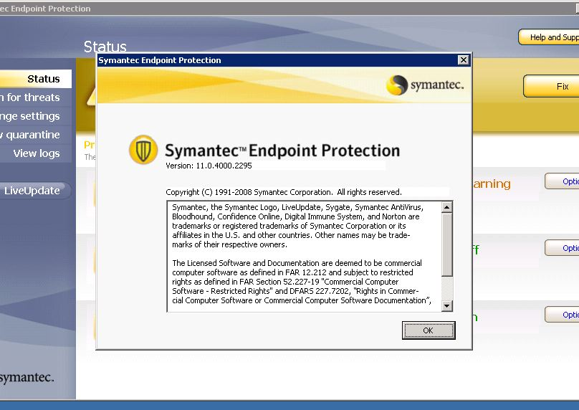

This is what I get on the server when I try to update using the “fix” button:
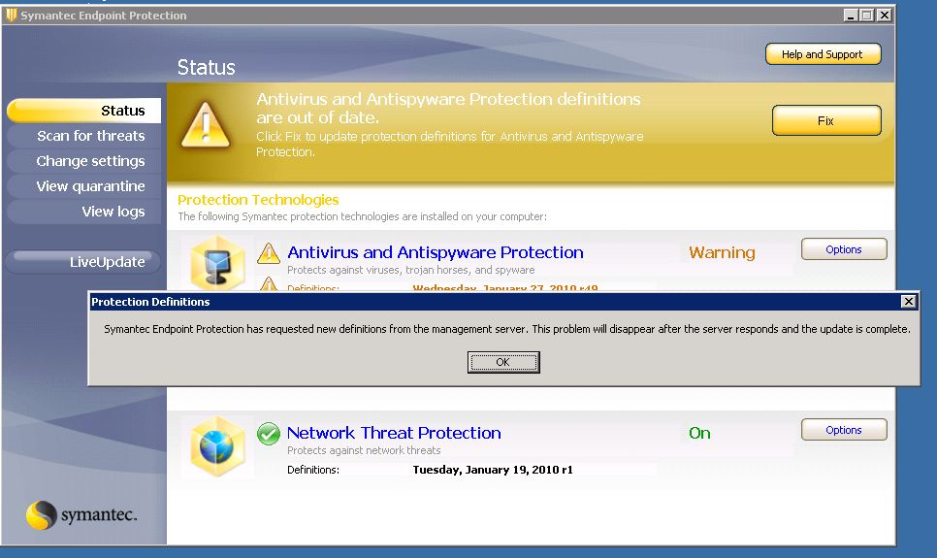

Of course, that never “fixes” or goes away.
LiveUpdate gives me this message (and doesn’t work):
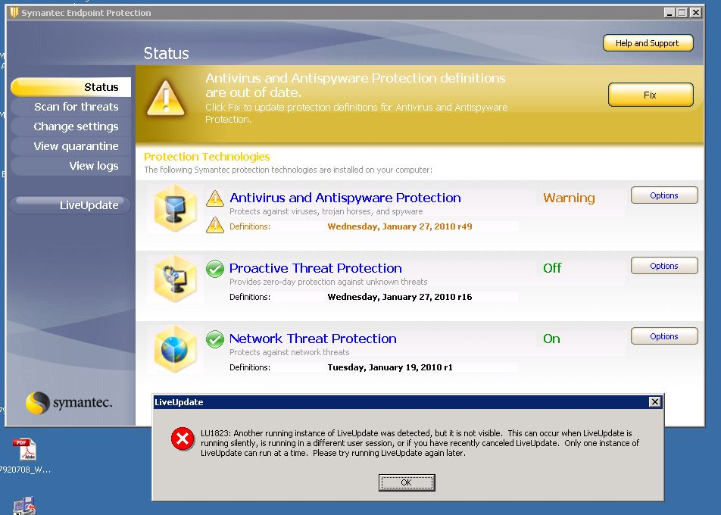

This is my SEPM version that, with this forum’s help, I was able to change the password and obtain a glimpse of:
