WebDrive Application Installation

In order for the Vontu Discover application to connect to UNIX based servers it requires the use of the SFTP protocol. The SFTP protocol connections to the UNIX servers are done using a 3rd party product called WebDrive.

This document provides the installation instructions on how to get WebDrive installed and configured for use with the Vontu DLP system.

Installing application

Install the corresponding WebDrive application for 32bit or 64bit operating systems. Install the program on the E: Drive under the WebDrive directory.

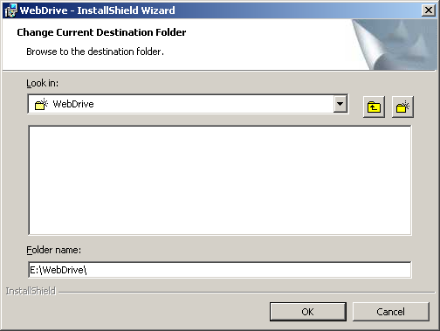

Configuring the WebDrive Application

The WebDrive application has configurations that apply to each user. As a result we will need to configure the WebDrive application for the user that the Vontu Discover application uses. In Visa’s case this is the ‘cmamgr’ user, which is a local account and not a domain user.

In order to run the application as a different user you will need to LOG into the server as the ‘cmamgr’ account. This will require you to temporarily add the LOCAL ‘cmamgr’ account to the Administrators Group.

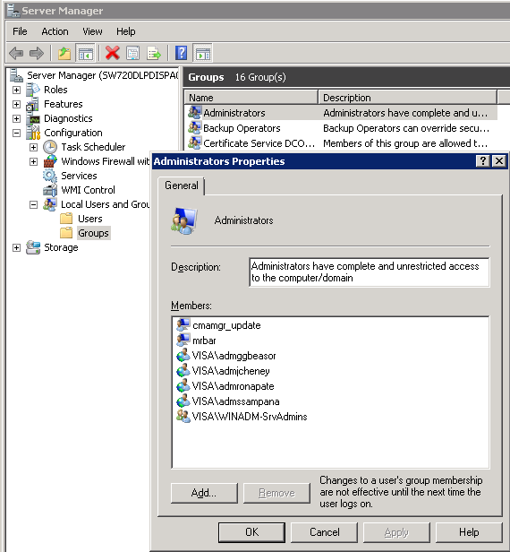

When entering the user account make sure to use the following format for the username:
Account: “servername\cmamgr”

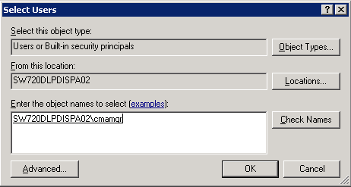

Once you have applied the change to the group, Logon to the server as the ‘cmamgr’ user and configure the Webdrive application as outlined below.
Configuring the WebDrive Site

When the discover server requests to mount a UNIX server it will use a specific name to call the temporary mount. That site name is “DiscoverMounter”.

So we will need to create a new site with the same name.

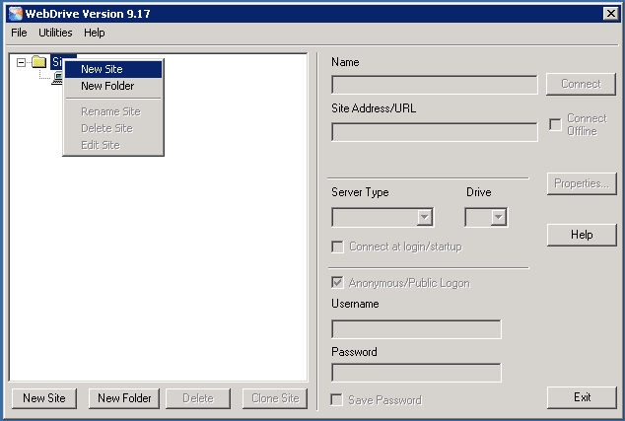

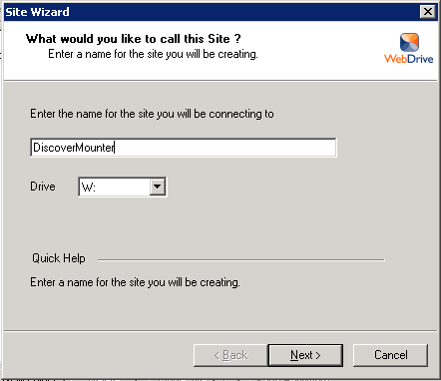

Select the SFTP protocol.

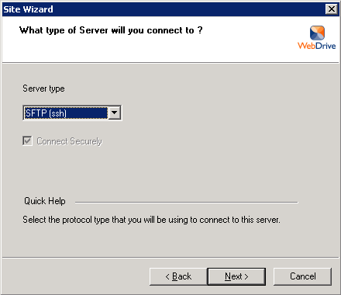

Make sure to enter the “\” as the root directory so it will search the whole filesystem when mounting the server.

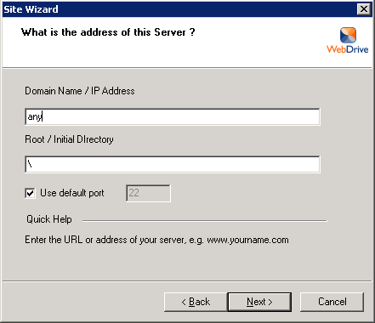

Use the default setting for the host key (none).

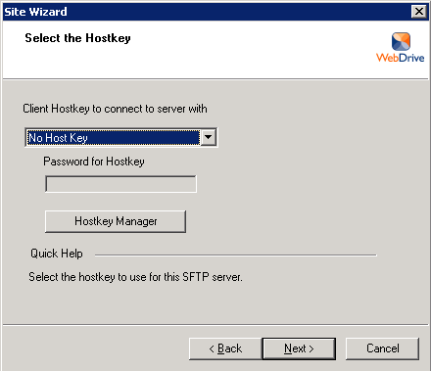

Select to use Anonymous logon and to not remember the password.

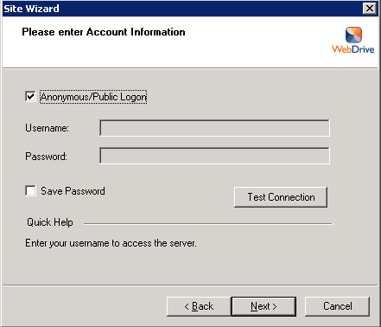

Finsh the setup and do not connect.

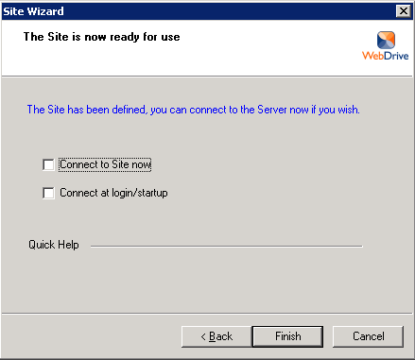

At this point you should see a new Site called “DiscoverMounter” and you are done.

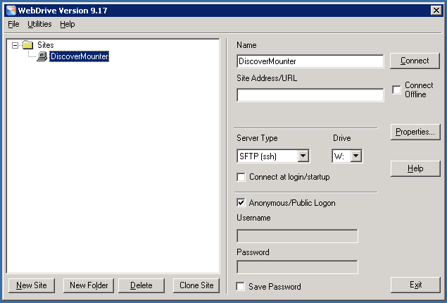

Remove CMAMGR login access

Log back into the server as you user and remove the ‘cmamgr’ account from the Administrators group.

