How to Configure SLAs
In CA SDM, the SLA or service type describes the level of service that the service desk analyst provides to the customer. To track your enterprise commitments and schedules (as they relate to specific tickets), events are attached to service types. Events are used to define the condition under which the service type is violated and the actions to be taken after the violation. Each event has three generic behaviour characteristics: conditions, actions on true, and actions on false.
- Condition identifies the measurable state of a ticket.
- Action identifies the processes that occur automatically when the condition is true or false after a specified amount of time.
The following diagram showcases how you can set up an SLA:

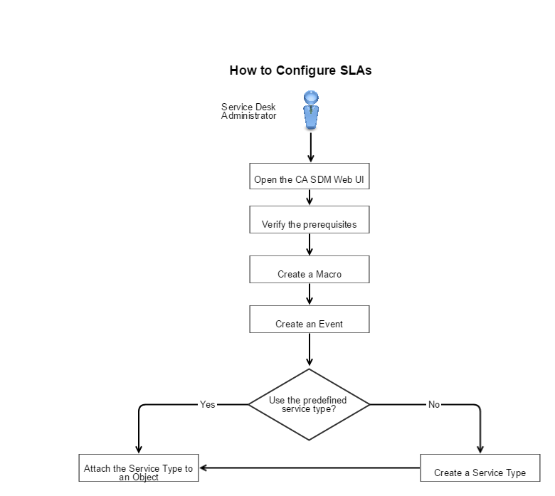

For creating a Service Type we need to create
- A Macro
- An Event

Create a Macro
Macros are small scripts that define either conditions or actions. When Events or Behaviours execute, they can execute one or more Action macros. Before the macros are executed, you can use a conditional macro to determine which set of Action macros to execute.
You can use macros in the following areas:
- Events
- Behaviour templates
- Activity Notifications
CA SDM includes several macros. Users can create their own macros too.
Note: Customers cannot add Action or Condition macros but can create simple macros with site-defined conditions. The Site-defined conditions are noncomplex macros that are created from GUI dialogs; they are not replacements for condition-type macros.
For each macro, you specify the object type that you want the macro to use. If you create a site-defined conditional to verify a Requests value, you set the type to Request. CA SDM displays only those object type macros that match the ones on the Events or Behaviours.
Create a macro. Use this macro to add actions to objects, check for certain characteristics, or conditions.
Note: If multi-tenancy is installed, select the appropriate tenant from the drop-down list. The public (shared) option creates the object for all tenants.
Follow these steps:
- Select Events and Macros, Macros on the Administration tab.
- Click Create New.
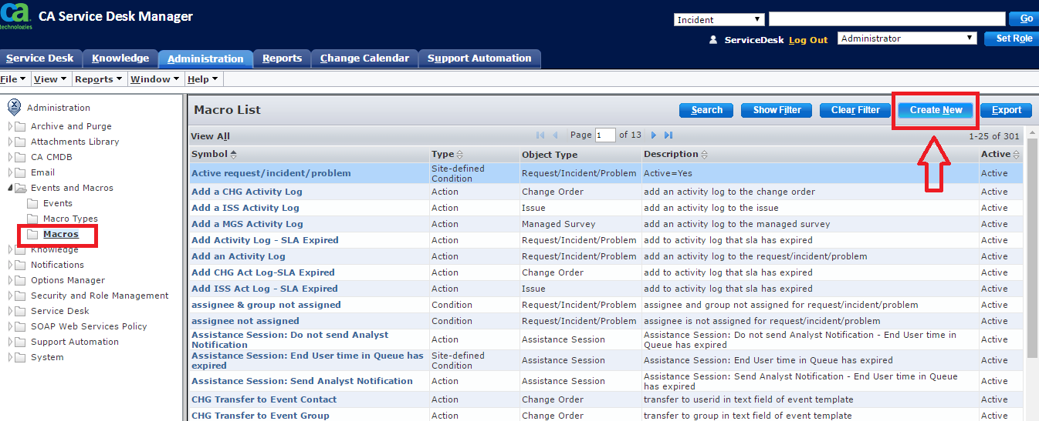
- Complete the fields as follows:
  - Symbol
Enter a descriptive identifier for the macro.
  - Macro Type
Select the type for this macro. The selected macro type controls the remaining data that is supplied.
Note: The Execute CA IT PAM Action selection is only available when CA Process Automation Workflow is configured with CA SDM.
Object Type
Select the type of object on which the macro can be run
- Click Continue.
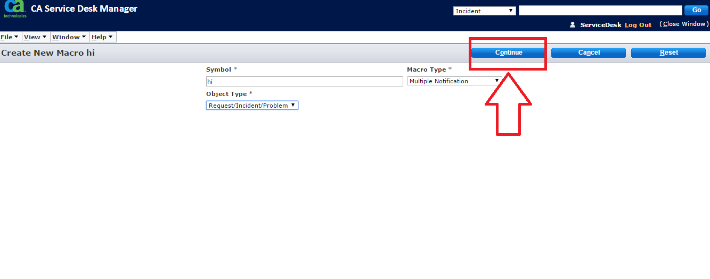
The page fills in with the remaining data.

Create an Event
You can configure events that are attached to objects to execute configured actions. Events are procedures that execute after a certain amount of time has elapsed. For example, an event sends a message to a service desk analyst if a "priority 1" issue is not received within an hour. Other parts of the system use events, for example, Service Types.
You can define events for Requests, incidents, problems, change orders, issues, contacts, configuration items, and global and specific tenants. CA SDM schedules the events execution time that is based on the delay time and work shift.
Note: If multi-tenancy is installed, select the appropriate tenant from the drop-down list. The public (shared) option creates the object for all tenants.
Create an event and attach a macro to this event. This event is executed after certain time is elapsed. If any macro is attached, an action is performed.
- Select Events and Macros, Events on the Administration tab.
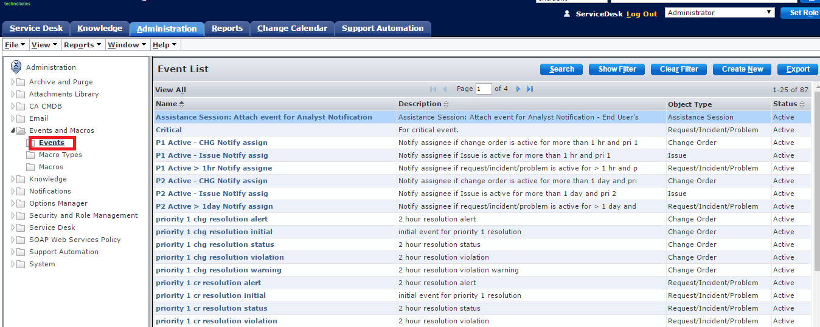
- Click Create New.
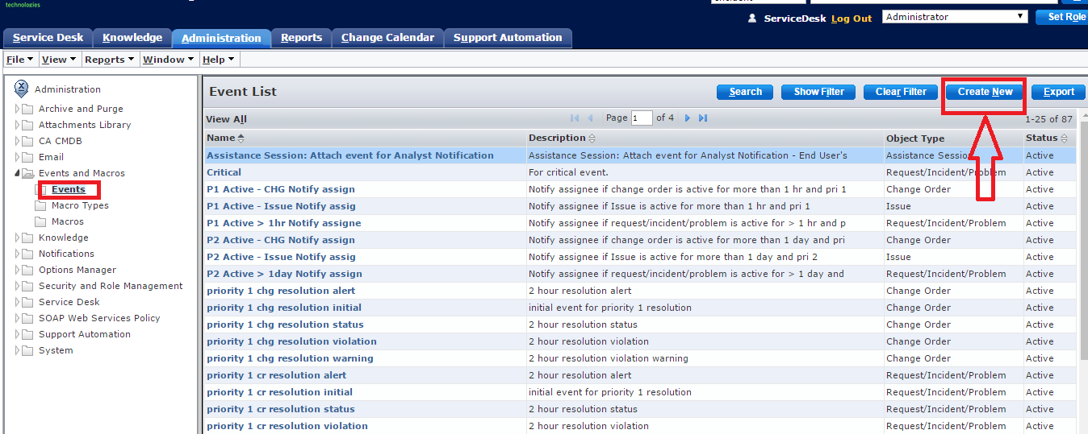
- Complete the event fields and the configuration information fields.
- Click Save.
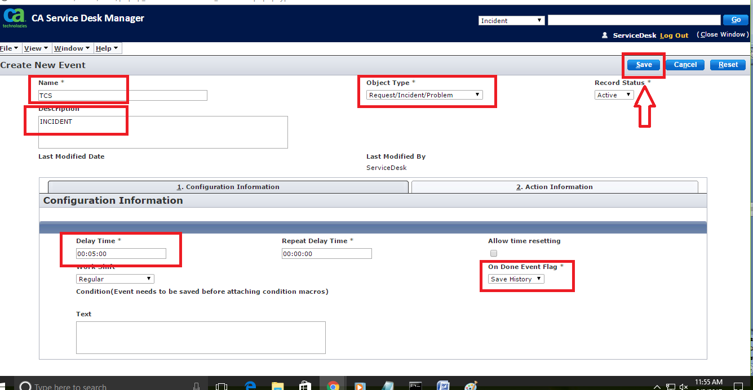
- To add the macro to this event, complete the action information fields with condition.
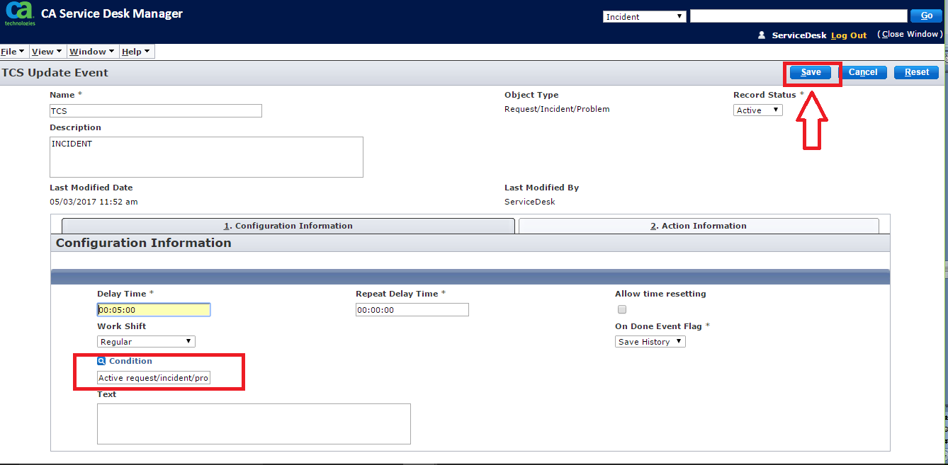
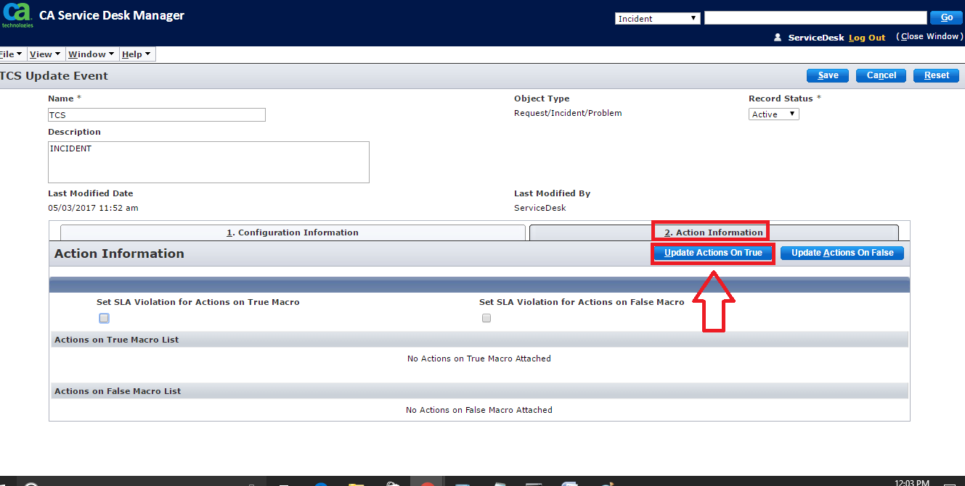
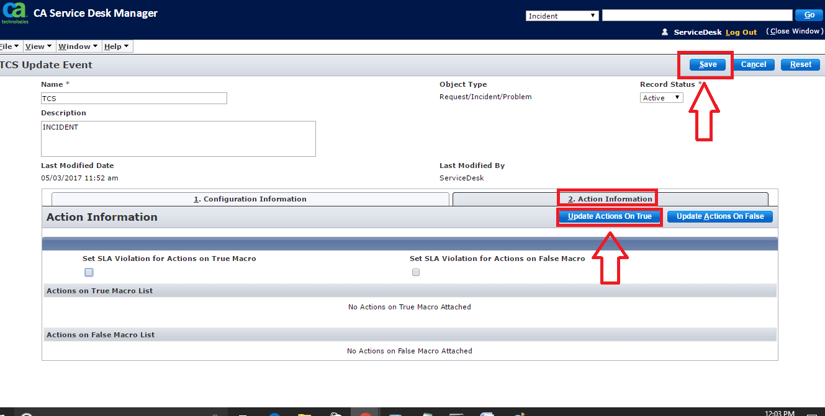
The new event is saved.

Event Fields
- Object Type
Indicates if the event is attached to an issue, request, change order, workflow task, knowledge document, knowledge report card, assistance session, or managed survey.
This field can only be edited when creating an event. This field is read-only when you want to update the event.
- Record Status
Indicates whether the event is active or inactive. Only active events can be used.

Configuration Information Fields
Complete the following configuration information fields:
- Delay Time
The time after which the event is triggered.
- Repeat Delay Time
The interval of time after which you want the event to be triggered again.
- Allow Time Resetting
Indicates that the desk analyst can change the Delay Time. Select this option to use an event as a Service Type event.
- Work Shift
The dates, days, and hours when the service type is in effect.
- On Done Event Flag
The action that is taken once the event is complete.
  - Repeat Event
The event at the specified time interval until the issue is closed.
  - Save History
Records the history of activities that are taken on the event.
  - No History
Do not record any history of the event. The event does not appear in the Event History window.
- Condition
Displays the macro (if associated with the event) indicating the condition that is checked for by the event.
- Text
Defines the event configuration. For some action macros, this field is used for a specific purpose. For example, the Transfer to Event Contact action macro contains the User ID of the person to whom the ticket can be transferred.

Action Information Fields
Select the actions to be associated with the event as follows:
- Click the Action Information tab.
- Select one or both of the Set SLA Violation for Actions on True/False Macro check boxes. Selecting these check boxes logs a Service Level Agreement (SLA) violation when a true or false condition is encountered for the event.
Note: Specify appropriate macros for true or false condition under the action list to log the SLA violations.
- Click Update Actions on True.
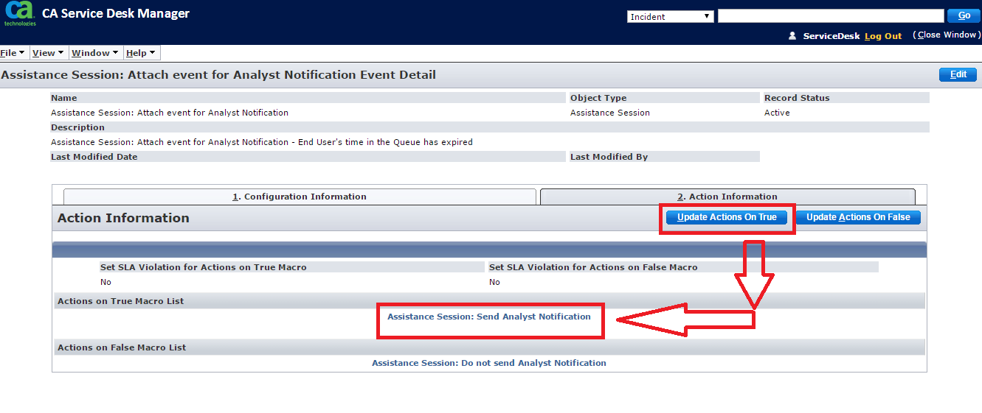
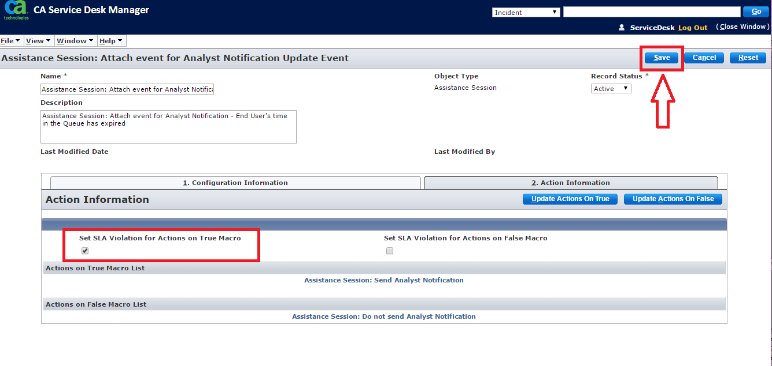
The Macro Search page opens.
- Search for the macros to be performed if the event condition is true.
- Select the desired macros from the list on the left, and click More (>>).
The selected macros are added to the list on the right.
- When all desired macros are in the list on the right, click OK.
The selected macros appear in the Actions on True Macro List.
- Click Update Actions on False, and repeat the previous procedure to select the macros to be performed if the event condition is false.

Create a Service Type
You can create a service type that suits your requirements. You can also modify a predefined service type.
Follow these steps:
- Select Service Desk, Service Types on the Administration tab.
The Service Type List page opens.
- Click Create New.
The Create New Service Type page opens.
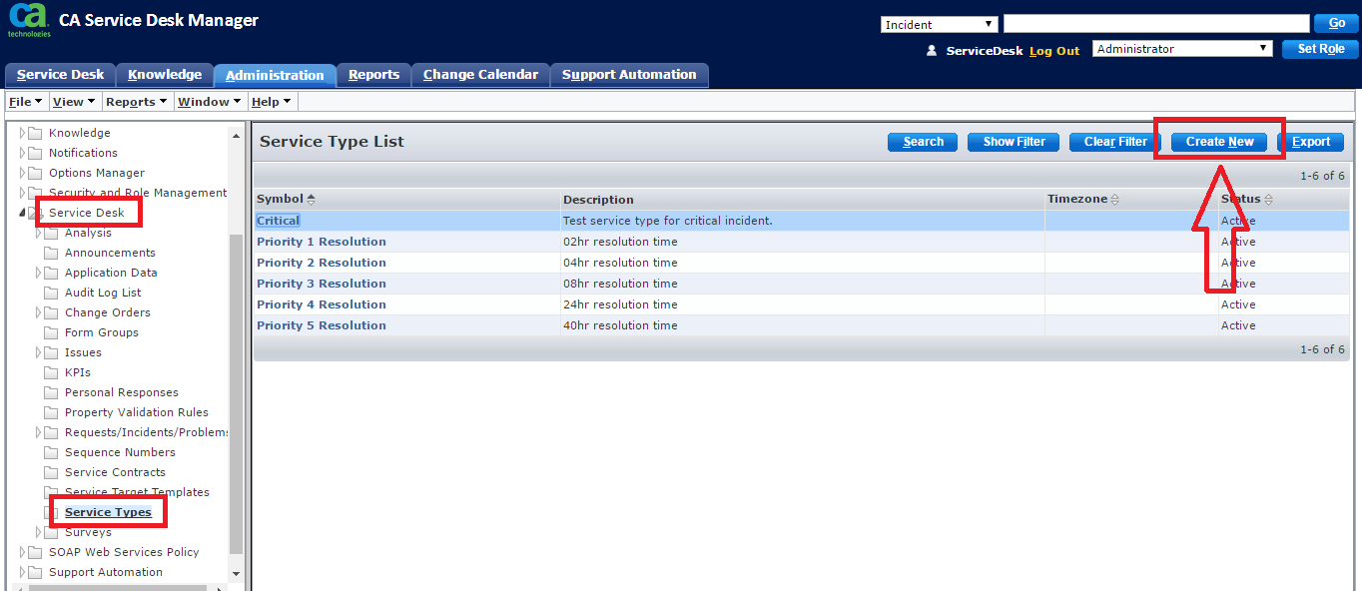
- If multi-tenancy is installed, select the appropriate tenant from the drop-down list. The public (shared) option creates the object for all tenants.
- Complete the following fields, as appropriate:
  - Symbol
Defines a unique identifier for the service type. In this example, you assign the symbol as 24_hr_resolution.
  - Ranking
Defines a ranking for the service type. In this example, the hardware request ticket may be associated with multiple service types. The ranking value determines the applicable service type. The service type with low ranking has the highest priority.
Enter 1.
  - Workshift
Specifies the dates, days, and hours when the service type is in effect. The following rules apply to workshifts:
    - If you apply a workshift to a service type, stop and restart the service for the workshift to take effect immediately.
    - If a workshift for a service type has been specified, but not for an event, the service type workshift is in effect.
    - If a workshift for an event has been specified, but not for a service type, the service type workshift is ignored.
    - If a workshift for the event and service type have been specified, the service type workshift is ignored.
  - Timezone
Specifies the time zone for the service type. This time zone is used for triggering events in the system if the Use End User's Time Zone option is not selected.
  - Use End User's Timezone
Specifies the timezone of the affected end user to trigger the events.
  - Violation Cost
Specifies the cost that is incurred if the service type time limit is violated.
- Click Save.
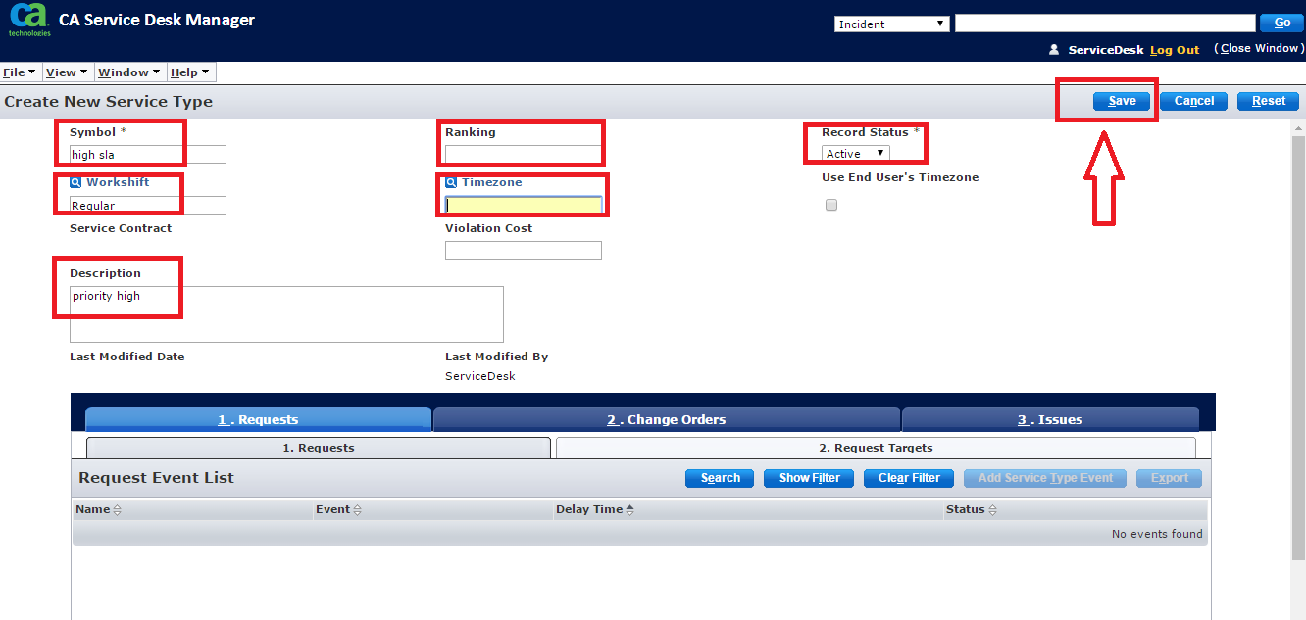
The service type is saved.
- To attach a service type event, select the appropriate tab (Requests, Change Orders, Change Order Tasks, Issues, or Issue Tasks) and click Add Service Type Event.
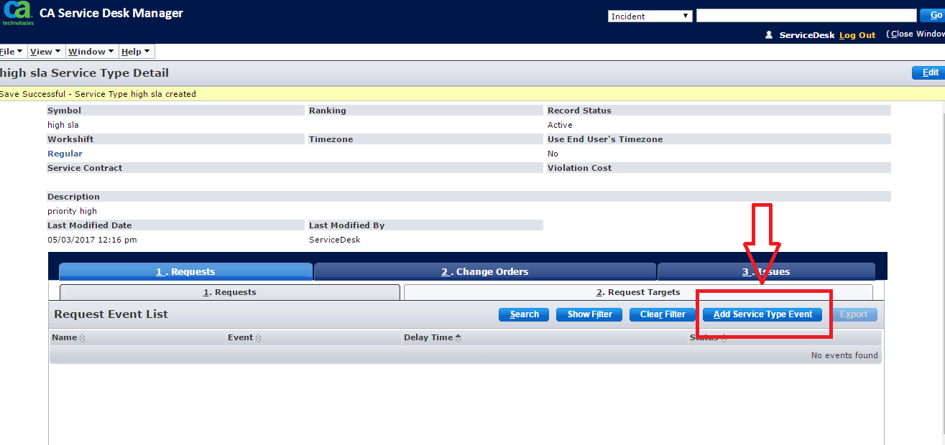
The Create New Service Type Event page opens.
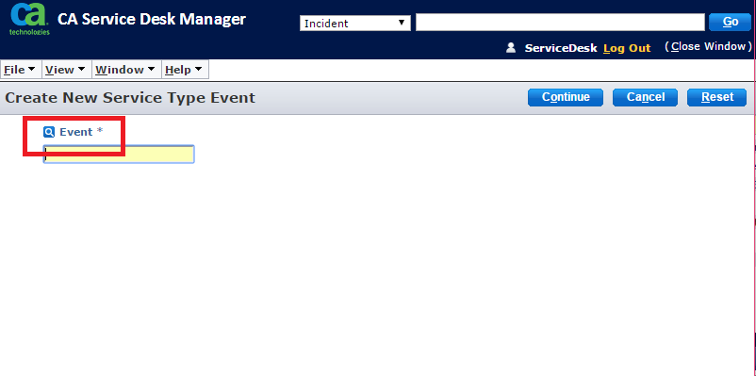
- Click Event.
The Event List page opens.
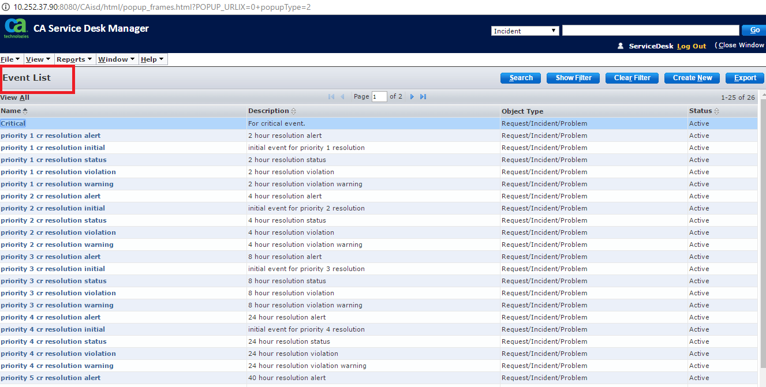
- Select one of the existing events from the list.
The selected or created event is displayed in the Event field.
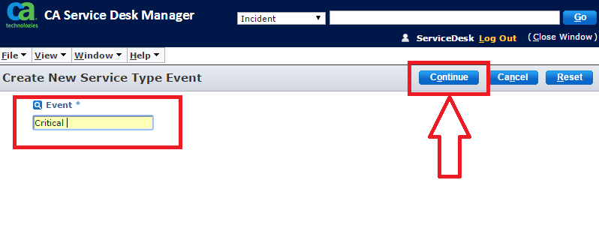
- Click Continue.
The service type detail page is displayed with the attached event.

Attach the Service Type to an Object
Service types can be associated with various objects such as contacts, organizations, categories, priority codes. According to the example, you attach the service type to the Incident Area, which is Hardware.
Follow these steps:
- Open the related ticket for which you want to assign an SLA.
- Click Hardware from the Incident Area field.
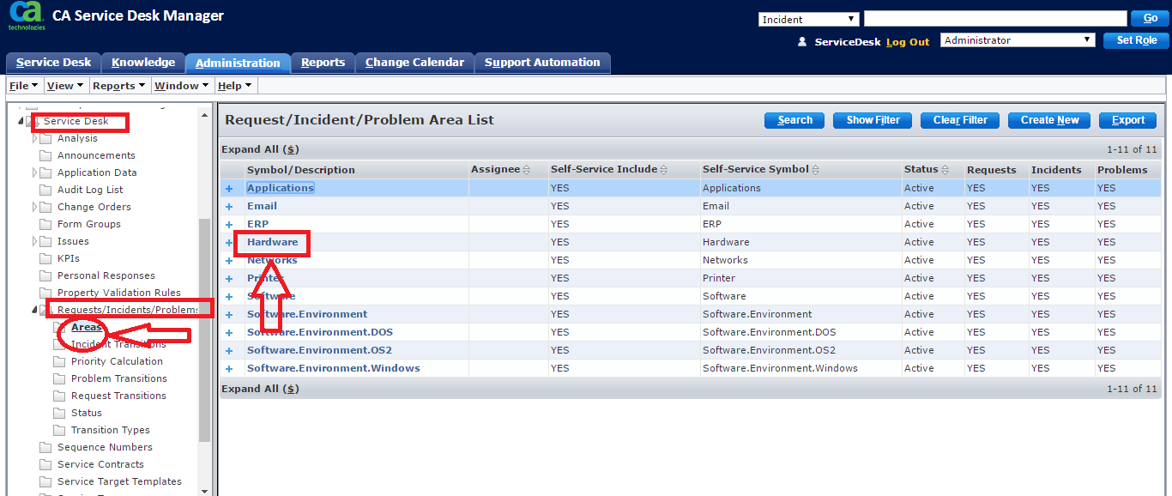
The Hardware Update Request/Incident/Problem Area page opens.
- Click Edit.
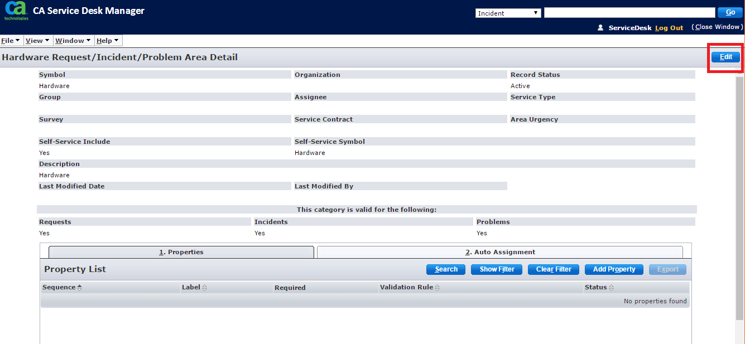
- Click Service Type.
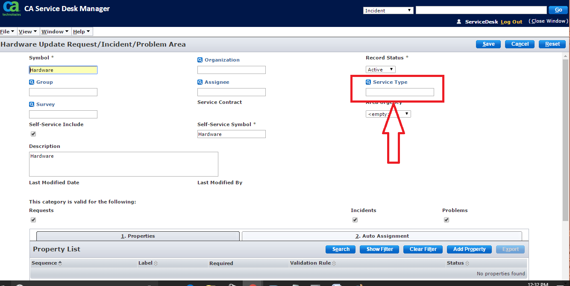
The Service Type List page opens.

- Search for High Sla resolution service type that you have created.
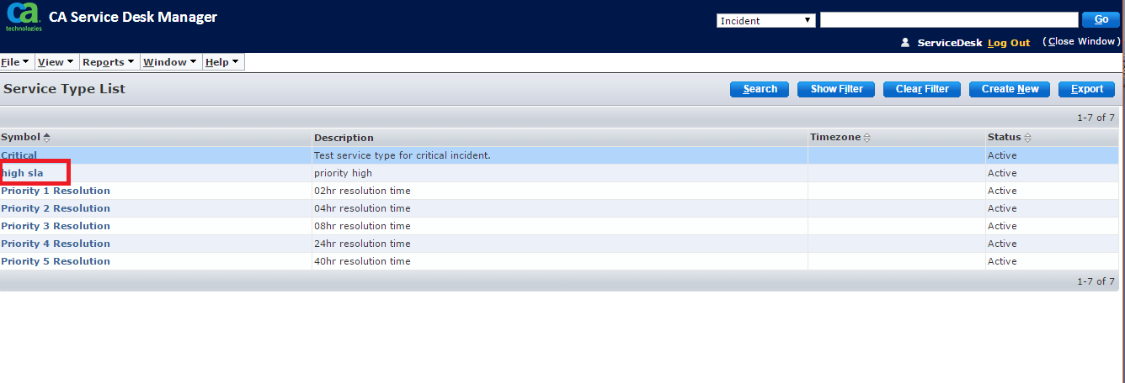
- Click high sla resolution from the search result.
The Hardware Update Request/ Incident/ Problem Area page opens with the updated service type.
- Click Save.
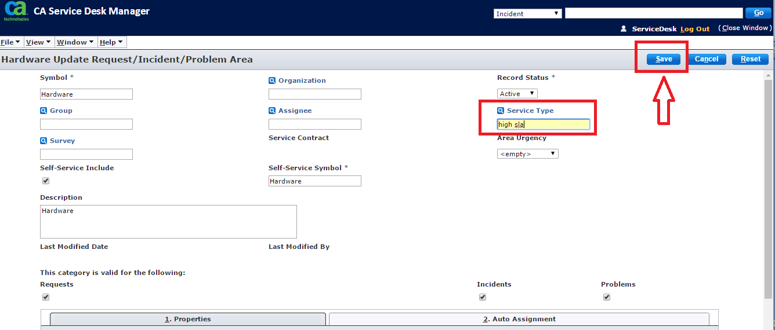
The service type is attached to the Hardware incident area.
