Windows IWA Failover to HTML Form Login

Overview
This document compliments the install instructions that come with the field kit referenced below.

Prerequisites
IWA Failover to Forms field kit – Free add-on / download from CA.

Install Steps
Copy authenticationselector.asp, integratedauthenticationtester.js and requiresauthentication.xml into D:\Program Files\CA\webagent\samples\forms\authselector

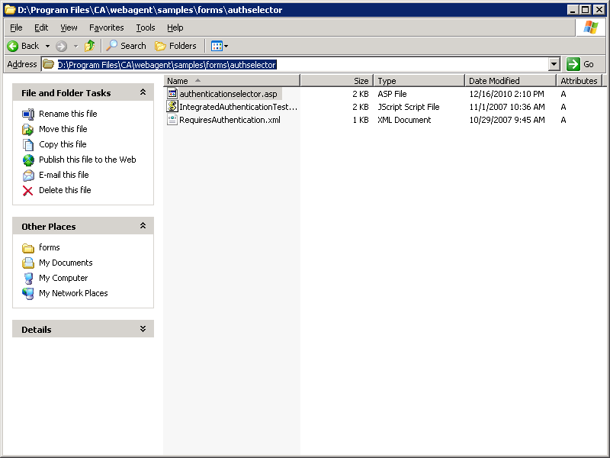

In IIS admin remove anonymous access to requiresauthentication.xml and ensure only Integrated Windows Authentication is selected.

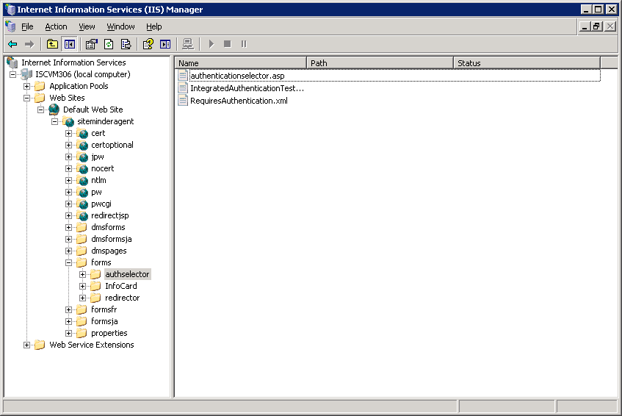
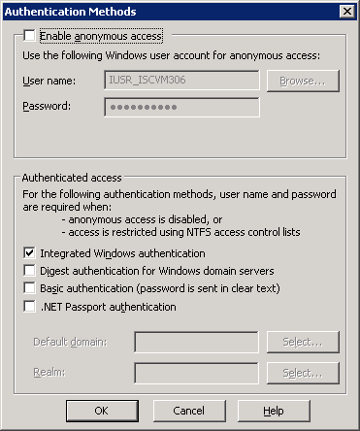

Copy file “redirector.asp” to D:\Program Files\CA\webagent\samples\forms\redirector
Note: If directory redirector does not exist please create.

- Create a Windows Authentication Scheme
- Type “NTLMv2” for Name
- Type “Collect Windows Desktop Creds” for description
- Type 5 for Protection level
Enabled Password Policies

- Type IIS server address for server name
- Type /siteminderagent/forms/authselector/authenticationselector.asp in the Target field.
Type (sAMAccountName=%{UID}) for User DN lookup filter
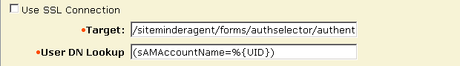

Click submit
- Create a security policy to protect the resource /siteminderagent/forms/redirector
Allow All in all user stores

Set FCCForceIsProtected = NO in agent object NTLMCollector-ACO

Set Allow for Active Server Pages in IIS Admin
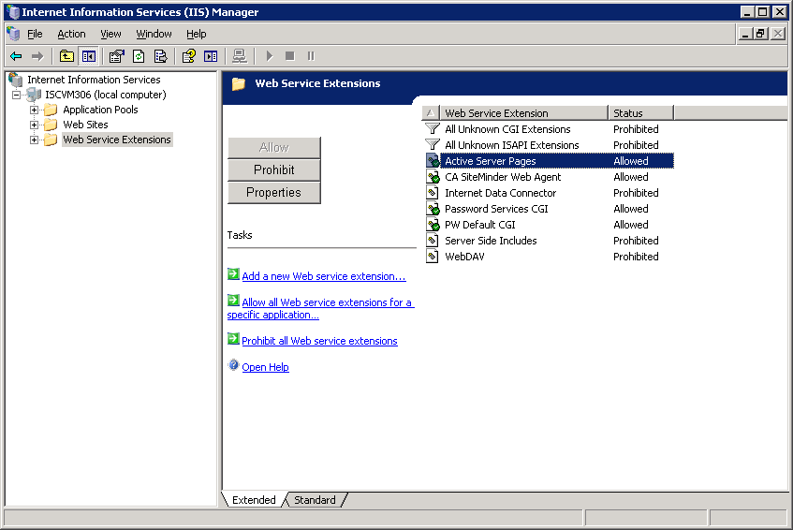

Restart IIS

Set all IE browsers participating in SSO to Automatic logon with current username and password

Troubleshooting
Typical looping is due to the directory not explicitly defined as unprotected.
1. Put authenticationselector.asp, integratedauthenticationtester.js and requiresauthentication.xml into a directory not protected by Siteminder.
-OR-
1. Put redirector.asp into a Siteminder protected directory that uses forms authentication.

