Multiple Value Mapping component
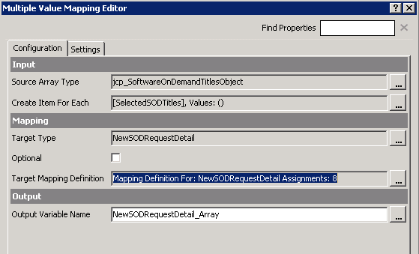

The component should create a new NewSODRequestDetail object for each row in the SelectedSODTitles array. However, the mapping only allows me to select properties of the First or Last entries in the array, not for each entry in the array.

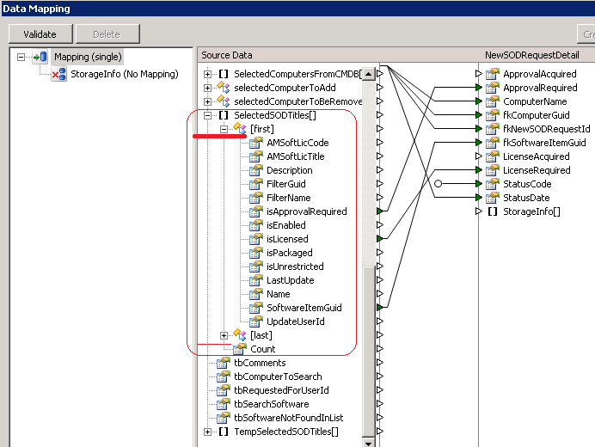

As a result I end up with the correct number of output entries, but their content is duplicated.

