Update Parameters in the environment
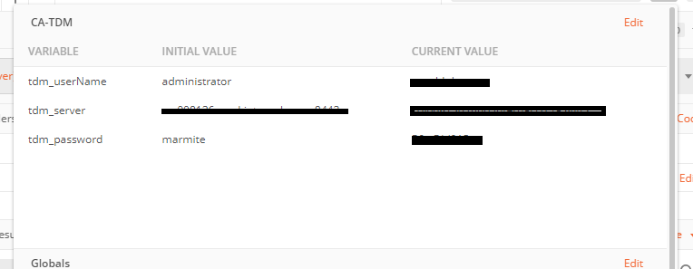
tdm_username: User with the relevant admin access to the project
tdm_server : Connect to the TDM Server <serverName>:<serverPort>
tdm_password: Password to connect to the environment

Request Login
Get Access Token
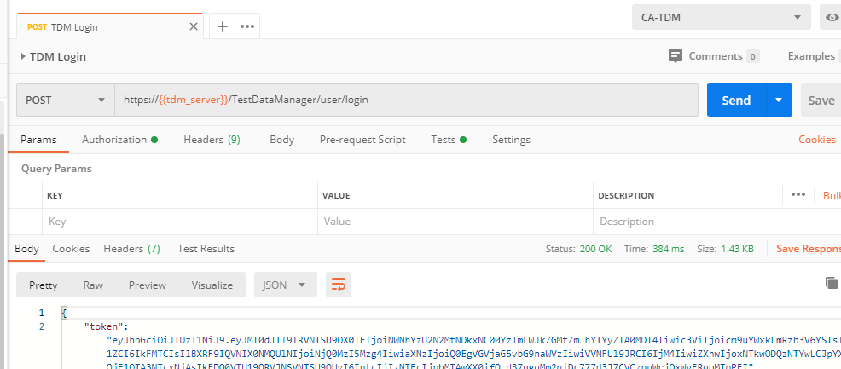

Get Projects
This will display all project that are not Sample Project that come with Default Installation (Demo Project). If you want to display it update the following in the pre-request scripts

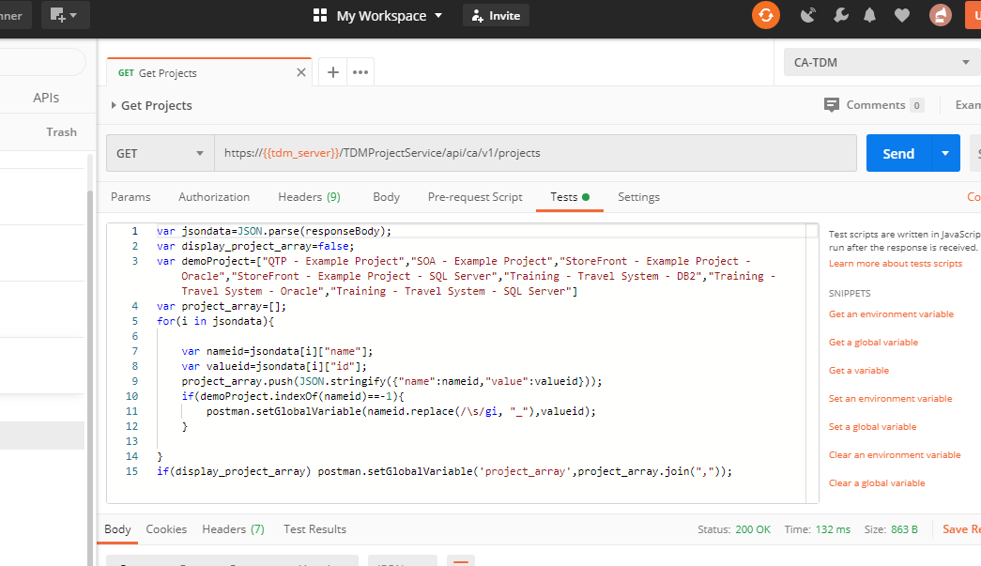
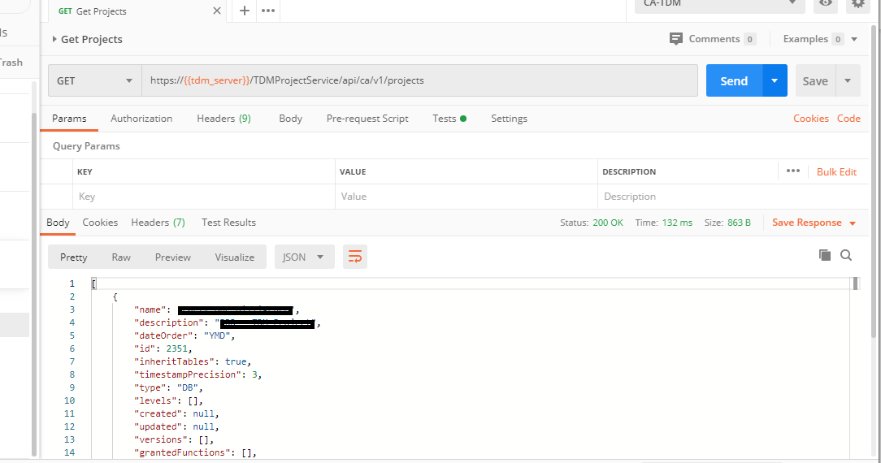

This will populate global variables with Project IDs
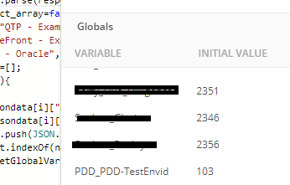
Note Project Name e.g. Sample_Project ID value 2351, the project name replace space with underscore
You can update this in the Pre-Request Scripts

Get CheckPoints
Return available checkpoint on TDM portal
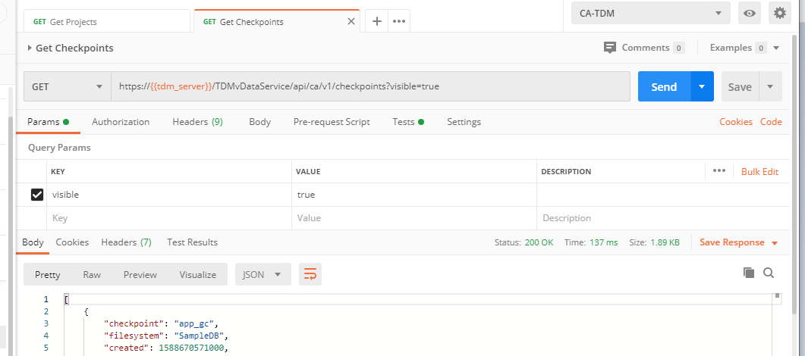
Also add it to a global variable
<CheckPointName>id -Return the check point id
<CheckPointName>id_con Return the connection parameters
<CheckPointName>uuid Return the UUID

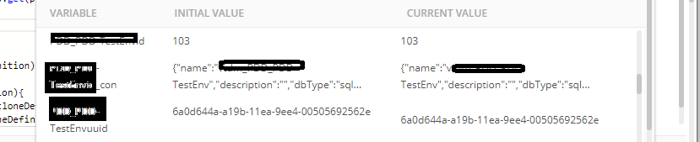

Get Appliance
Return Appliance Server

Create Clone
Create the Clone
- Pre-Request Parameter Required
- var projectName="<ProjectNameGlobalVariable>";
- var checkpoint_name='<CheckpointNameGlobalVaraible>'
Other attribute are automatically derived
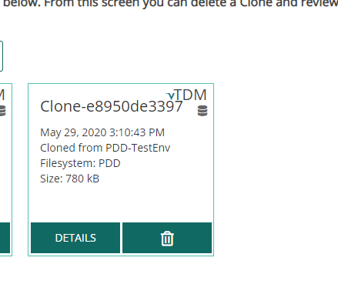

Get Clone
Get information of the existing created clone
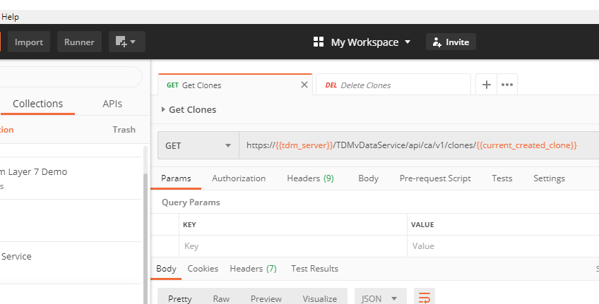

Delete Clone
Delete Created Clone
