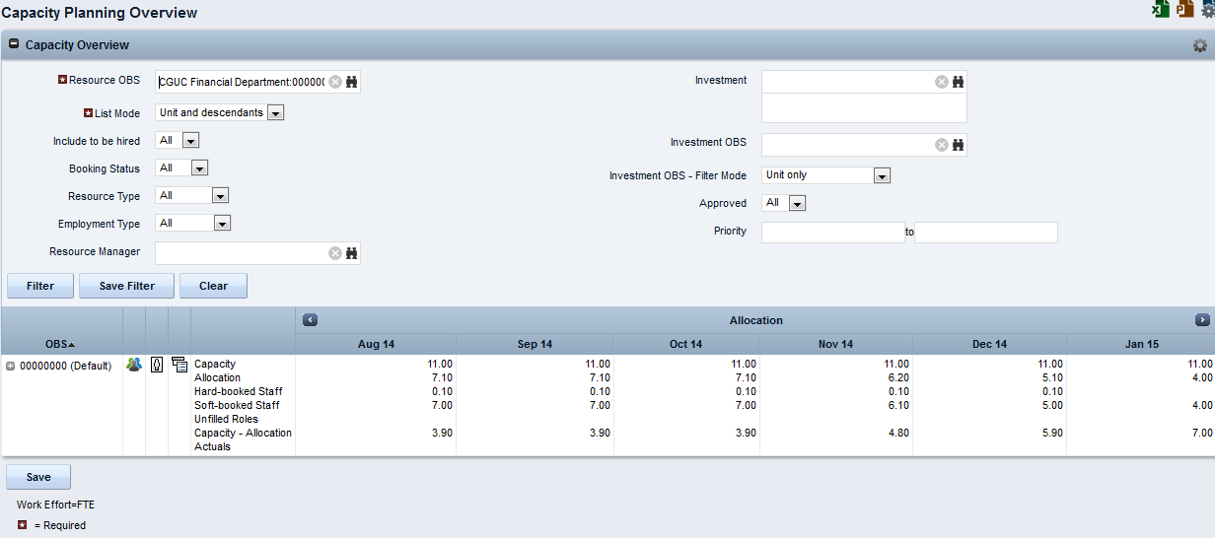
Follow these steps:
- Open Home and under Resource Management select Capacity Overview.
- Click the Unfilled Roles icon in a row for an OBS in the Capacity Overview portlet.

