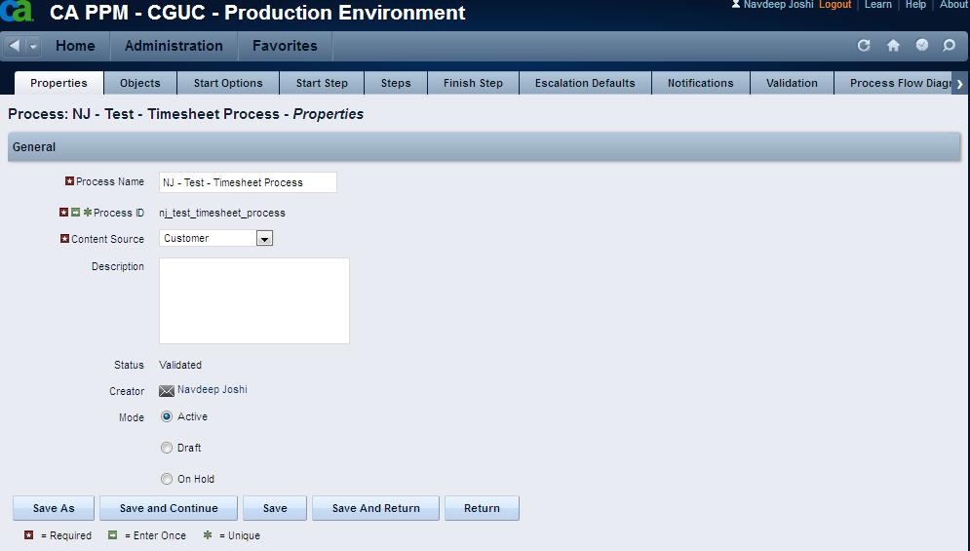

Associated the process to the timesheet object

Set the
Start Option as Auto-start
Start Event as Update
“Do not start a new process if one is already running” checkbox to true
Start Condition as “Timesheet Status = 'Submitted'”
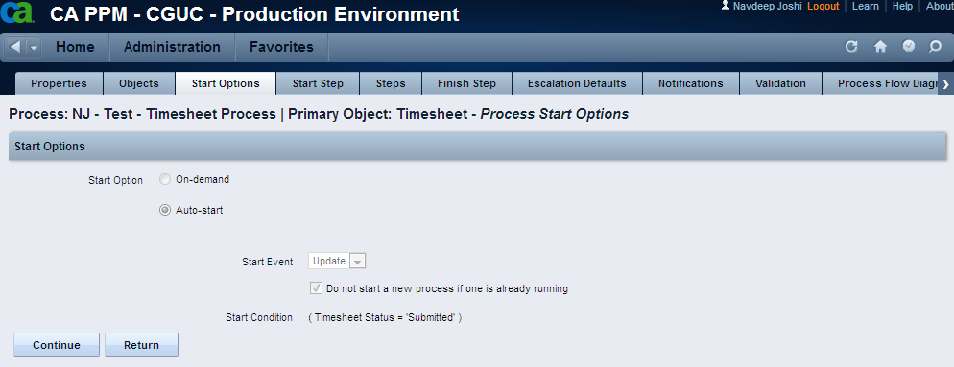

In the Steps tab, created a step, Approve Timesheet

In the above step, created a System Action as below –
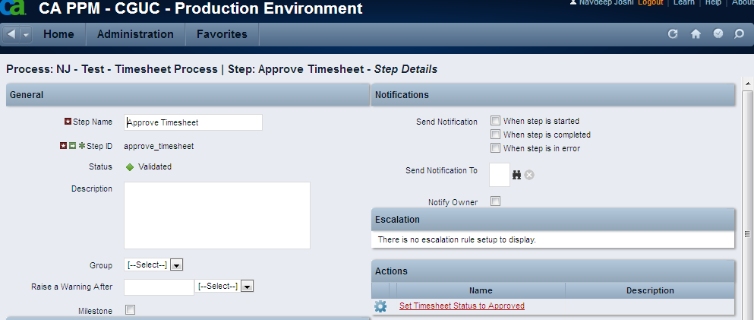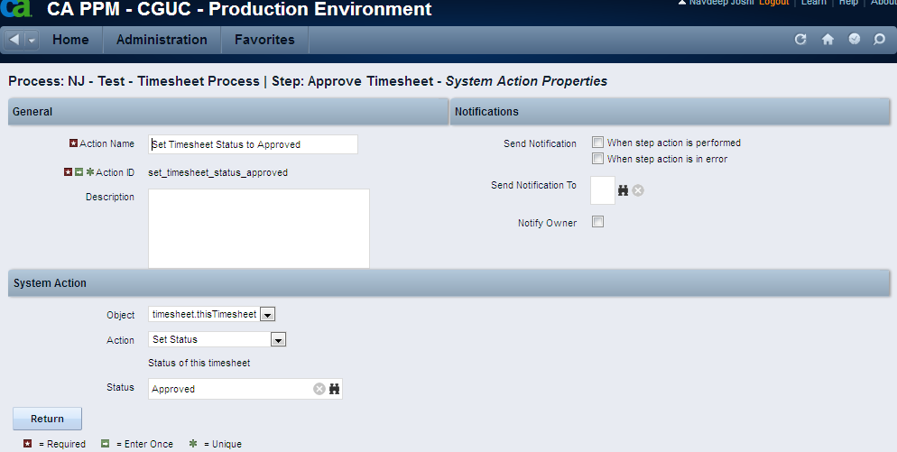

In the Post-conditions section of the above step, mentioned Finish in the Then Go To part
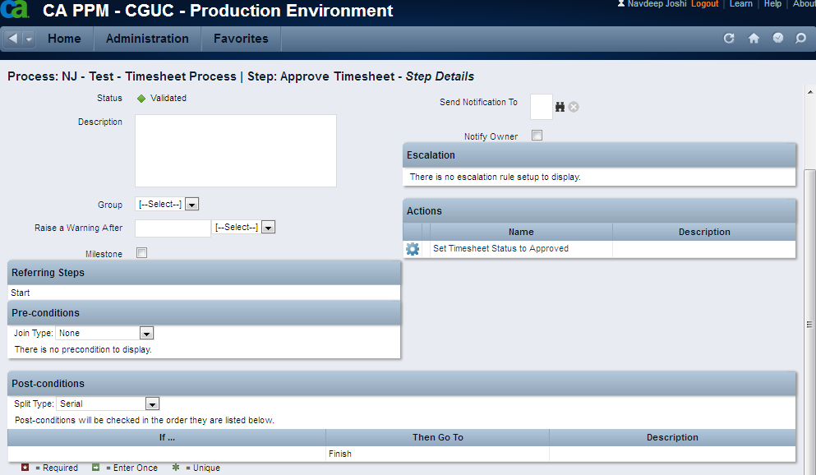

Click on the Start Step tab, and in the Post-conditions section, mentioned Approve Timesheet in the Then Go To part
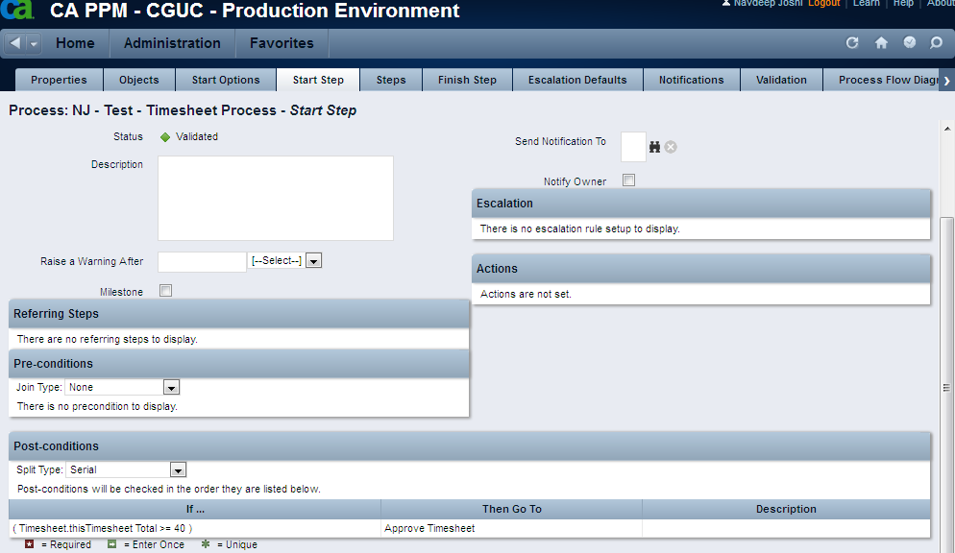

In the Validation tab of the process, click on Validate All and Activate button
