External Dependency issue:

We have many jobs with the external dependencies same as below in the screenshot. 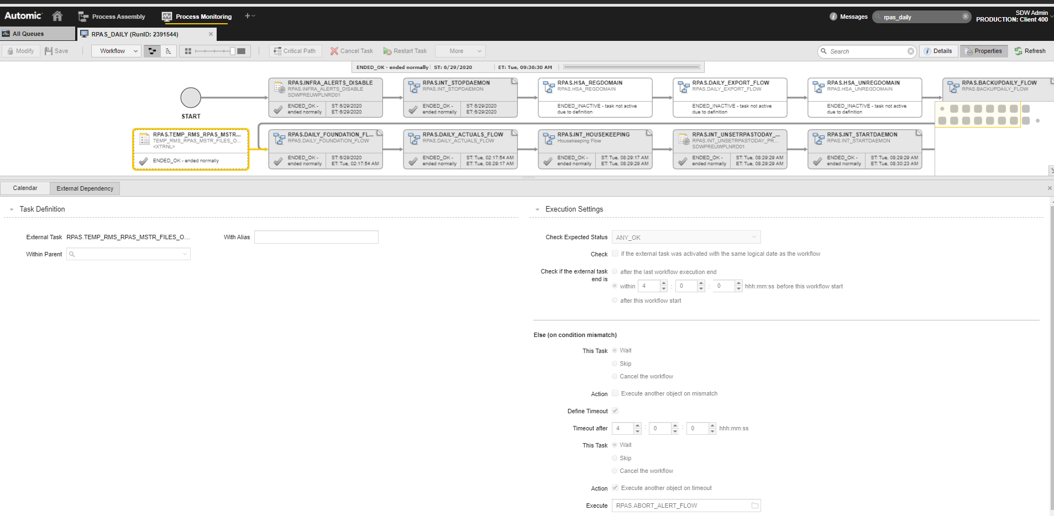

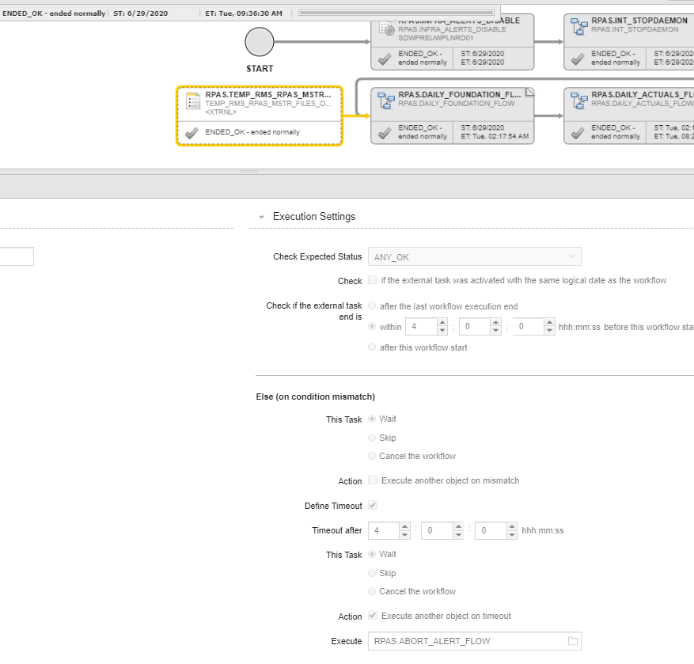

There is issue when external dependency and work flow having these dependencies activated or running on different days.
In this scenario we have configured the external dependency with “Check if external task end is ” with values 4-8 hours. Sometimes external dependency executes even if external job is not finished. Also these external jobs executes normally once in 24 hours.
All the external dependency jobs are scheduled around 2am each day (D day) and the work flow that requires these external dependency scheduled 11 PM day before (D-1 day). New Period objects are created at 00:00 hours for external dependency jobs. In this scenario, work flow (that has external dependencies) that starts at 11 PM (D-1 day) keeps executing without waiting for the external job that is scheduled around 2am (D day) to finish instead of waiting for the external dependency jobs to finish that starts at around 2am.

