Runtime Error in Symantec Endpoint Protection (11.0)

Problem
Symantec Endpoint Protection fails to start with the following error:
"Runtime Error! Program Files\Symantec\Symantec Endpoint Protection\Smc.exe."
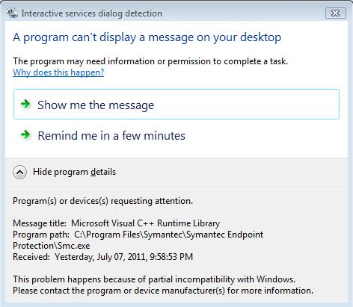
Symptoms
Microsoft Visual C++ Runtime Library dialog box displays the following error message: "Runtime Error! Program Files\Symantec\Symantec Endpoint Protection\Smc.exe."
This happens at system startup on Windows 2003 32 bit machine with SAP installed.
The Application Log shows SAP related errors.
Tamper Protection is enabled but does not log any error messages.
The System Log does not show any error messages specific to the SEP client.
Cause

SMC.exe has been corrupted by some other application.
Solution

To resolve this issue, please do the following:
- Go to a command prompt and run wbemtest
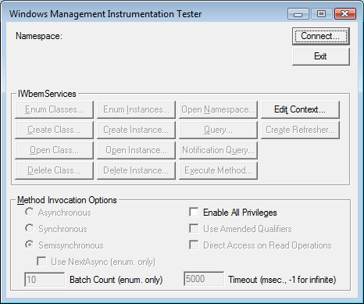
- Click the Connect button
- Replace root\default with root\securitycenter and click Connect
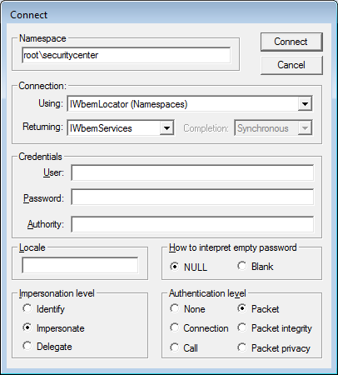
- You will be returned to the original screen, now click the Enum Classes button, leave the Superclass info box that appears as is (empty) and click OK
- On the Query Results screen, highlight Antivirus Product and choose the Delete button.
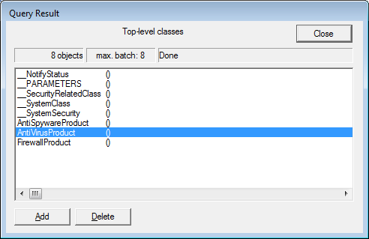
- Close the Query windows and exit wbemtest.
- Reboot the System.
- Check the Symantec Endpoint Protection Client, its working fine.

Note- If any other error display after process then Uninstall, reboot and reinstall the Symantec Endpoint Protection Client.

