NS7.1 - Double click on the below results in nothing – is this normal behaviour

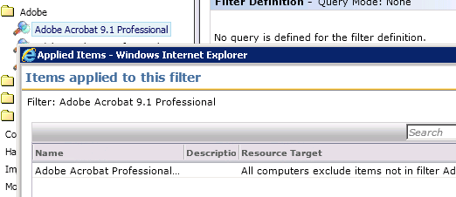

NS6.1 – double click goes directly to the program settings

