%EJCK PANEL is

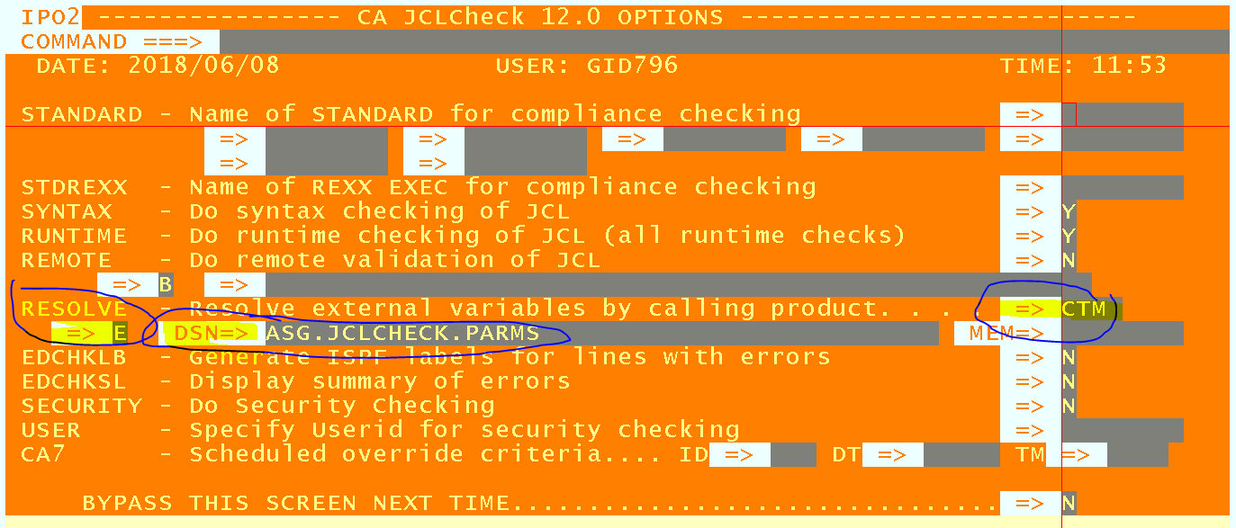

////////////////////////////////////////

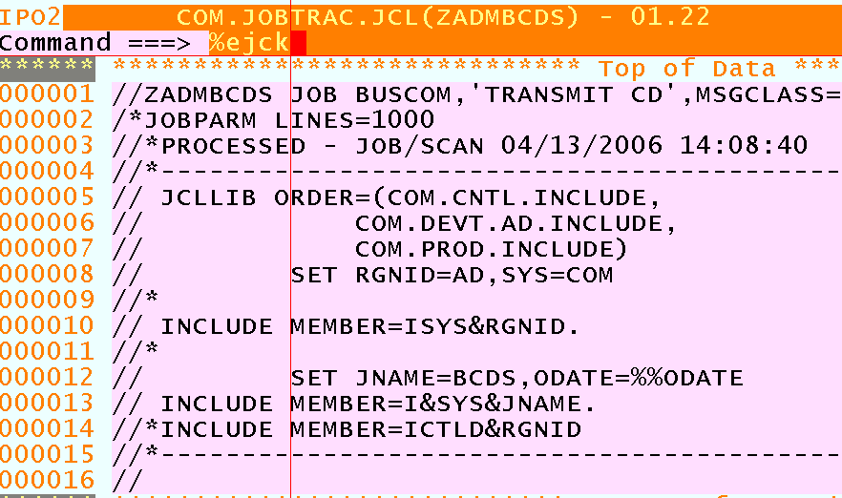

Then I get the panel (as above), to which I hit PF3 or Enter

Then I am in edit on ASG.JCLCHECK.PARMS (RESOLVE DSN on the panel)

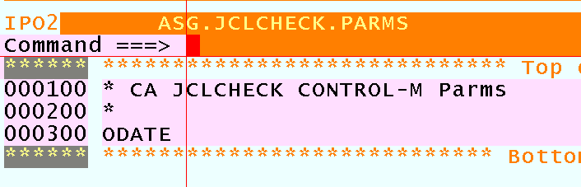

I hit PF3, and I am back in edit on the JCL on the above screen

If I hit enter again, I go around this loop again.

So how do I get %EJCK to actually parse the JCL with the RESOLVE options set ?
(same result whether I EDIT or BROWSE the parms dataset, or Bypass the Panel)

There are no error indications

Am I missing something in the setup ?

/////////////////////////////////////////////

. . . contd. next page . . .

Using !JCK, I get

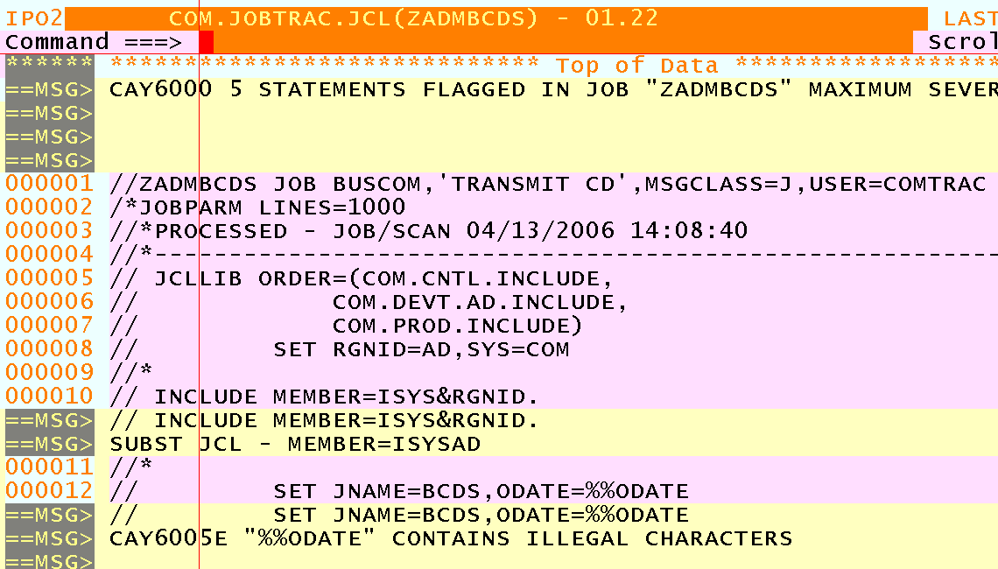

Process Control Options
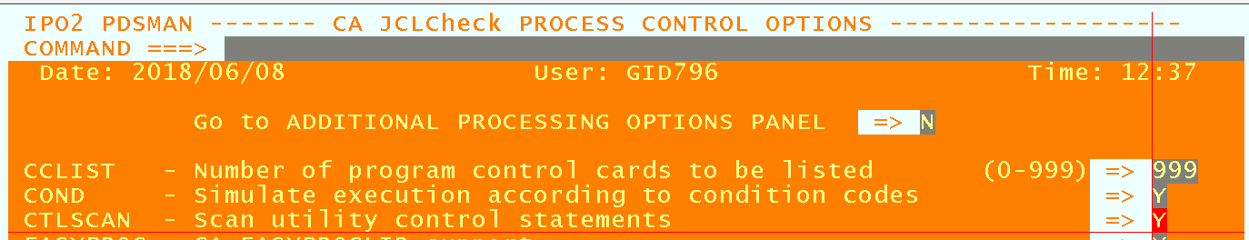

%EJCK LIST
( This is when “resolve product” = N (on %EJCK PANEL), as if it = CTM,
“%EJCK LIST” fails to parse the JCL, and I go around the loop as above )
