View Submitted Tasks queries:
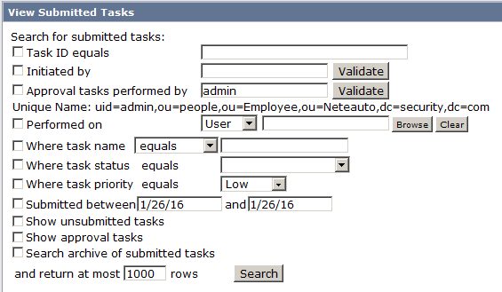

Task ID equals:
select * from tasksession12_5 WITH (NOLOCK) where environmentid = '16' and (name <> 'View My Submitted Tasks') and (name <> 'View Submitted Tasks') and (tasksessionid like '338b0b85-90b4eb04-93613d6b-1e39676%' ) and (state <> '16384' ) order by created_time
Initiated by:
select * from tasksession12_5 WITH (NOLOCK) where environmentid = '16' and (name <> 'View My Submitted Tasks') and (name <> 'View Submitted Tasks') and ({ fn LCASE(user_dn) } LIKE 'uid=admin,ou=people,ou=employee,ou=neteauto,dc=security,dc=com' ESCAPE '\') and (state <> '16384' ) order by created_time desc
Approval tasks performed by + Show approval tasks:
select * from tasksession12_5 WITH (NOLOCK) where environmentid = '16' and (name <> 'View My Submitted Tasks') and (name <> 'View Submitted Tasks') and (parent_of_wf_id IS NOT NULL) and ({ fn LCASE(user_dn) } LIKE 'uid=000000000w19855,ou=people,ou=ou4,ou=neteauto,dc=security,dc=com' ESCAPE '\') and (state <> '16384' ) order by created_time desc
Performed on (User object in this example):
select * from tasksession12_5 WITH (NOLOCK) where environmentid = '16' and (name <> 'View My Submitted Tasks') and (name <> 'View Submitted Tasks') and tasksessionid IN (select tasksessionid from event_object12_5 where object_type='USER' AND ({ fn LCASE(object_uniquename) } LIKE 'uid=00000000j916955,ou=people,ou=ou5,ou=neteauto,dc=security,dc=com' ESCAPE '\')) and (state <> '16384' ) order by created_time desc
Where task name equals (Approve Create User in this example):
select * from tasksession12_5 WITH (NOLOCK) where environmentid = '16' and (name <> 'View My Submitted Tasks') and (name <> 'View Submitted Tasks') and ({ fn LCASE(name) } LIKE 'approve create user' ESCAPE '\') and (state <> '16384' ) order by created_time desc
Where task status (In Progress in this example):
select * from tasksession12_5 WITH (NOLOCK) where environmentid = '16' and (name <> 'View My Submitted Tasks') and (name <> 'View Submitted Tasks') and ((state = '1024' ) or (state = '0' ) or (state = '1' ) or (state = '4' ) or (state = '8' ) or (state = '16' ) or (state = '64' ) or (state = '2048' ) or (state = '4096' ) or (state = '8192' ) ) order by created_time desc
Where task priority (Low in this example):
select * from tasksession12_5 WITH (NOLOCK) where environmentid = '16' and (name <> 'View My Submitted Tasks') and (name <> 'View Submitted Tasks') and (state <> '16384' ) and priority<=2 AND priority<>0 AND priority>=0 order by created_time desc

Submitted between (26th Jan 2015 – 26th Jan 2016 in this example):
select * from tasksession12_5 WITH (NOLOCK) where environmentid = '16' and (name <> 'View My Submitted Tasks') and (name <> 'View Submitted Tasks') and (state <> '16384' ) and ((created_time >= '2015-01-26 00:00:00' ) and (created_time < '2016-01-27 00:00:00' ) ) order by created_time desc
Show unsubmitted tasks:
select * from tasksession12_5 WITH (NOLOCK) where environmentid = '16' and (name <> 'View My Submitted Tasks') and (name <> 'View Submitted Tasks') order by created_time desc
Show approval tasks:
select * from tasksession12_5 WITH (NOLOCK) where environmentid = '16' and (name <> 'View My Submitted Tasks') and (name <> 'View Submitted Tasks') and (state <> '16384' ) order by created_time desc
Search archive of submitted tasks (using this as a combination with any other search criteria is possible):
select * from archive_tasksession12_5 WITH (NOLOCK) where environmentid = '16' and (name <> 'View My Submitted Tasks') and (name <> 'View Submitted Tasks') and (state <> '16384' ) order by created_time desc

