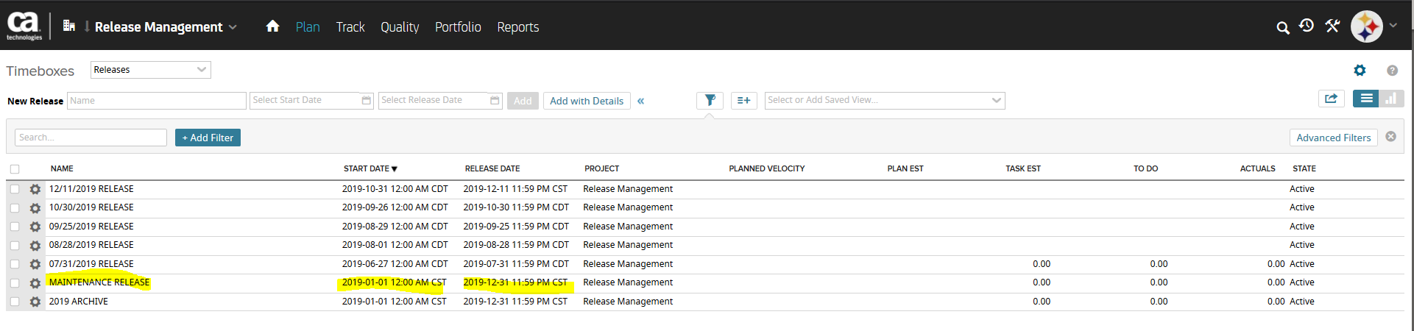Notice in this screen shot, the time box 7/31/2019 RELEASE does not show up.
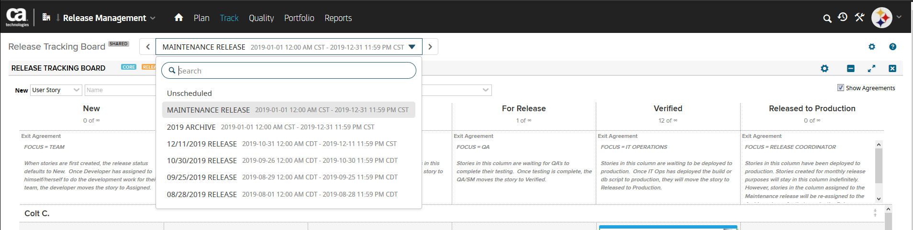
When I toggle through the time boxes to get 7/31/2019 to show up, now MAINTENANCE RELEASE does not show up.
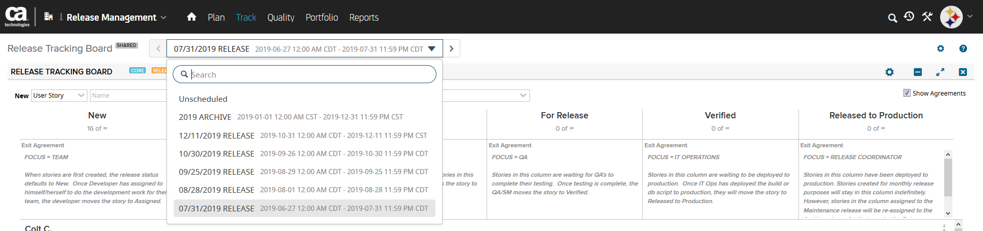

Basically, I can’t get them all to show up at the same time, which is causing users to get confused when I tell them to go to MAINTENANCE RELEASE.

