Introduction to Asset Management Suite 7.1
Hands-On Lab

Description | Learn how to implement cost-saving license compliance using the new features in Asset Management Suite. Experience the automated features that now come included in the latest version of Asset Management Suite.  This lab assumes a basic understanding of navigation with the Notification Server console and Inventory Solution.
At the end of this lab, you should be able to | - Understand basic setup of a license compliance calculation  - Understand the role and be able to create  - Software products  - Software purchases  - Software licenses  - Use the Connector Solution to import license data  - View compliance reports from the resource manager  - Create custom data classes associated with the custom resource type that will be created.  - Create the custom resource type and associate the custom data classes.  - Create the custom views for the resource type  - Demonstrate associating the asset with a user
Notes | - This Lab is built for the use of Asset Management Suite only. The silver light console is currently only available with Client Management Suite, and not available if AMS and inventory are the only solutions owned.  While the demo environment includes CMS and the Silver Light, this particular lab does not utilize that functionality.

License Compliance Overview
Conceptually, license compliance is a straightforward, simple concept.
- Report on installed licenses
- Keep track of what is purchased vs. what is installed.
- Never install more than you buy.
- Never buy more than you need.
Practically, license compliance is a challenging endeavor.
- There is no standard, industry-wide de facto method for vendors to denote the presence of an application.
- Software procurement is often de-centralized, making it difficult to know exactly what is purchased.
In this lab we will present the Symantec Asset Management solution’s approach to software license compliance. Upon completion of this lab you will understand how to create a license compliance calculation for a particular software title.

Basic Terms
Please read through the definitions below. These terms are used extensively in the lab and also represent some new terminology in comparison to version 6.x products.
- Software Catalog
  - The Software Catalog is a centralized model of the software that is known in your organization, regardless of where the software is installed. The Software Catalog does not contain any software. Instead, it contains the data that describes the software. If a package is associated with the software, the Software Catalog also points to the source of the package file.
  - Example: The software catalog will hold information about installed software as well as yet-to-be-deployed applications/releases/patches.
- Software Library
  - The Software Library is the physical directory location of the package files that are associated with the software in the Software Catalog. Because the Software Library is a repository of the definitive, authorized versions of the packages, you should restrict access to the library to maintain its integrity.
  - Example: the MSI file for the installation of OpenProject would reside in the software library, and perhaps be used by Symantec Software Distribution to install the application on client computers.
- Software Resource
  - A software resource is the meta data that describes a specific instance of a software product. A software resource provides a common way to describe the software so that all software-related actions can identify it accurately.
  - Example: The data of all files installed when OpenProject is installed (dll’s, exe’s, etc.) represents a software resource.
- Software Product
  - A grouping of one or more software resources. Use of the software product is optional in the Symantec Management Platform, but required for software license compliance.
  - Example: For example, you create a software product named Norton Internet Security 2008. Then you assign that product to separate software resources for Norton Internet Security 2008 - English,Norton Internet Security 2008 - English SP1, Norton Internet Security 2008 -French, and so on.
- Software Purchase
  - The record of the rights purchased for a particular software title.
  - Purchases may reflect procurement events or organizational events.
  - Example: PO 12345 for 10 copies of Microsoft Visio, “purchase” of 500 copies of Microsoft Visio due to acquisition of company ABC, “purchase” of -500 copies of Microsoft Visio to reflect divesture
- Software License
  - A contract type within Symantec Asset Management used to relate software purchases to a software product.
- Master License Agreement
  - A parent-child relationship among software licenses. This agreement typically coincides with an actual agreement your company has.
  - Example: A Master License Agreement “Microsoft Win32 Applications” could have child software licenses “Microsoft Office”, “Microsoft Visio”, “Microsoft Visual Basic”, etc.
- Virtual License Agreement
  - A parent-child relationship among software licenses, not typically corresponding to an actual contractual agreement.
  - Example: My role is to manage AutoCad and Great Plains within my company. “My Special Virtual Agreement” is a parent license with child software license for AutoCad and Great Plains.

Basic flow of lab exercise
- Create cost centers.
- Create a software purchase linked to the cost center; show multiple cost center ownership.
- Import a software purchase from a CSV file.
- Create a software product from the inventoried software resource OpenProject .
- Create a software license for OpenProject
  - Link the license to the purchases
  - Link the license to the software product
- View the license summary data
- View various software license reports
- View software license policies

Optional exercises (time permitting)
- Create data classes to allow tracking individual license keys assigned to users.
- Link the data class to a software purchase.
- Create a filter based on this list of authorized users.
- Use the filter to assign an authorized collection in the license compliance.
- View license compliance data product authorization summary.

Create Software Purchases

Create cost centers that our purchases will be billed against
- Before starting the lab, revert to the included Snapshot in VMware
- On your desktop, open the Internet shortcut for Symantec Management Console 7.1
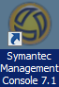
- Navigate to Manage -> Assets
- Expand the folders on the left to select Organizational Type -> Cost Center
- Right click on Cost Center, and select Create Cost Center 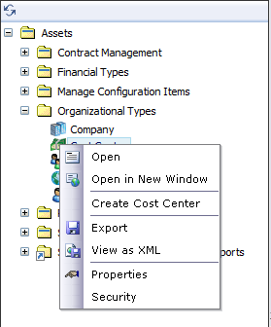

- Complete the cost center as follows:
  - Name: Sales Western Region
  - Cost Center Code: 12345
  - Cost Center’s Location: Las Vegas
  - Cost Center’s Manager: End User 1
- Select Save and Create New to create an additional cost center
  - Name: Sales Eastern Region
  - Cost Center Code: 8675309
  - Cost Center’s Location: Atlanta
  - Cost Center’s Manager: End User 2
- Click OK

Create a software purchase for OpenProject
- Expand Software Licensing
- Right Click Software Purchase and select Create Software Purchase 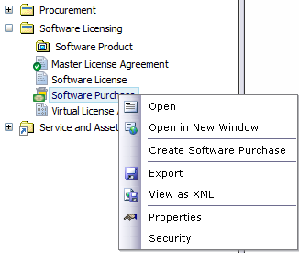

- For convenience select the view Software Purchases (global)
  - This retracts the fields you see to those most relevant to a software purchase
- Name the purchase OpenProject - March 2011
- Purchase Date: enter any date/time
- Description: This is the desktop purchase for OpenProject licenses.
- Quantity: 10
- Cost Items
  - Select Add
  - Select Purchase then OK
  - Select the ellipsis for Accounting Code 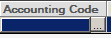 and choose “Purchase Cost”
  - OK
  - Double click the Date column and enter a date mm/dd/yyyy
  - Double click Amount and enter 29.99
  - Status Incurred
  - If you had imported the PO for this purchase you could link to the PO in the Purchase Order field. You may select a PO, but any data there does not match our demo scenario, i.e. any PO there would not truly reflect our purchase of OpenProject, though you could select it for demo purposes.
- Select Add under Software Purchase Owners
  - Select Sales-D
  - Click OK
  - Enter 100 for ownership percentage
- Select Add under Software Purchase Cost Center Ownership
  - Select Sales Eastern Region
  - Click OK
  - Select Add
  - Select Sales Western Region
  - Click OK
- Assign the ratio for the two cost centers to own this purchase
  - We will demonstrate the auto calculate feature
  - Under the Ownership Percentage column for Sales Eastern Region enter “20”
  - Under the Ownership Percentage column for Sales Western Region enter “30”
  - These percentages only add to 50. But to keep the same ratio of ownership, select “Auto Calculate”
  - The ownership should reflect a 60/40 split.
- If you were using the procurement features of Symantec Asset Management suite and had a vendor catalog of software titles, you could reference this software title in the field denoted “Software Purchases’ Associated Catalog Item”. This has not been set up for this lab.
- Click OK

Import a software purchase from a CSV file
- Navigate to Settings -> All Settings
- Expand Notification Server -> Connector -> Data Sources
- Right click “Data Sources” and select “New” -> “CSV File Data Source”.
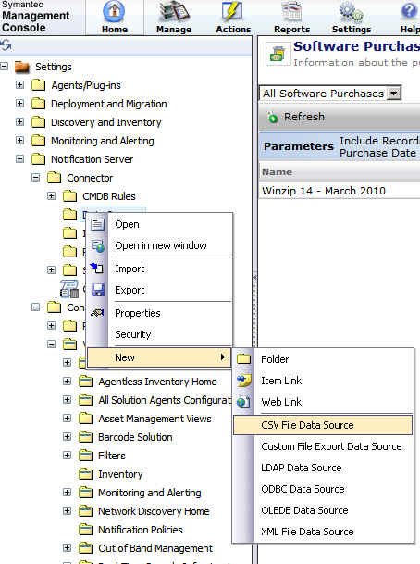

- Create the CSV file data source
  - Change the title to “CSV file import of Software Purchases”
  - Check the box “Allow imports’
  - Select the ellipsis to the right of “Import from file” to select the file “Software Purchase.csv” found on your desktop.
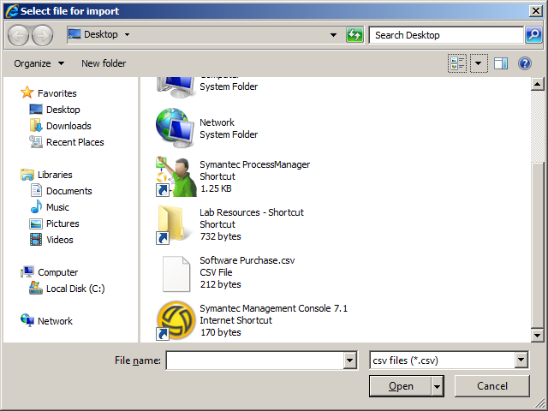
  - Select “View Import Data” to see the line item that will create our software purchase.
  - Close the view import data window.
  - Select “Test Data Source” to insure the connector can read the file. This might fail if the file is currently opened by another program.
  - Save Changes
- Create an Import/Export rule to correspond with this data source.
  - Right click “Import/Export Rules”, select “New” -> “Resource Import/Export Rule”
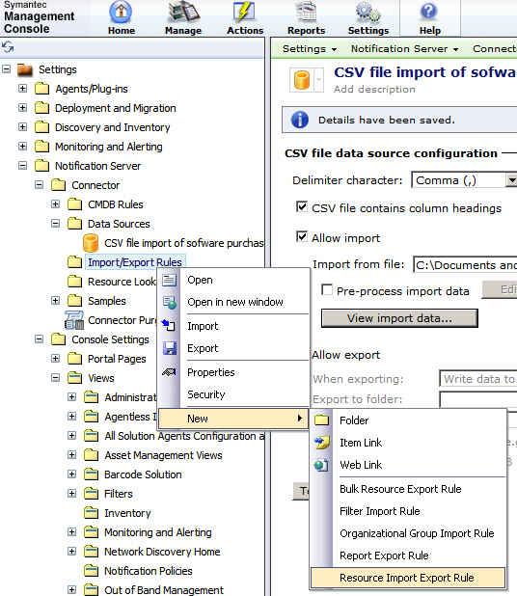

- Change Name to Software Purchase Import
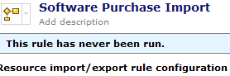
- Select the CSV file as our data source. 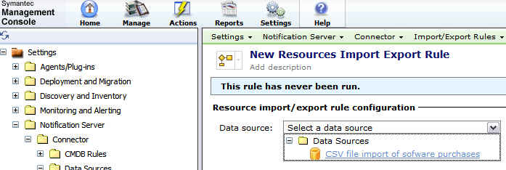
- For resource type select Software Purchase 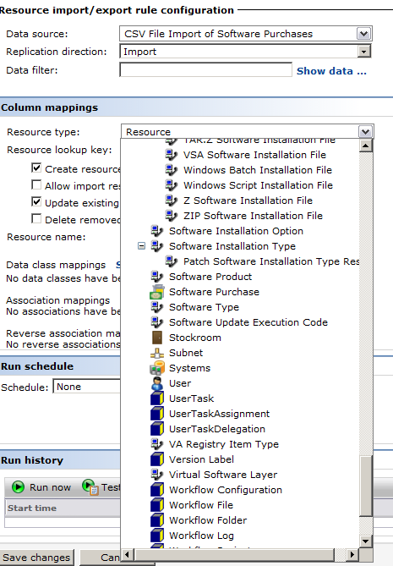

- For Resource Lookup key and Name select Resource Name and Name respectively. Not a best practice, but this indicates the name of the license in our CSV file is the unique identifier. A purchase number in combination with the purchase name would better ensure uniqueness.
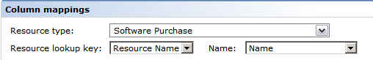
- Complete the data class mappings as shown below. You will need to uncheck some of the default mappings. (By default if a column heading in the data source matches a data class, Symantec will assume that field to be a desired mapping. This can cause some undesired results, especially with multiple data classes of the same name, e.g. description, owner, etc.)
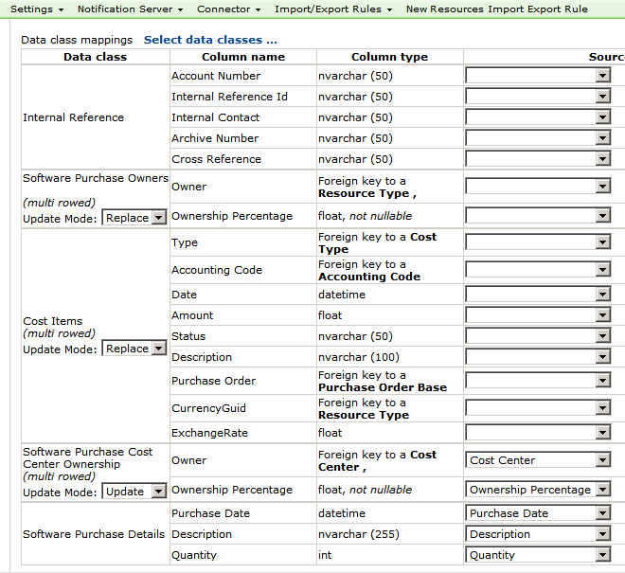
- Click Save Changes.
- Scroll to the bottom and select Test rule
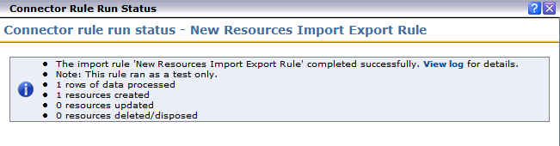
- Close the test view window then select Run now to execute the rule and import our purchase.
- Close the import rule window.
- Navigate to Manage -> Assets, and then expand Software Licensing
- Select Software Purchase. You should have 2 purchases for OpenProject, the one created manually, and the one that was just imported. Each purchase is for quantity 10, resulting in a total of 20 licenses purchased. 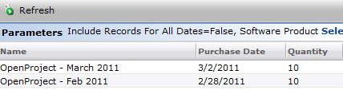

Create a Software Product for OpenProject
- Navigate to Manage -> Software Catalog
- In the search pane enter OpenProj
- One resource should appear 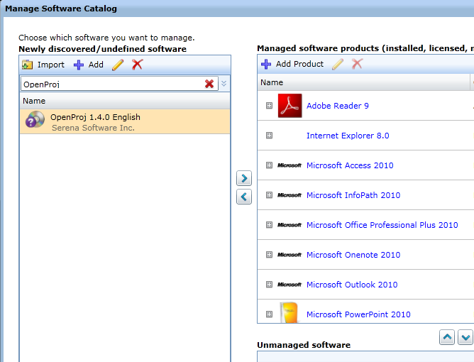
- Select Edit
- It is here that you see that a software resource in the software catalog is an integral part of the Symantec Management Platform. Minimally all that is needed for software resource to be defined is the company name, software name and version. The tabs you see extend the definition to data that will be used by software distribution and other solutions for interacting with (inventorying, distributing, etc.) this software.
- Note in the “File Inventory” tab a list the EXE is present. From the inventory of this system (which has OpenProject installed) the files associated with the application are listed.
- Navigate to the “Properties” tab and enter a software product name to be associated with the software resource.
- To the right of “Software Product” select “New”
- Complete the software product fields:
  - Name: OpenProject
  - Company: Serena Software Inc.
  - Category: Desktop Application
  - OK
- Click Save Changes
- Close the window for the software resource.
- Click Close

Create a Software License for OpenProject
We have created 2 purchases for OpenProject. We have created a software product based on the discovered software resource for the OpenProject application. Now we will create a software license to link the installation (software product) to the purchases (software purchase).
- Navigate to Manage -> Assets
- Right click Software License, and select Create Software License
- Under the view drop down select Software Licenses (global)
- Name the license OpenProject Software License
- For Covered Software Product select OpenProject, the product you created in step 46.
- OK
- Description: This is the software license calculation for OpenProject .
- Start Date: 01/01/2011
- End Date: 10/31/2011
- Under “Software Purchases” use the edit pencil icon to select the two purchases previously created in our lab. 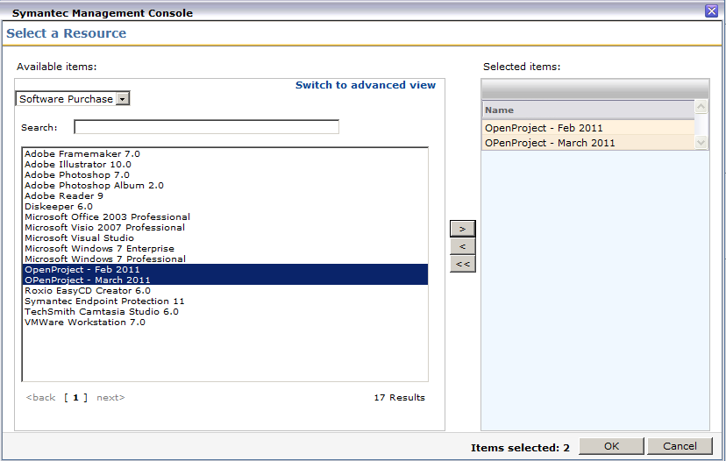

- Click OK5
- The section Non-Inventoried installs is where you would account for copies of OpenProject that cannot be discovered, perhaps in an off-network location where the Symantec Management Agent is not installed.
- Select “Add”
- Count: 50
- Description: OpenProject in the off-network training lab.
- Type: In Use
- Assigned: End User 1
- Click OK

View Compliance Data for our Software License
- Select Software License, you may need to right click and select Open
- You should see displayed our newly created license. (If you do not, click refresh)
- Right click on the OpenProject license and select Resource Manager

- Select Summaries -> Software License Summary
- You will see reflected a summary of our purchases and non-inventoried installs.
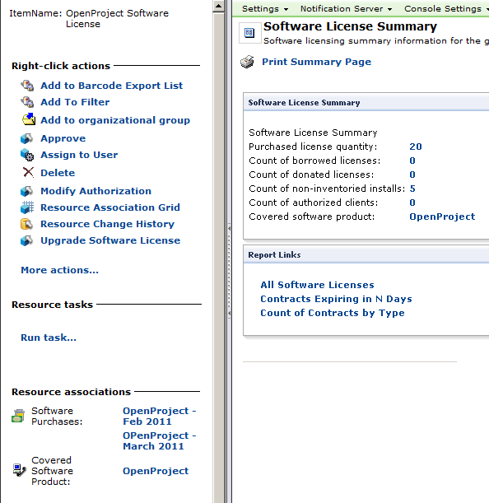
- A better view of the data (integrated inventory and purchase data will be from the resource manager of the covered software product).
- Select OpenProject from Covered Software Product.
- Select Summaries -> Software Product Licensing Summary
- Select the refresh data cyclical arrows.
- If your data matches that of the lab:
  - 1 installation of OpenProject
  - 2 purchases of 10 copies each
  - 50 non-inventoried installs
  - Then the purchases (20) minus the installs (1+50) reflect an overage of 31.
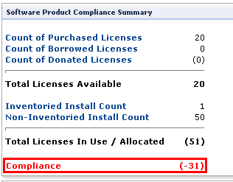

View reports related to license compliance
- Expand Service and Asset management Reports
- Expand the folders
  - Contract Management
  - Software Licensing
- Select the report Software Product Licensing Compliance
- Enter Open in Software Product Name field and click refresh 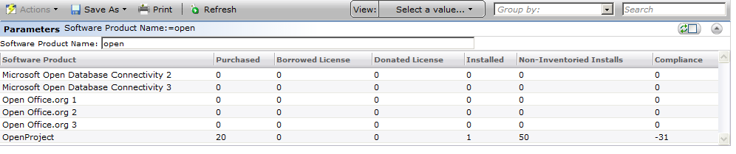
- This report will show all license compliance summaries in tabular form so you can readily see which titles are close to or beyond overages.
- Select the report Contracts Expiring in N Days. By default the report runs with 30 days as the default. Enter 365 in Days Until Expiration field. Click Refresh Our contract for OpenProject should appear in the report.
- Another useful production report is “Software Product Compliance Trend.” You may run the report by selecting the software product OpenProject . Over time, if you calculate compliance monthly, this trending report will provide useful data about over/under trends.

View Policies related to license compliance
- Navigate to Manage -> Automation Policies
- Select Software Product with license out of Compliance
  - This policy is set to run weekly
  - An email will be sent to a specified contact for all licenses out of compliance
- Select Software Product with license within 10% of compliance
  - This policy will send an email alert when the license is within 10% of being over.

Tracking individually-assigned license keys
Customers often purchase a title and assign/track individual license keys assigned to users. In the exercise that follows, we will create data classes to track the key and user. We will assign this data class to the software purchase resource. Then we will create a filter based on this list of users, and then modify our OpenProject software license to make this filter (list of users who’ve been assigned a license) the authorized group for OpenProject. Our license summary will show any install outside of this list to be unauthorized.

Create new data classes for tracking the license key and assigned user
- Navigate to Settings -> All Settings
- Expand Notification Server
- Expand Resource and Data Class Settings
- Right click on Data Classes
- Select New -> Editable Data Class
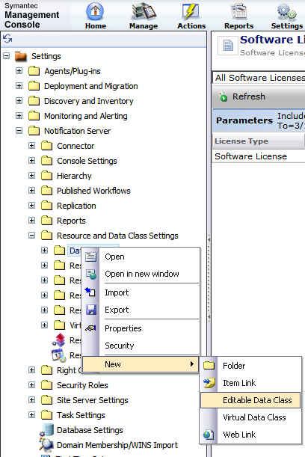
- Name the data class OEM License Key Information
- Make sure the check box Multiple Rows is selected.
- Select Add new attribute
- Name the attribute License Key
- Type: string
- Maximum length: 50
- Click OK
- Select Add new attribute
- Name: Assigned User
- Type: Resource Foreign Key
- Resource type: User 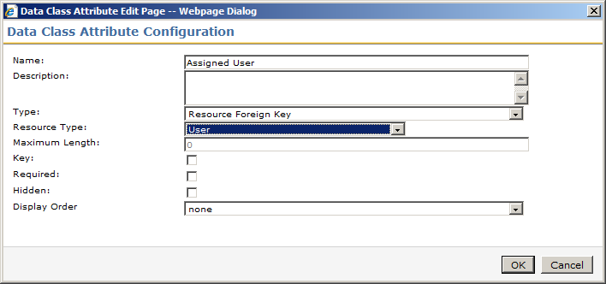
- Click OK
- Click Save Changes

Assign the OEM License Key Information data class to the software purchase resource type
- Collapse the folder Data Classes
- Expand Resource Types, Contract Types, Software Licensing
- Select Software Purchase
- Select Add data classes
- Select OEM License Key Information
- Click Save Changes
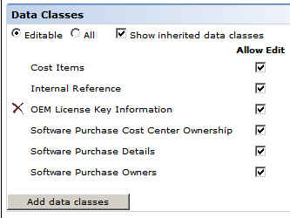
- Click Save changes

Edit one of our previously-created software purchases and complete the data for OEM License Key Information.
- Navigate to Manage -> Assets
- Expand Software Licensing
- Select Software Purchase
- Double click on one of the existing purchases for OpenProject.
- Scroll down to the data class OEM License Key Information
- Select Add.
- Enter License Key: WHAT-HAPP-ENS-VEGAS
- User: Select End User 1
- Click OK
- Click OK

Create a filter to list the users who have been assigned the OEM license key for OpenProject

This SQL report and created filter is a “quick” report, simplified for lab purposes. For production you would need to create a report with appropriate joins so as only to list users for a particular title. The report below would find users who’d been assigned any license key for any purchase, any product.

- Navigate to Reports -> All reports
- Right click on Reports
- Select New -> Folder
- Name the folder TFE Enablement
- Right click on TFE Enablement
- Select New -> Report -> SQL Report
- Name the report OEM License Users
- Delete all SQL in the window pane of the Parameterized Query tab.
This section deals with the role based security of the report. For the sake of this lab, we are removing that complexity.
- Input the following SQL
SELECT [Assigned User] FROM [Inv_OEM_License_Key_Information]
- Preview the report. You should see the GUID from the user inputted in the software license in step
- Click Save Changes
- The report should be in the preview pane on the right.
- Select Save as -> Static Filter 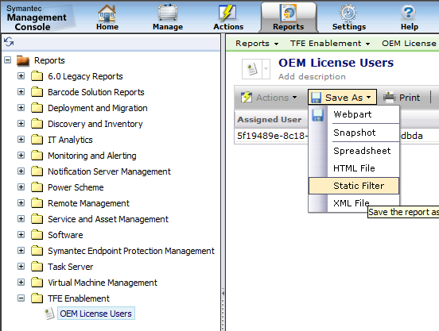
- Click Save.
- Click OK

Edit the software license to point to this filter as the authorized collection.
- Navigate to Manage -> Assets
- Expand Software Licensing
- Select Software License
- Edit the existing OpenProject Software License
- Scroll down to Authorized clients
- Select Add
- Select OEM License Users 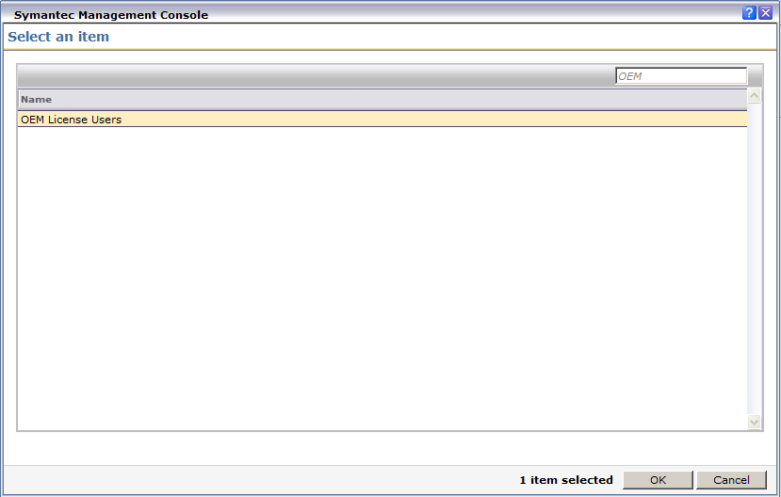
- Click OK
Under Authorization Group select Owner. This means that the owner of a computer who also appears in the OEM License Users report/filter will be considered by license compliance to be an authorized user of OpenProject . All others will be unauthorized.
- Click OK
- Right click on the OpenProject Software License, select Resource Manager.
- Select Summaries -> Software License Summary
- Under Resource Associations select the Covered Software Product OpenProject
- Select Summaries -> Software Product Licensing Summary 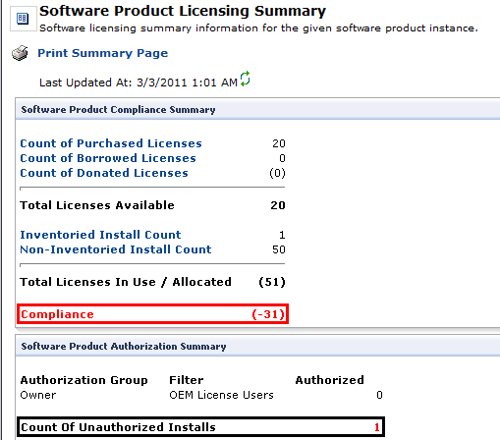
- View the data in the Software Product Authorization Summary section. We have designated End User 1 as an authorized user. The one computer with OpenProject installed is not owned by End User 1. Hence the summary shows 0 authorized and 1 unauthorized install.

Scenario
This demonstration will walk through the creation of a custom resource and the custom data classes associated with it. We will be creating a resource type for a VPN authentication token. This token will then be assigned to a user.

Data Class Creation
- Navigate to Settings | All Settings
- Expand Notification Server | Resource and Data Class Settings
- Right click on the Data Classes folder and select to New | Folder
- Type in the name Custom Data Classes and select OK.
- Right click on the Custom Data Classes folder and select New | Editable Data Class
- Name the new data class Authentication Token
- Uncheck Multiple Rows
- Click Add new attribute
- Fill Name field with Token ID Number
- Check Required
Select 1 in Display Order field
- Click OK
- Click Add new attribute
- Fill in Name field with Expiration Date
- Change Type to Date
- Select 2 in Display Order field
- Click OK
- Click Token Type
- Fill in Name field with Token Type
- Change Type to Static List
- Click Edit
- Enter Hard Token and click Add
- Enter Soft Token and click Add
- Click OK
- Select 3 in Display Order field
- Click OK
- Click Save Changes

New Resource Type
- Collapse the folder Data Classes
- Right click on the Resource Types folder and select to New | Folder
- Type in the name Custom Resources and select OK.
- Right click on the Custom Resources folder and select New | Resource Type
- Rename new Resource Type to Authentication Token
The Base Resource Type will dictate the default data classes. For Example Resource will have no assigned data classes and the Asset resource type will have several inherited data classes such as Serial Number and Manufacturer
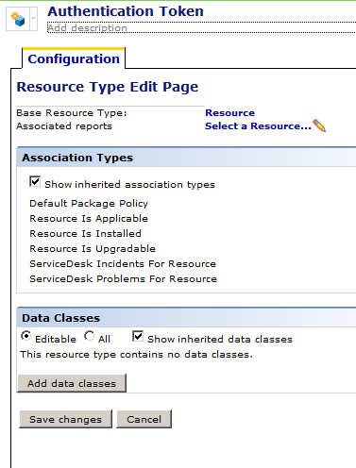
- Click Add Data Class
- Expand Custom Data Classes
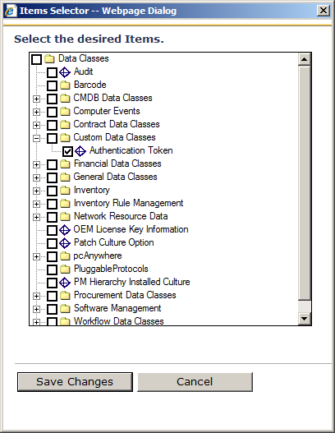
- Select Authentication Token
- Click Save Changes
- Click Save Changes

New Resource Association
Associations can be inherited based on the original resource type chosen when creating the resource type. In our case we used resource which has no default associations. If you choose Asset as the base type, then your new resource type will have all the associations that assets have.
- Expand Resource Associations Folder
- Right click CMDB Association Types select New | Editable Association Type
- Change the Name to Token Owner
- Enter Owner’s Token in the Reverse Display Name
- Click Select a Resource Type in From Type
- Select Authentication Token and click OK 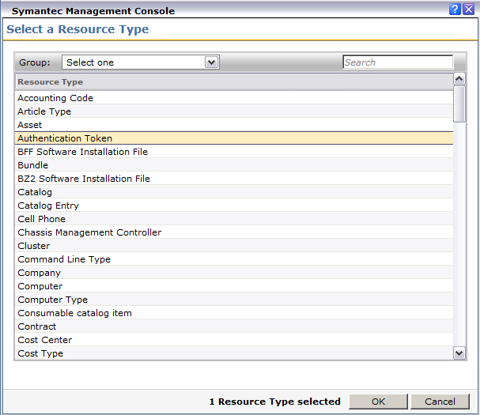
- Click Select a Resource Type in To Type
- Select User and click OK
- Enter 0 in Minimum Cardinality
Cardinality allows for a Many to One relationship. If Minimum Cardinality is set to 0, then the association is optional, and if there is only a one to one relationship then Maximum Cardinality would be set to 1.
- Select Authentication Token and User in Enable Editing From 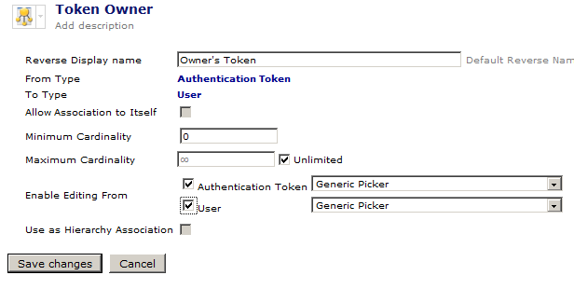
- Click Save Changes

Resource View Link
A view needs to be created so that the new Resource Type will show up in the console.
- Expand Console Settings | Views| Asset Management Views | Manage Configuration items
- Right Click on Computers and Peripherals and select New | Resource Type Link
- Highlight Authentication Token and click OK 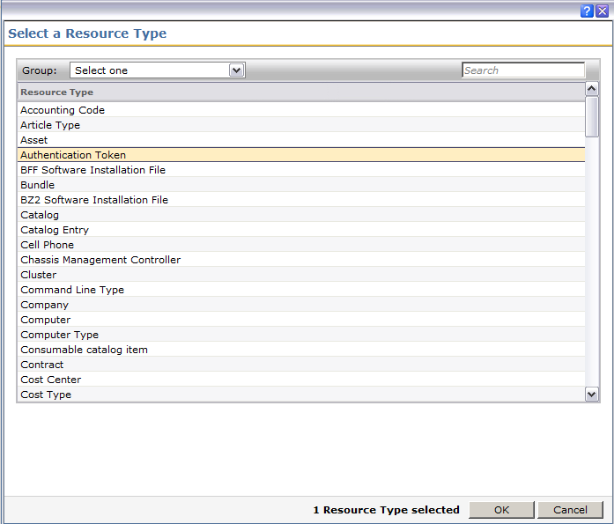

Create Resource
- Navigate to Manage | Assets
- Expand Computers and Peripherals
- Right click on Authentication Token and select Create Authentication Token
- Enter a Name in Authentication Token field
- Enter Token ID Number
- Enter Expiration Date.
- Select Token Type
- Click Edit button and assign Token Owner 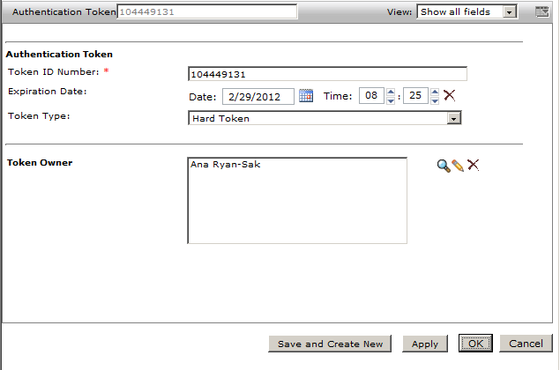
- Click OK

