Step 1: Create the Custom Data Class
From the Altiris Console Navigate to: Settings>All Settings
Navigate to: Settings>Discovery and Inventory>Inventory Solution>Manage Custom Data Classes
Click New data class
Add the attributes as shown below:
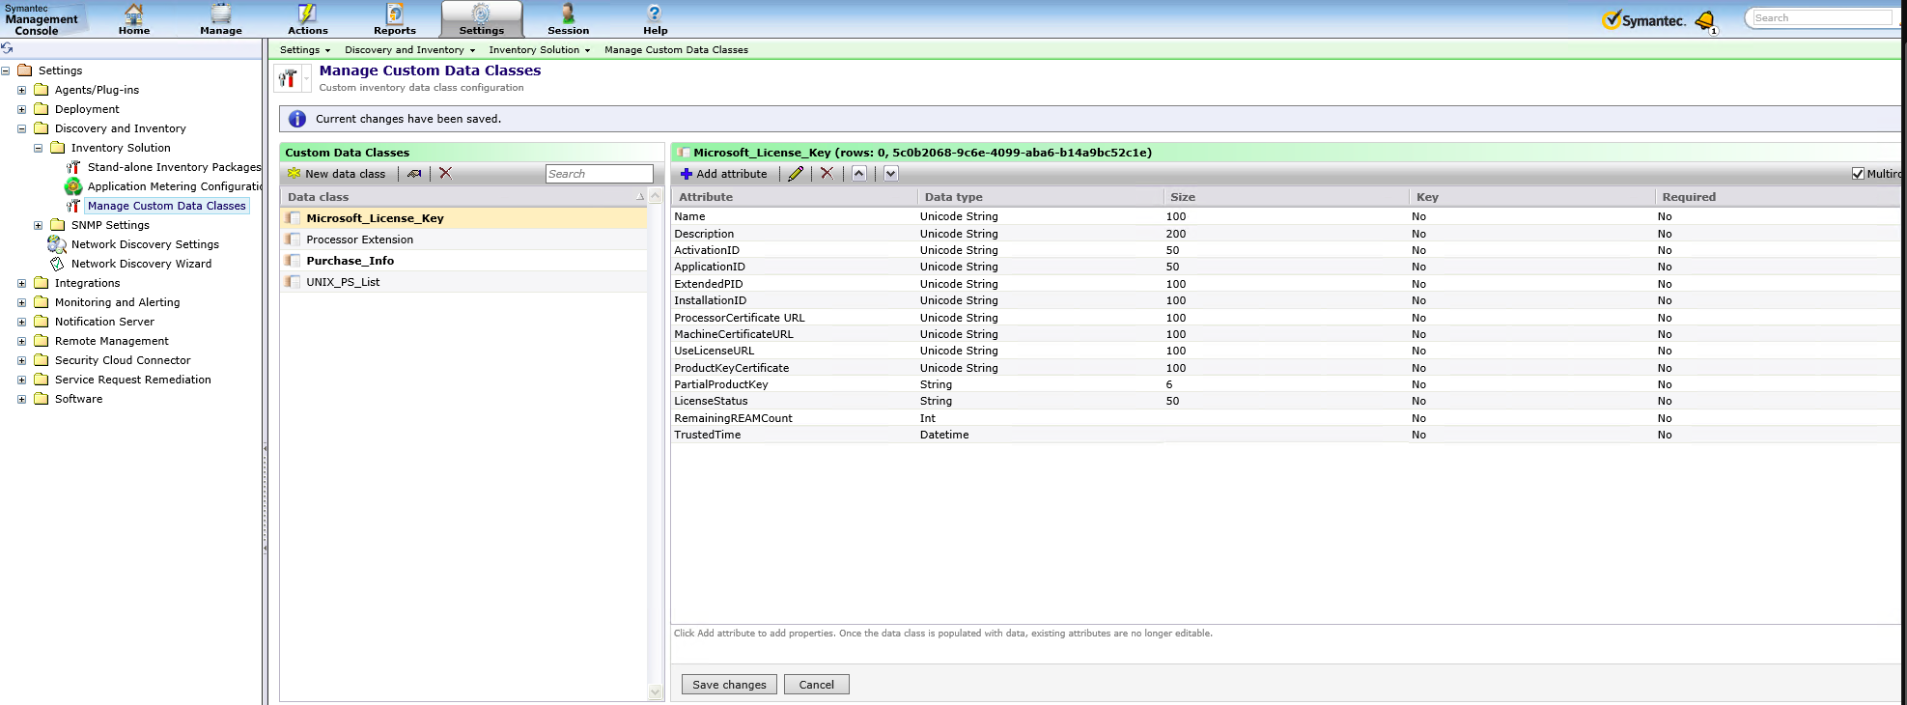

Zoomed In:
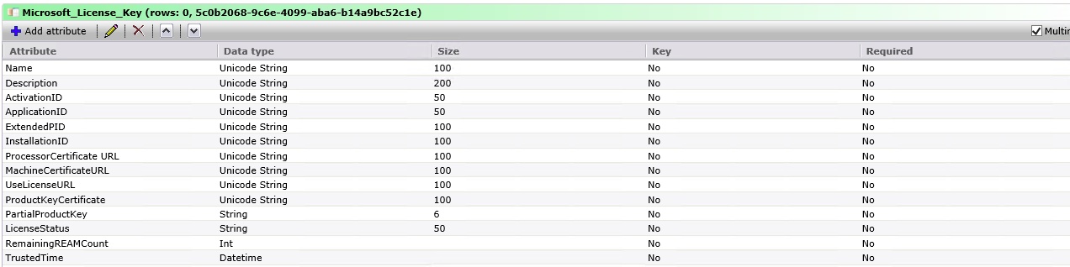

Make sure you check the Multirow checkbox in the top right corner.

Click Save changes

Step 2: Create the Task
From the Altiris Console Navigate to Jobs and Tasks
Create a new Script Task
Name the Script Custom Inventory - Microsoft Activation Keys
Set the Script Type to VBScript

Copy and paste the script below into your Task:
Set wshShell = WScript.CreateObject("WScript.Shell")
Set nse = WScript.CreateObject("Altiris.AeXNSEvent")
nse.To = "{1592B913-72F3-4C36-91D2-D4EDA21D2F96}"
nse.Priority = 1

Dim objDCInstance
set objDCInstance = nse.AddDataClass("Microsoft_License_Key")
Dim objDataClass
set objDataClass = nse.AddDataBlock(objDCInstance )

'Add New Rows
Dim startpo, strlen, strtemp, rlen, firstpass, counter, objDataRow
'Create Scripting Objects
set wso = CreateObject("Wscript.Shell")
set exe = wso.Exec("C:\Windows\System32\Cscript C:\Windows\System32\slmgr.vbs /dlv")

firstpass = True ‘Throw away the first line of SLMGR.vbs output
counter = 0 ‘This keeps track of which attribute/column we’re capturing
newrow = False ‘Determines if a new row is needed for the capture file

Do Until exe.StdOut.AtEndOfStream
‘Take the output from SLMGR one line at a time
‘Format the string for capture
strtemp = CStr(exe.StdOut.Readline)
strtemp = Replace(strtemp,",","")
startpo = InStr(strtemp,":")
strlen = Len(strtemp)
rlen = strlen - startpo - 1

if CInt(startpo) > 0 then ‘Makes sure there is info to capture
if not firstpass then
if newrow then
set objDataRow = objDataClass.AddRow
newrow = False
end if
objDataRow.SetField counter, Right(strtemp,rlen)
counter = counter + 1
if counter >= 14 then ‘Start new record if more than one
counter = 0
newrow = True
end if
Else
firstpass = False
newrow = True
End If

End If
Loop
nse.SendQueued ‘Write the NSE file

‘Cleanup some objects
Set wso = Nothing
Set exe = Nothing
Set objDataRow = Nothing
Set objDCInstance = Nothing
Set objDataClass = Nothing
WScript.Quit

Advice: change the feature “Show Script” to be run as “hidden” in order to avoid that users get the cmd screen (although it is during half second).

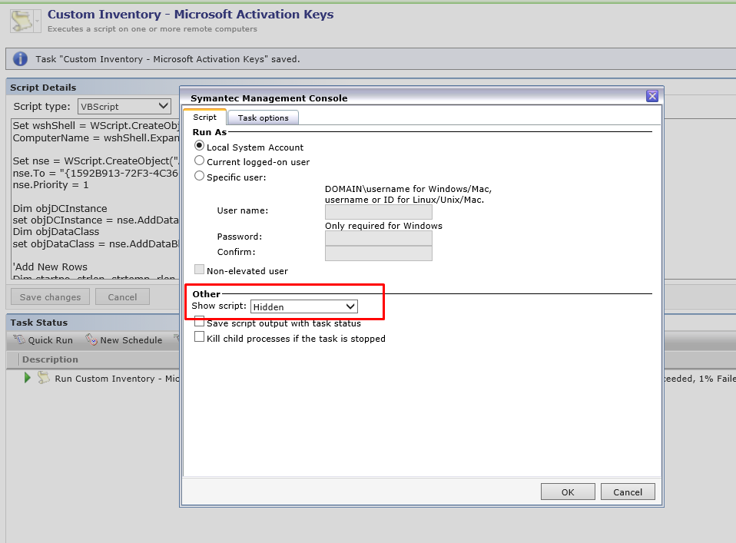

Click Save changes

Create your schedule to deploy this task to Windows 7 Machines.

Step 3: Reporting the Data
Steps 1 and 2 have created a new Table in the Symantec CMDB called Inv_Microsoft_License_Key
To generate a list of Computers that have installed the ESU Key create a new Report using the following SQL

SELECT pc.Name, pc.[IP Address], pc.[OS Version]
FROM vComputer AS pc INNER JOIN Inv_Microsoft_License_Key AS MSLic
ON pc.Guid = MSLic._ResourceGuid
WHERE MSLic.[ActivationID] = ‘77db037b-95c3-48d7-a3ab-a9c6d41093e0’

77db037b-95c3-48d7-a3ab-a9c6d41093e0 Is the Activation ID for the 1st year of ESU
Reference: https://techcommunity.microsoft.com/t5/windows-it-pro-blog/how-to-get-extended-security-updates-for-eligible-windows/ba-p/917807

