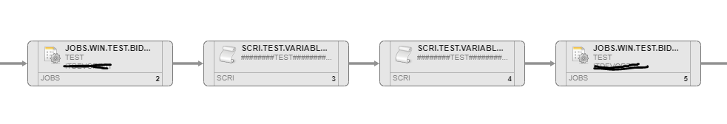
JWIN  :PSET &VARIABLE_JOB_BEFORE# = "xxx" | Script :  :PSET &VARA01# = YYYY | Script (KO)  :Print variable script1 is &VARA01#  - YYYY  :print variable job avant is &VARIABLE_JOB_BEFORE  - “” (empty) | JWIN (OK)  :Print variable script1 is &VARA01#  - YYYY  :print variable job avant is &VARIABLE_JOB_BEFORE#  xxx

