Upgrading from Test Data Manager 3.5 or higher to 4.0

Pre-requisite / Optional: Backing up current TDM Configurations.

Review the following link before beginning the uprade:

https://docops.ca.com/ca-test-data-manager/4-0/en/installing/upgrade-product-components

Download the new product release.

Go to https://support.ca.com.

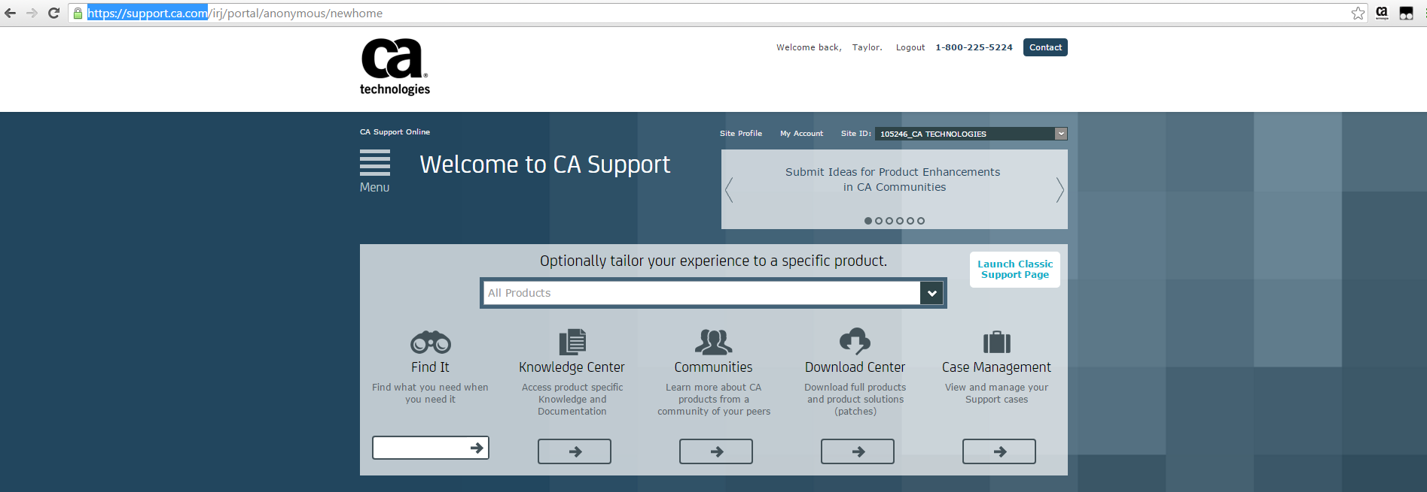

Hover over the arrow () under ‘Download Center’ so a list will appear.

Choose ‘Download Solution’ from the list.

You will be taken to the ‘Download Center’ at https://support.ca.com/irj/portal/ProductCDNSearch

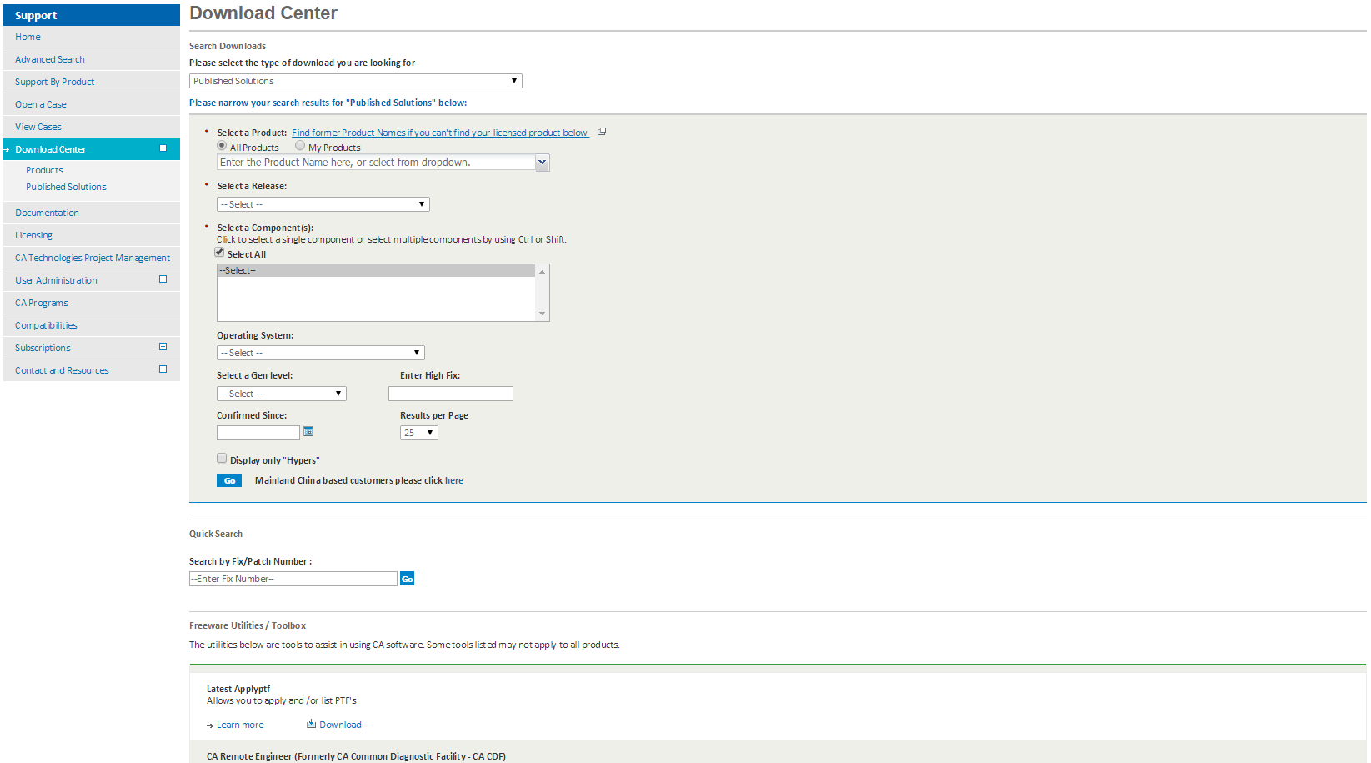

Choose the following information.

- Please select the type of download you are looking for: Products
- Select a Product: CA Test Data Manager for Data Generation and Test Matching - MULTI-PLATFORM
  - NOTE: The available SKUs to select are dependent on customer purchases
- Select a Release: 4.0
- Select a Gen Level: 0000
- Show me published solutions for this release: Check box. Check box for ‘All components’. Select ‘CA Data Finder, CA Test Case Optimizer, CA Test Data Manager’.
- Operating System: Choose the one that reflects your machine.

Click the ‘Go’ button.

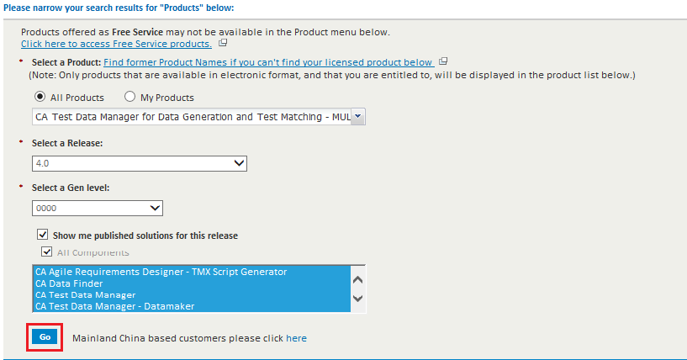

You will be taken to https://support.ca.com/irj/portal/ProdCDNResults page for ‘CA Test Data Manager for Data Generation and Test Matching - MULTI-PLATFORM’.

Click on the ‘Download’ for the latest product component. In this case, it will be ‘CA Test Data Manager Full Package 4.0.’

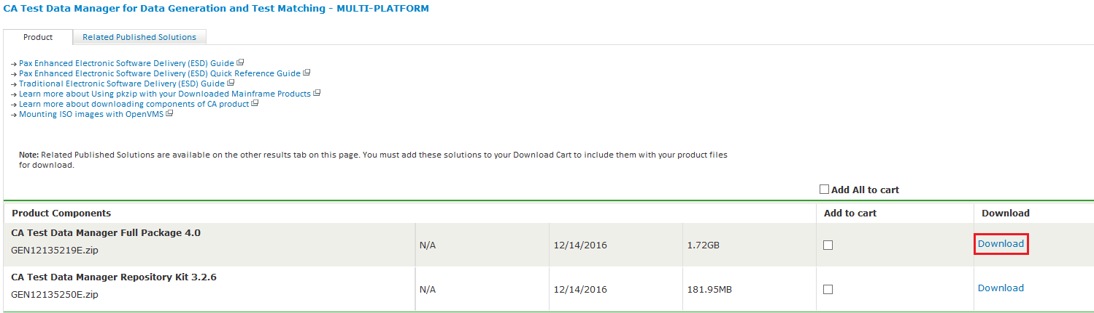

A ‘Download Method’ page will pop up.

The easiest method to download is to select “View File Link”.

Then select the zip file to download.

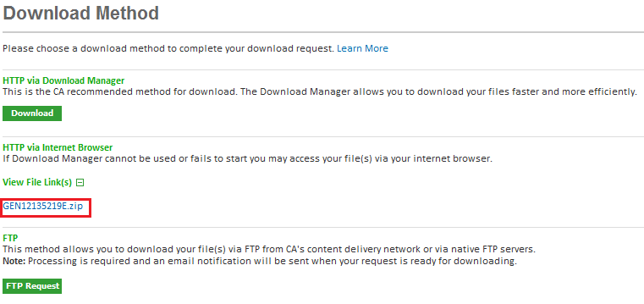

From the next pop-up, you can choose “Save as” to save the zip file to a location of your choice.

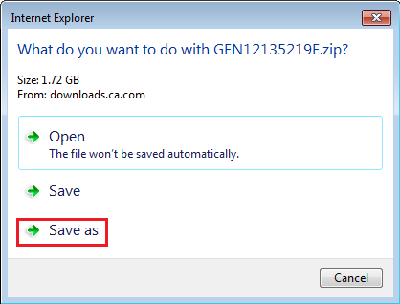

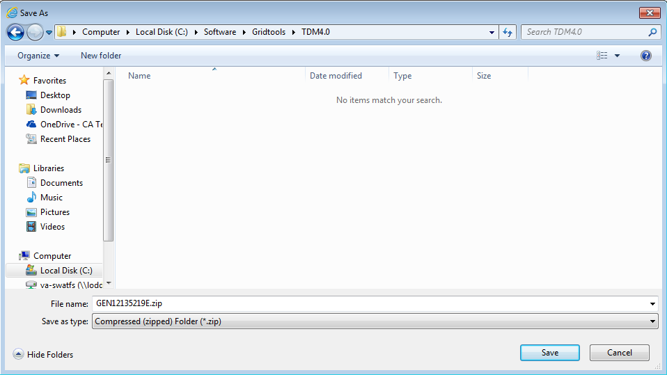

Go to the location where you chose the zip file to be downloaded to and uncompress the file. Once completed you should see product files as listed below:

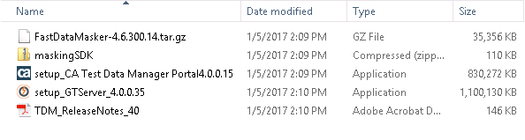

You should now see a setup executable with the Datamaker logo next to it.

Launch the executable by right clicking and select “Run as administrator”.

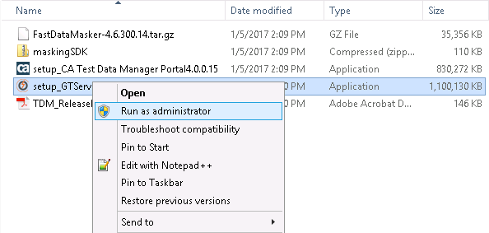

Installing the 4.0 Release.

Follow along with the following screen shots.

It is advised to leave everything as the default selections, unless you have specific components you want or don’t want to install, in which select/deselect as necessary. Also, the target install location should automatically be directed to the current installation, but it is recommended to check/verify that it is correct.

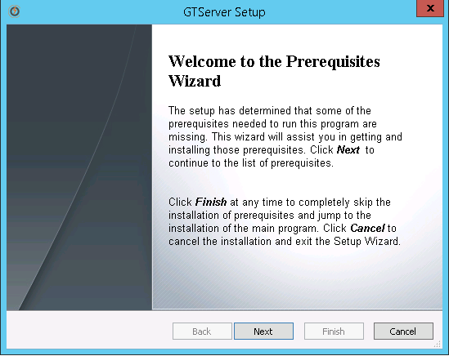

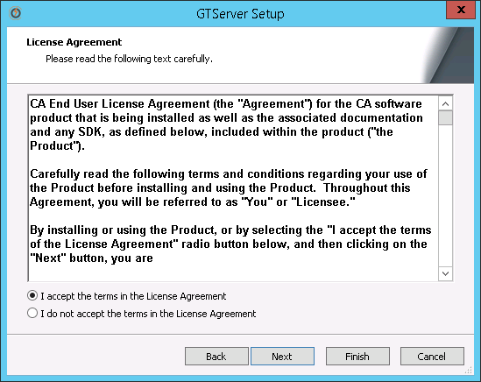

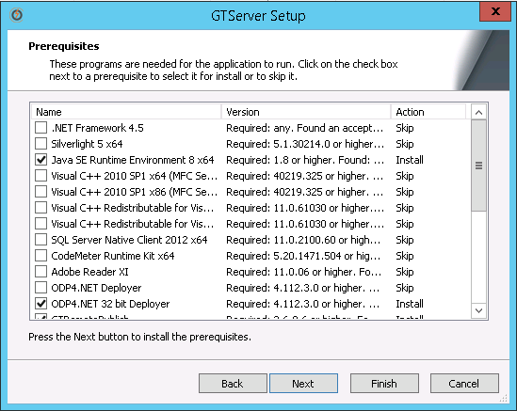

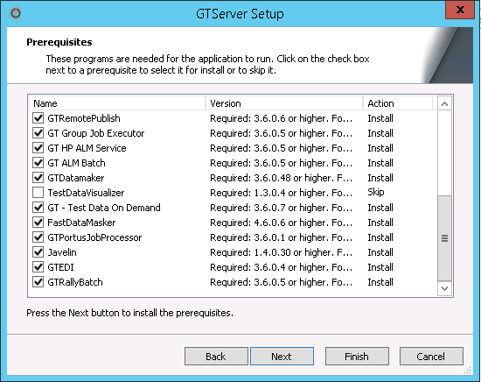

NOTE: Any prerequisites that are needed will be installed prior to the installation of the selected components

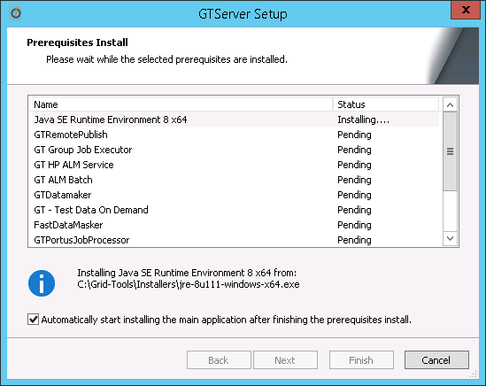

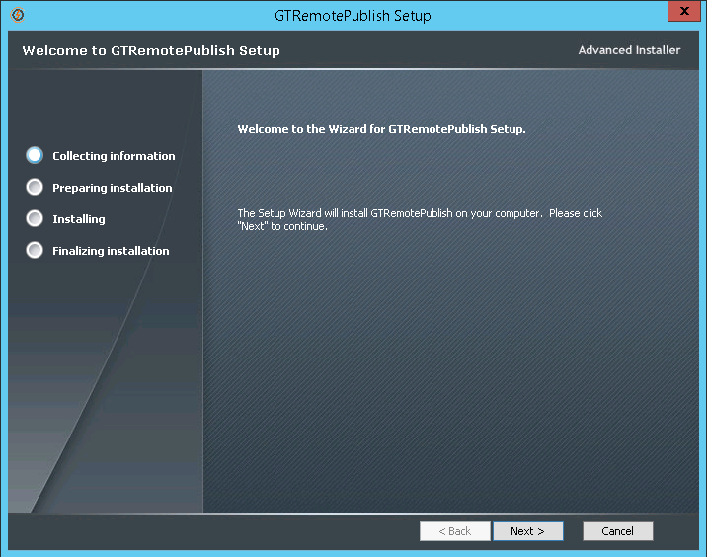

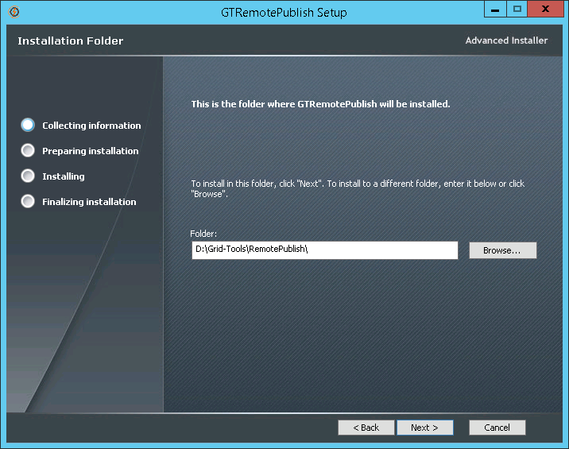

NOTE: Verify install destination is correct.

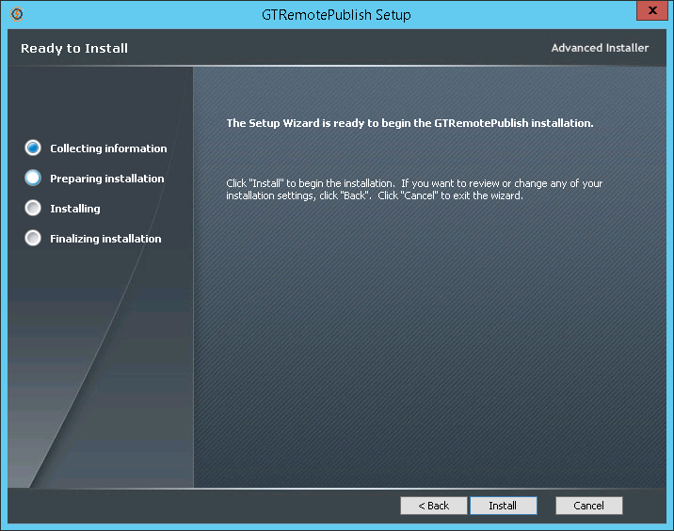

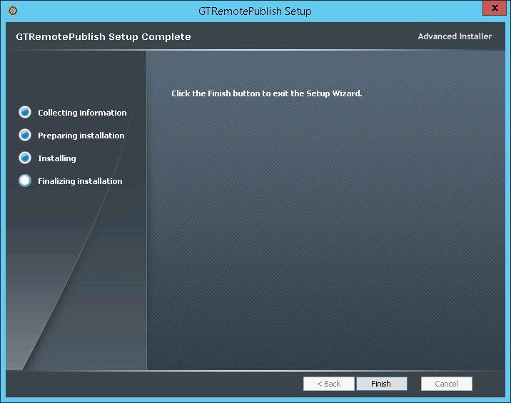

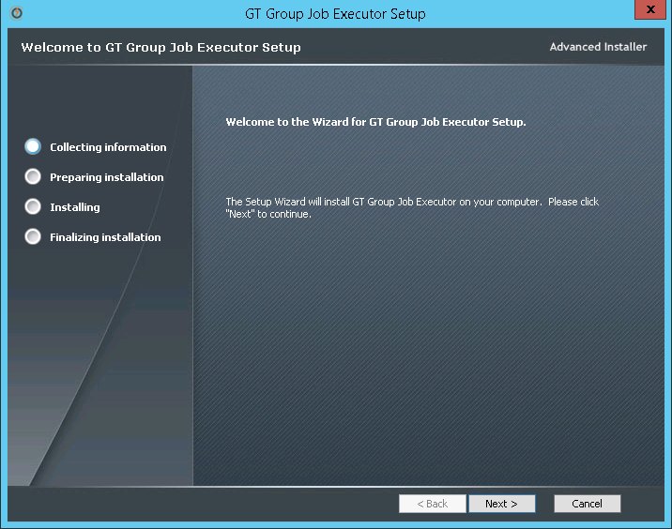

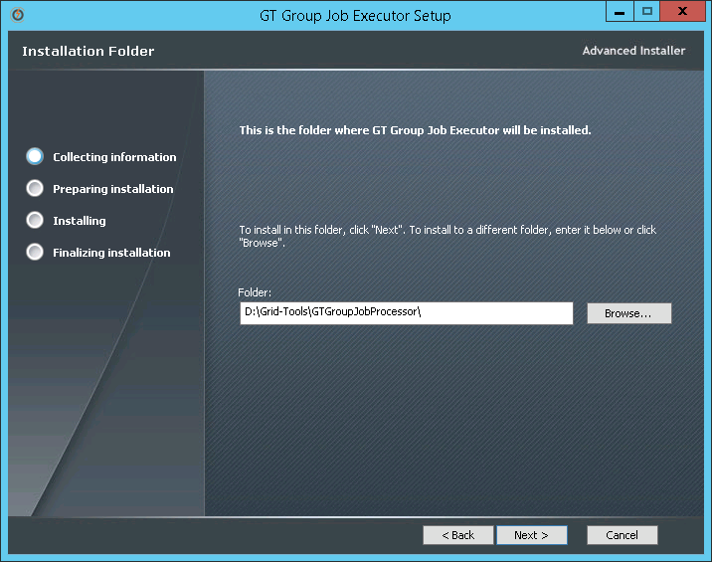

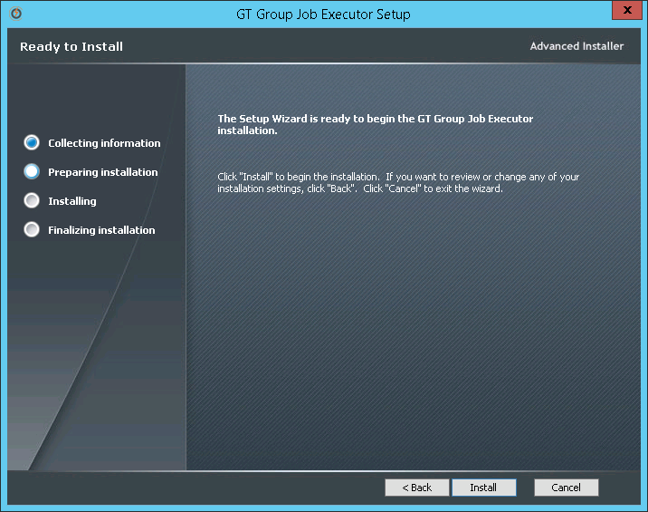

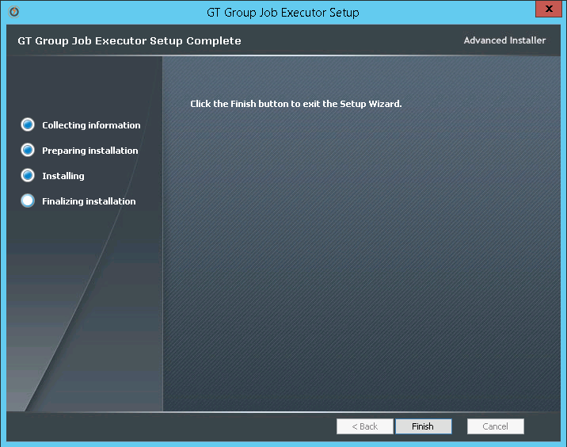

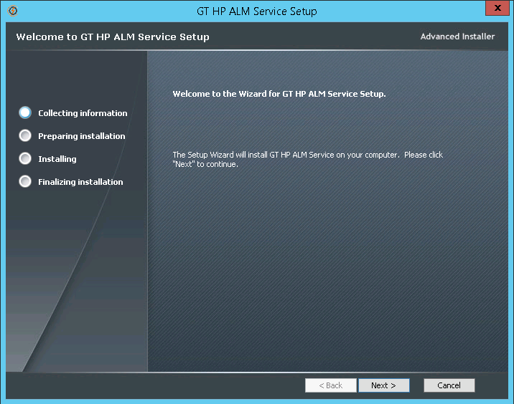

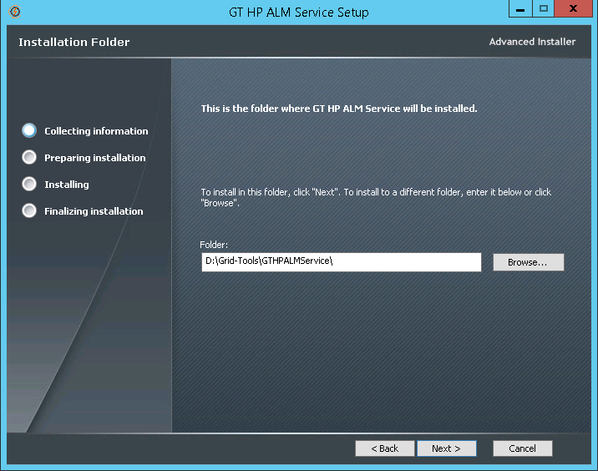

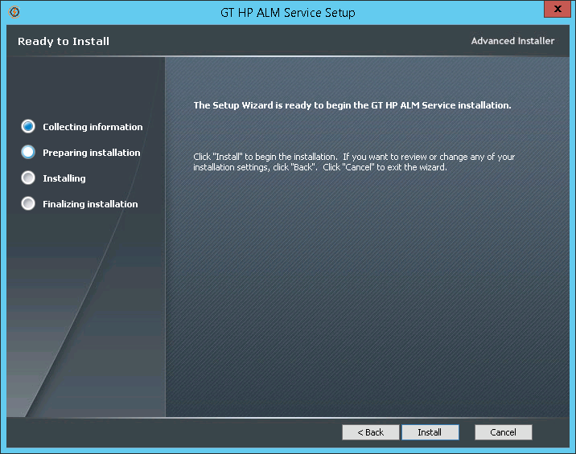

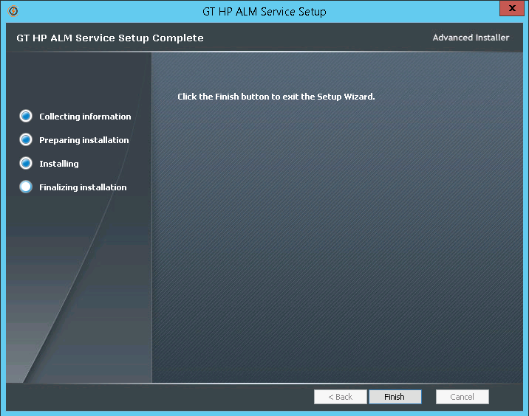

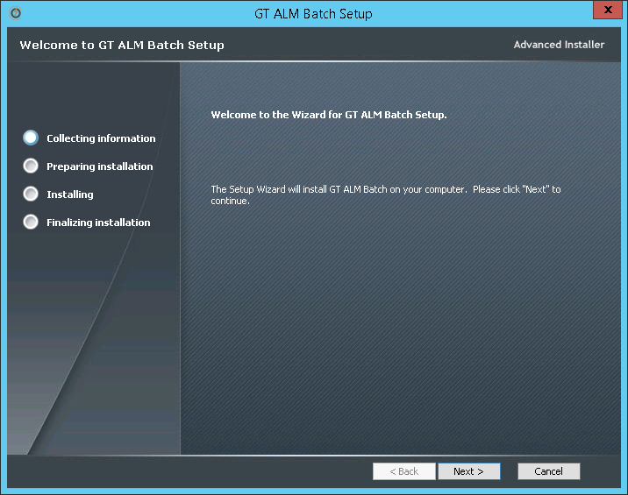

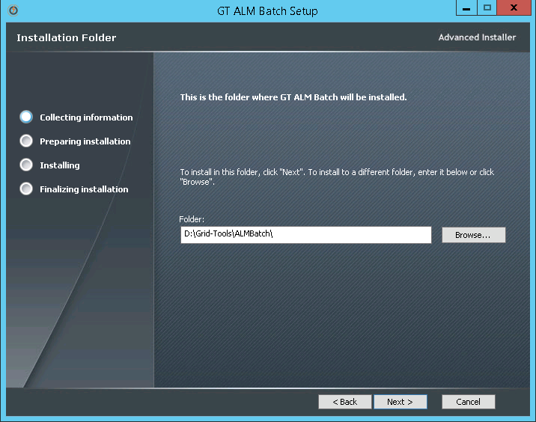

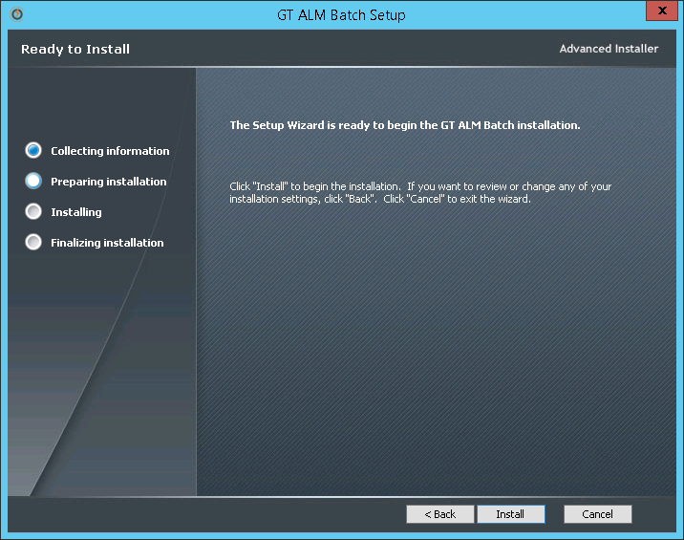

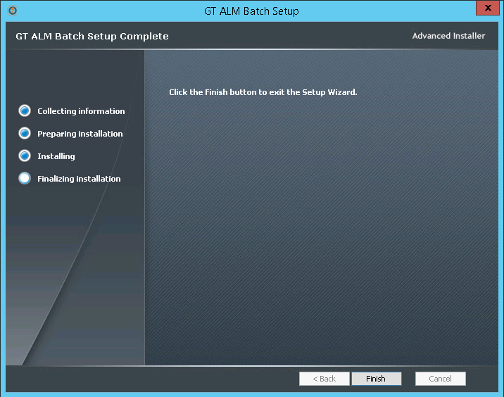

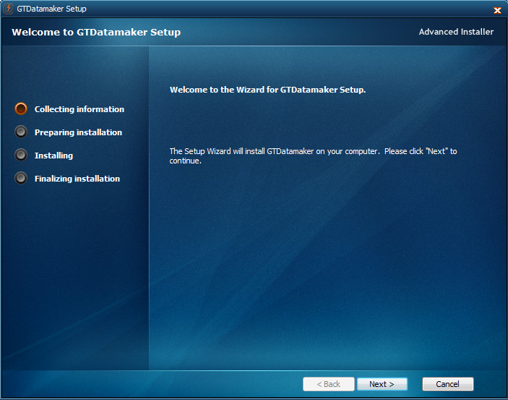

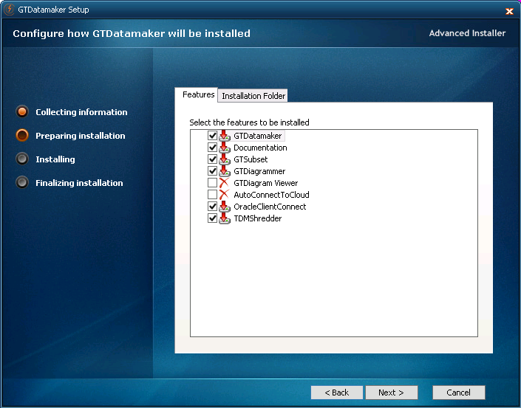

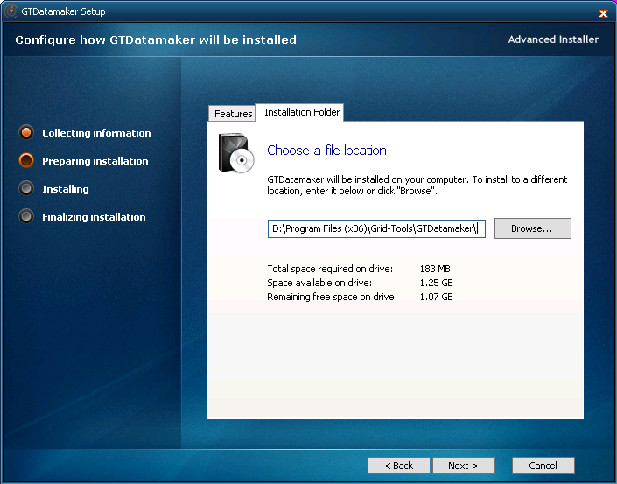

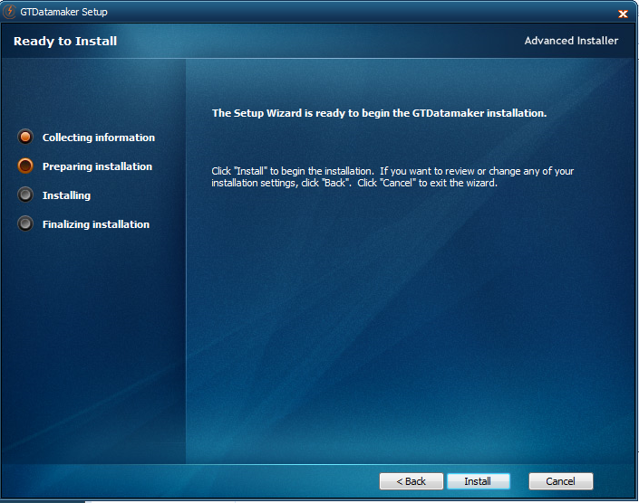

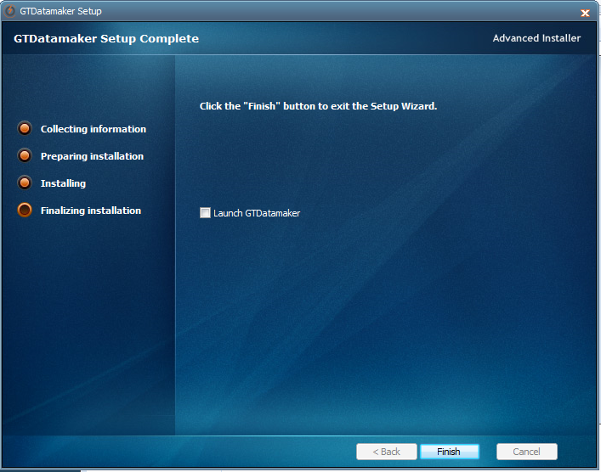

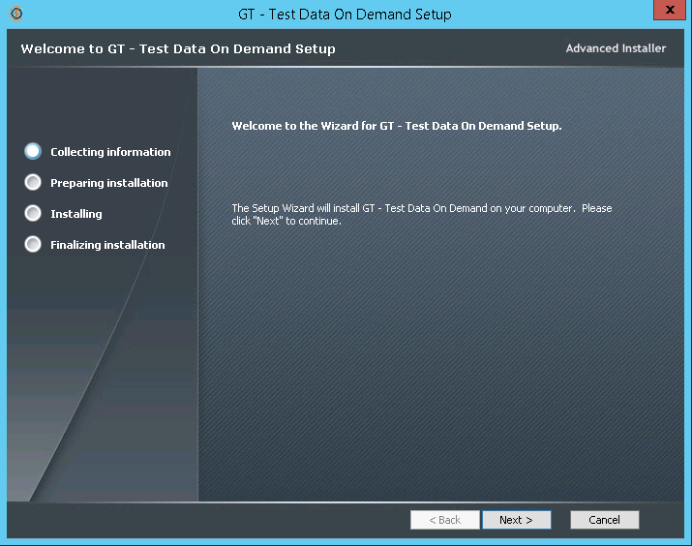

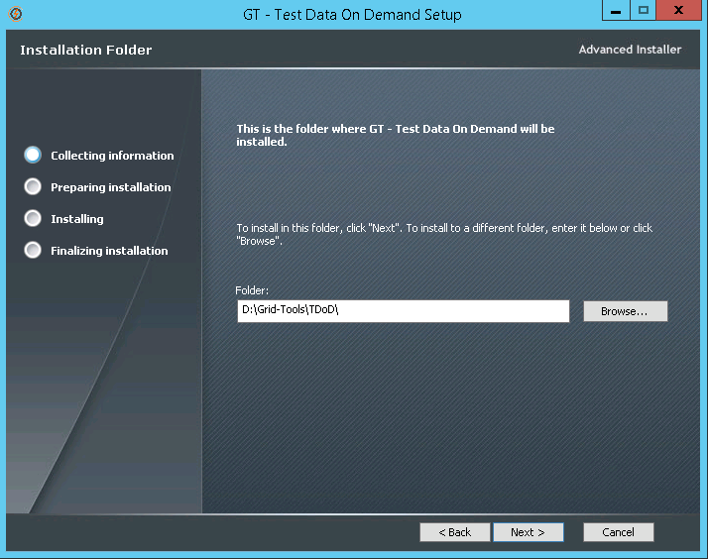

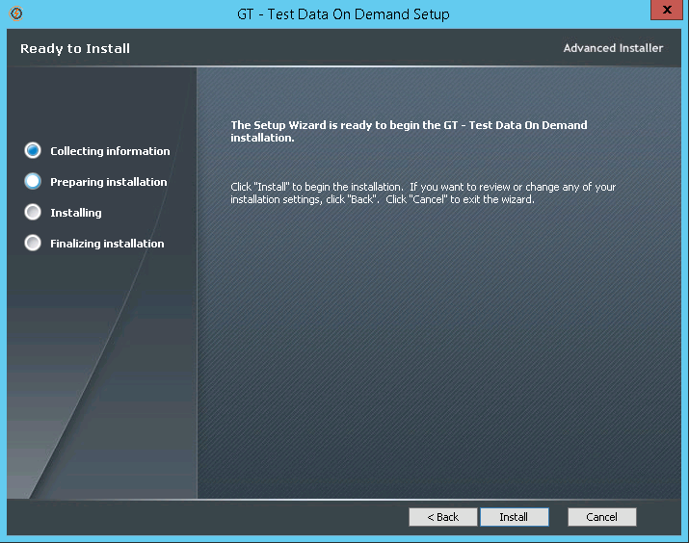

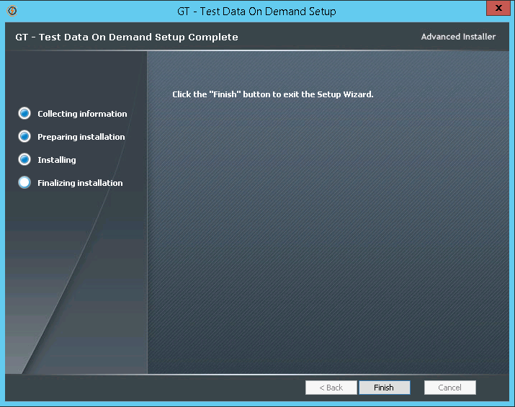

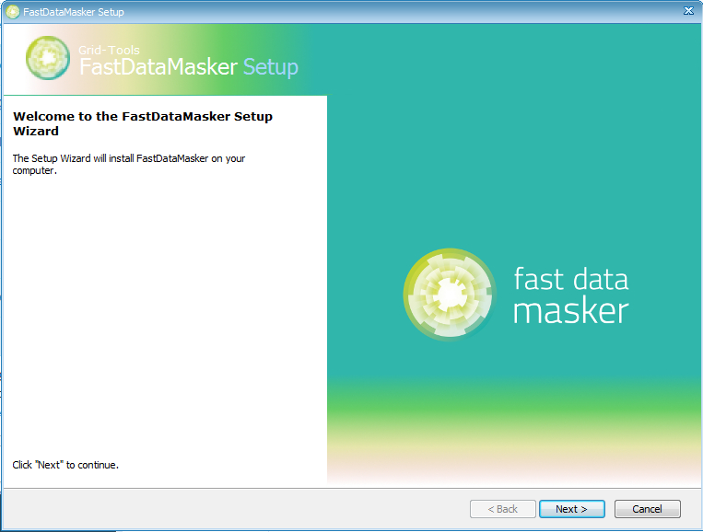

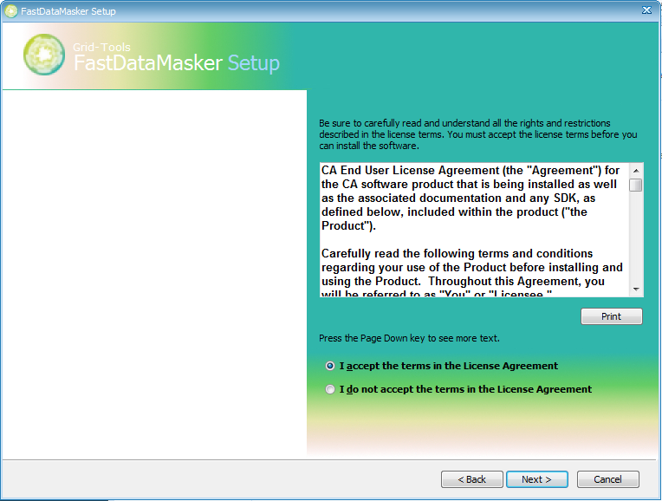

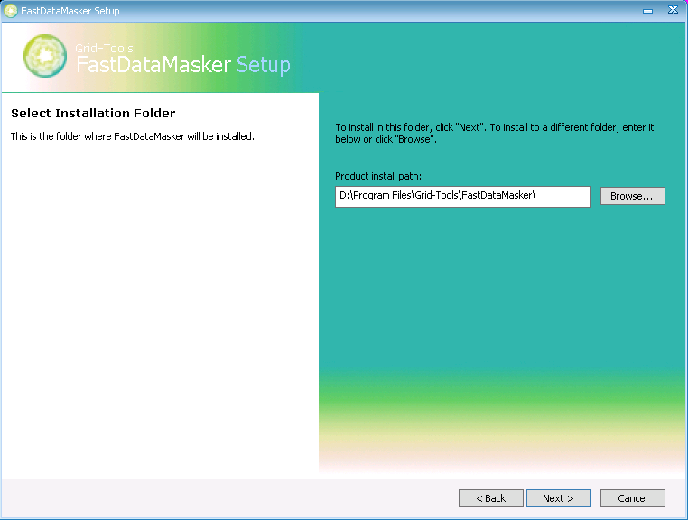

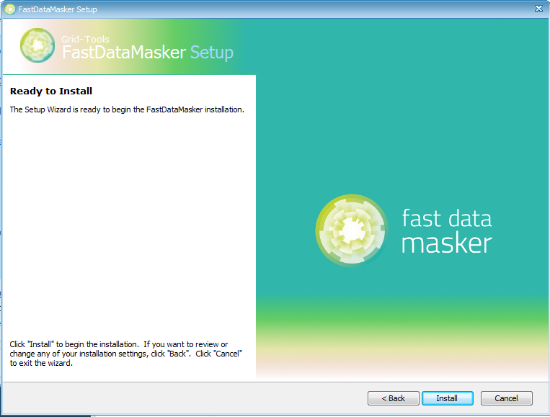

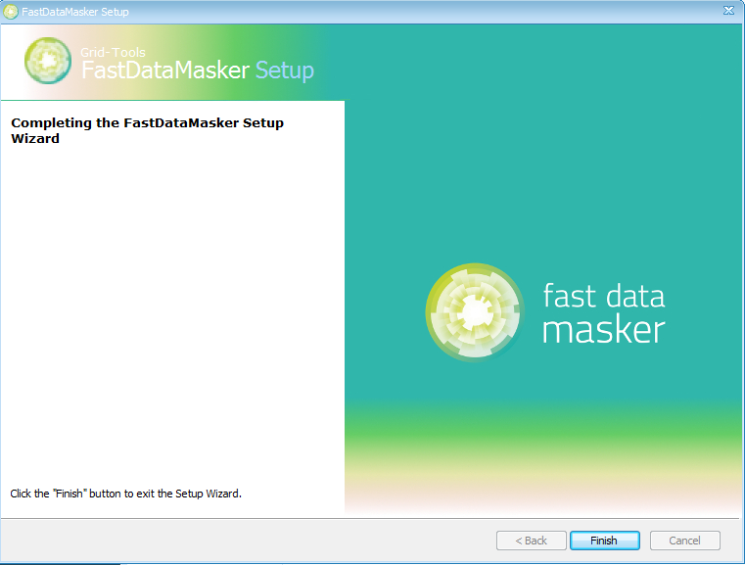

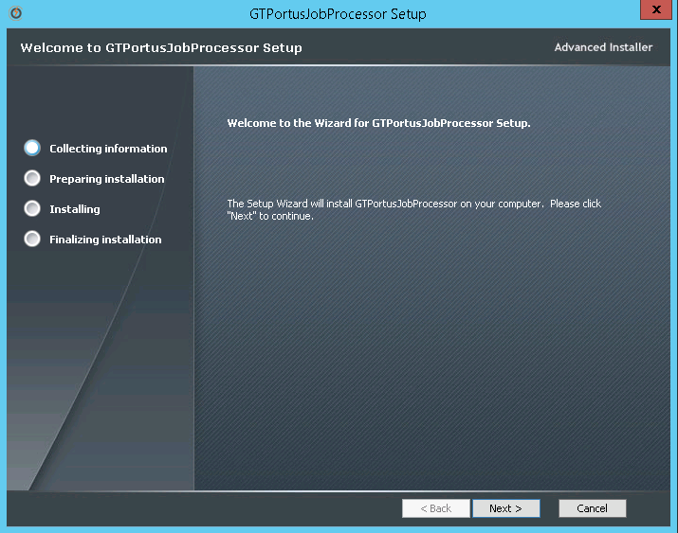

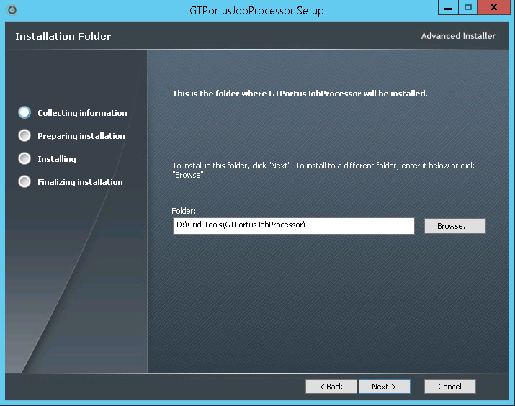

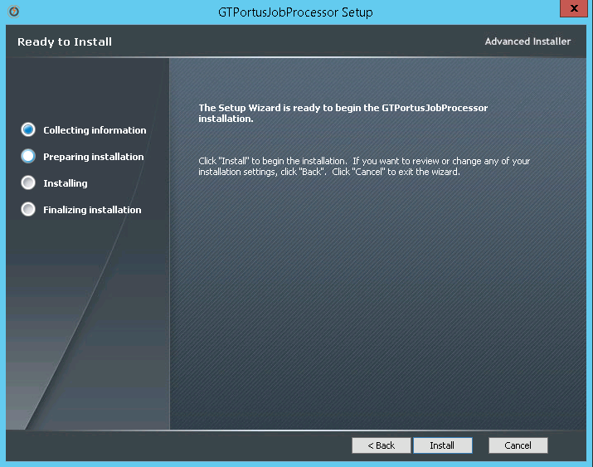

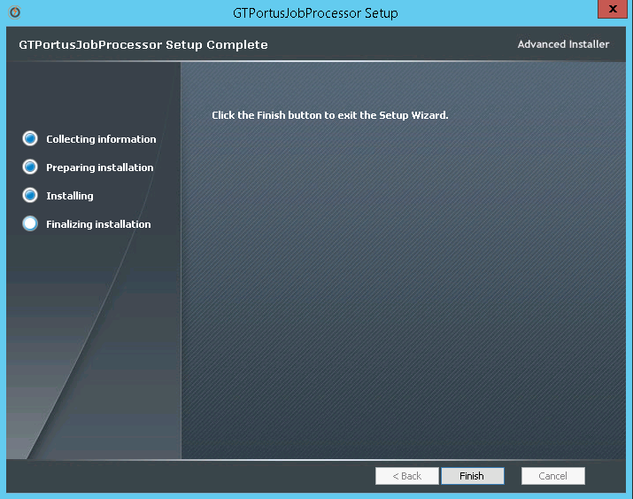

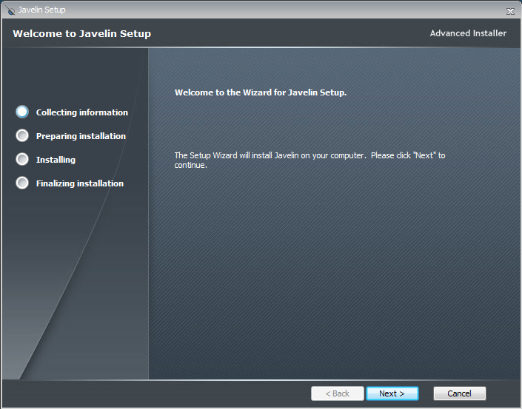

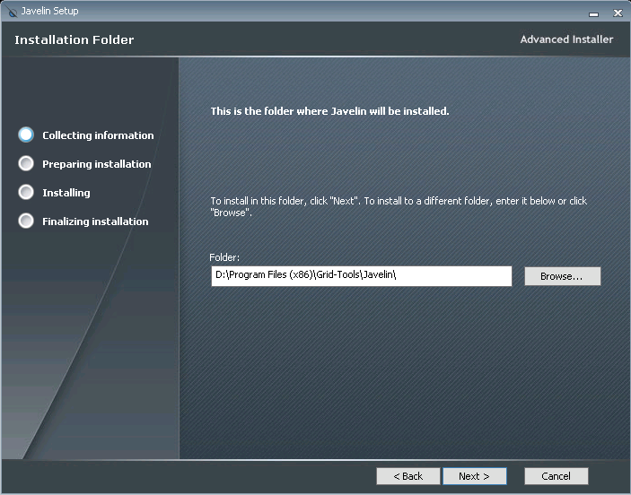

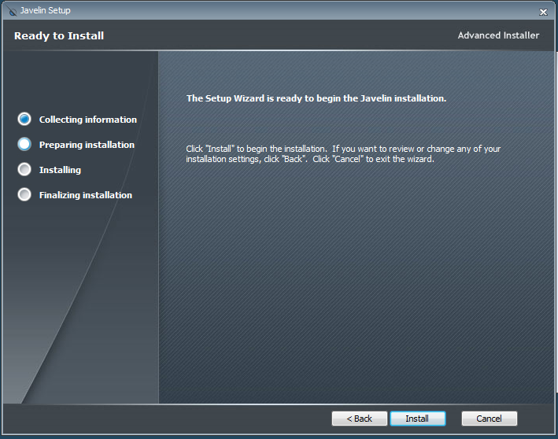

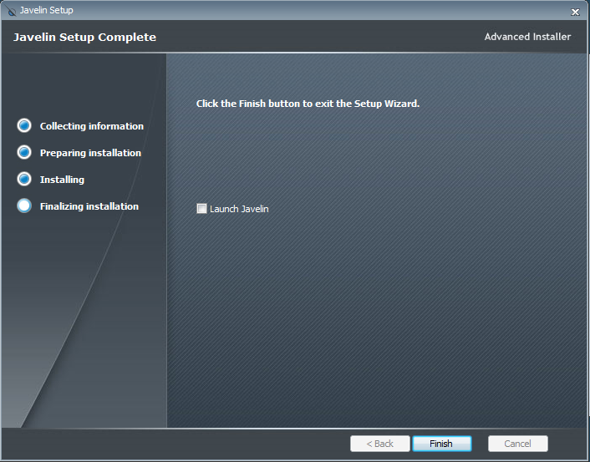

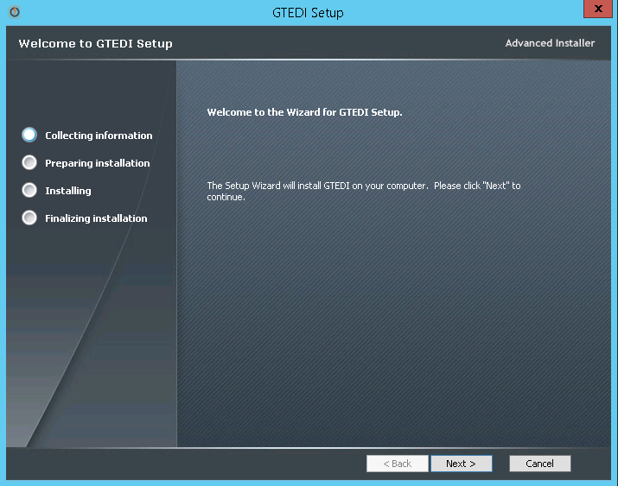

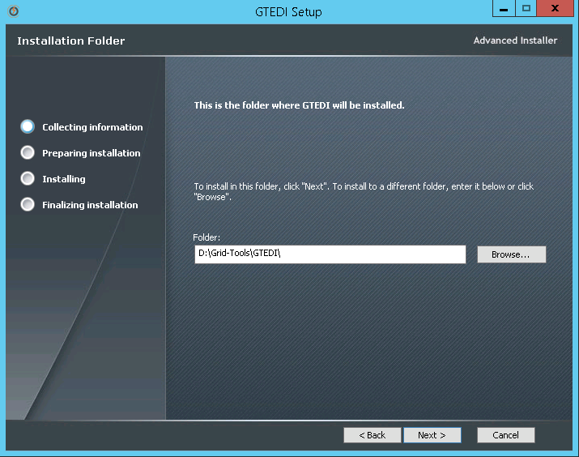

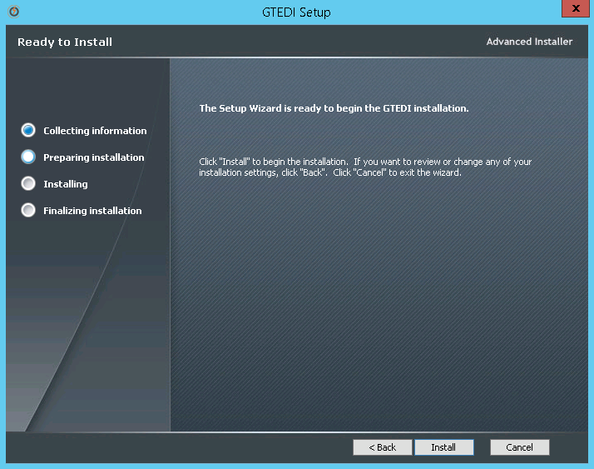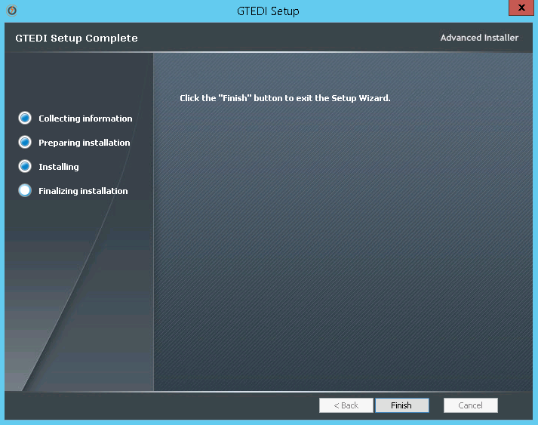

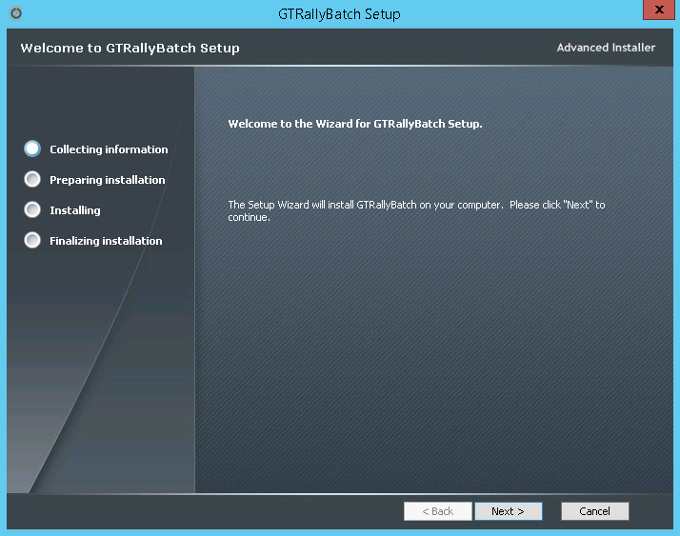

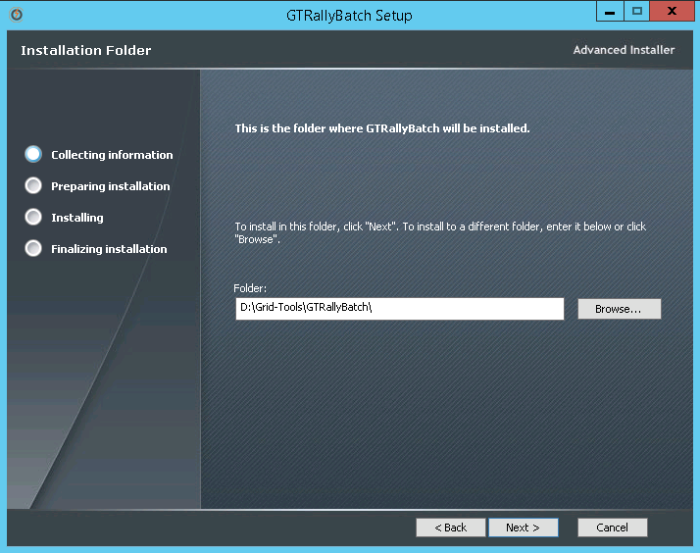

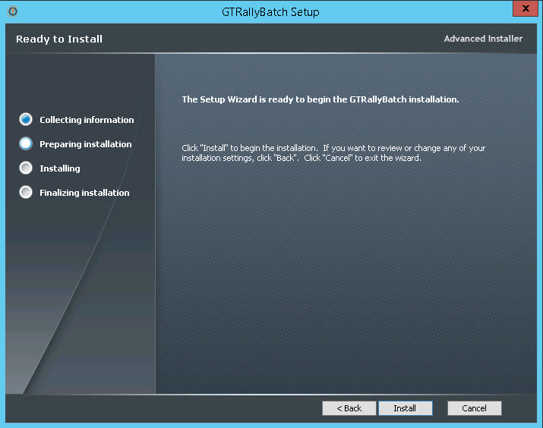

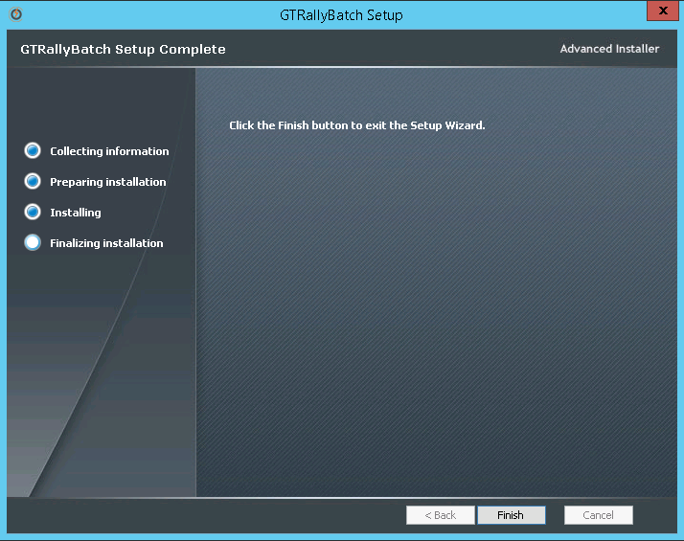

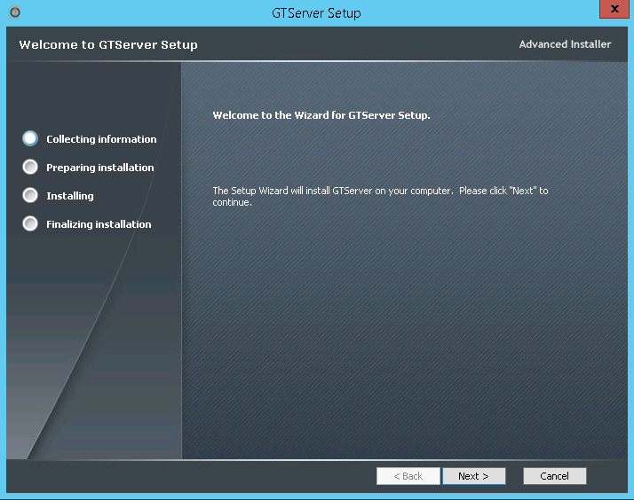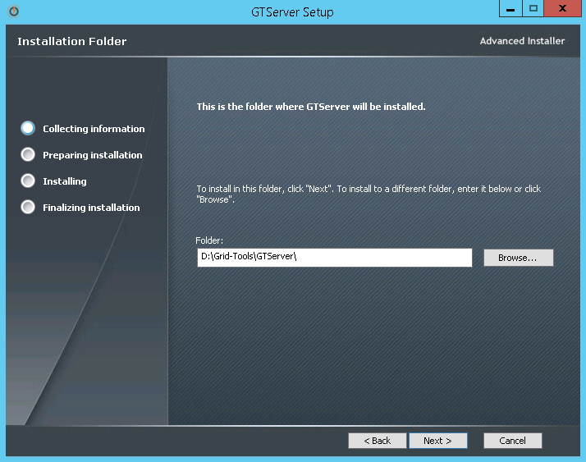

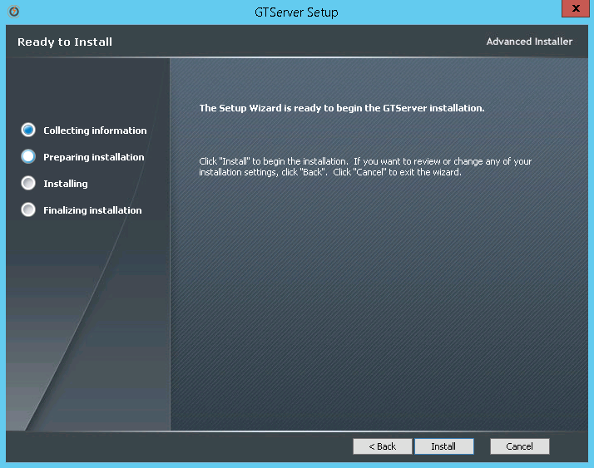

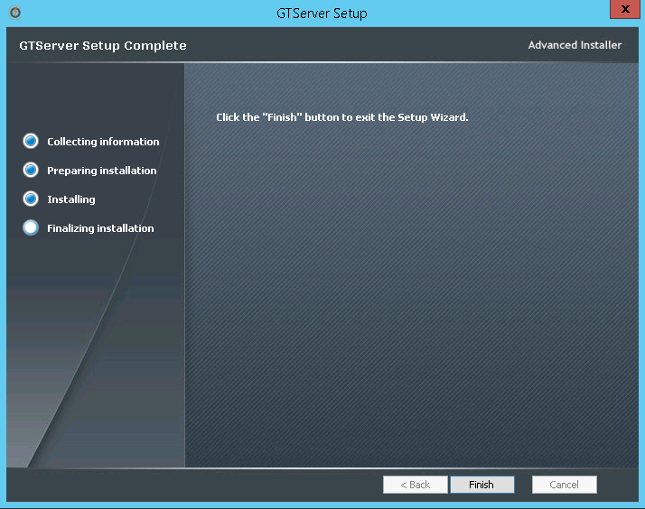

Renaming the rep.xml file and syncing the repository database.

After upgrading to the new version of Datamaker, if you have been using a rep.xml file to automatically connect to the Repository, this file will need to be renamed, and then upgrade and sync the repository database with the new version. Once completed, the rep.xml can then be renamed back for continued use. The following instructions explain how to do this.

Go to your GTDatamaker folder and locate the gtdatamaker.exe file. Or if there is a shortcut on the desktop you can use it as well.

Your file path should look like this- C:\Program Files (x86)\Grid-Tools\GTDatamaker\ gtdatamaker.exe

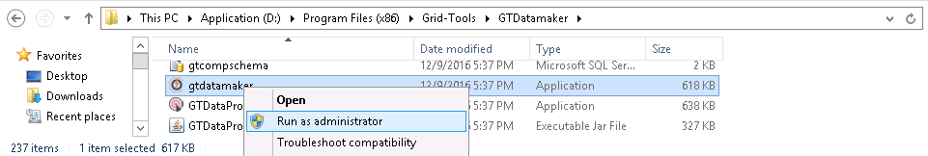

Launch gtdatamaker.exe by right clicking and select “Run as administrator”.

You may get the following error: 'DB version specified in database ‘X’ is invalid. This version of the software can work with DB version ‘X’ only. You are connecting with pre-distributed details (rep.xml) - no upgrade is allowed. Please contact support.

This error means that the repository needs to be upgraded to match the latest Datamaker version, however, a rep.xml file was in use with the previous existing installation, and this file needs to be renamed as was mentioned previously. This file can exist in 2 different paths, the current install directory and possibly in the current user’s AppData folder.

Rename the rep.xml that you want to use for the upgraded version (in C:\Program Files (x86)\Grid-Tools\GTDatamaker) to rep-old.xml

Now, in the file path pane, type in %appdata% and hit enter.

Alternatively you can navigate to it by C:\Users\(username)\AppData\Roaming

Choose the Grid-Tools folder. Your file path should look similar to C:\Users\AppData\Roaming\Grid-Tools

Here you may find another rep.xml file and if so, rename it to rep-old.xml as well.

Go to C:\Program Files (x86)\Grid-Tools\GTDatamaker again.

Open the rep-old.xml file to view its contents.

Right click on the gtdatamaker.exe and select “Run as administrator” to launch it.

A ‘Test Data Repository (3.2G) log in for CA Test Data Manager- Datamaker’ pop up will appear with the Repository profile you chose in the last installation.

Click on the green database connection button in the bottom, left hand corner.

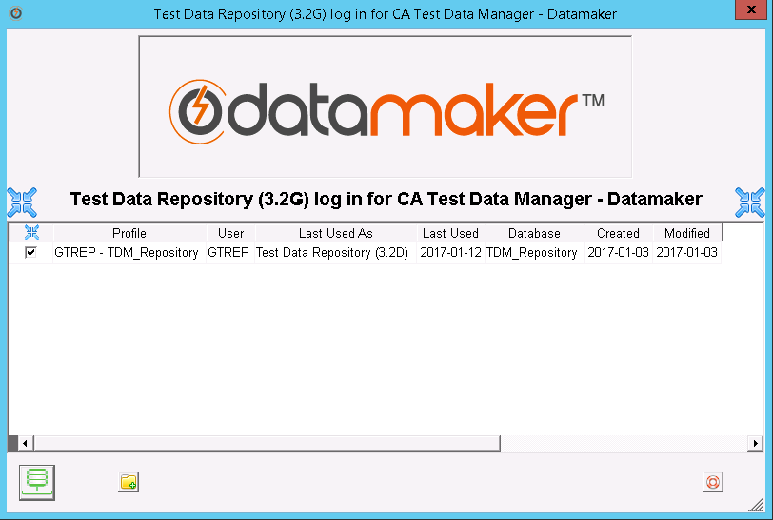

You will get an error message similar to
‘Test Data Repository version specified in database (3.2D) is invalid. This version of the software can work with Test Data Repository versions 3.2G and above only. In order to run the upgrade you will need to know the user name and password of a user in the ADMIN group. Would you like to attempt an upgrade?’

Click the ‘Yes’ button.

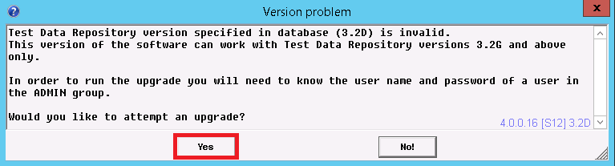

You will now be prompted for your administrator user name and password.

Enter the credentials and click on the green check mark in the bottom, right hand corner.

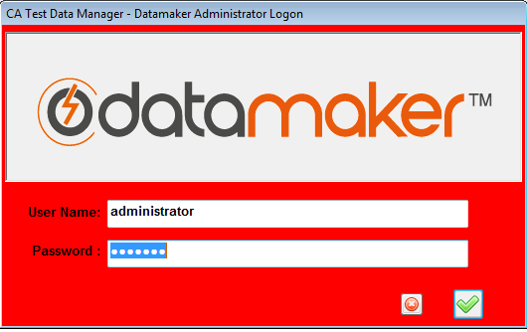

A ‘CA Test Data Manager-Datamaker Repository Schema-Update Required’ pop up will appear.

On it you will be asked ‘Do you wish to run this update now?’

Click the ‘Yes’ button.

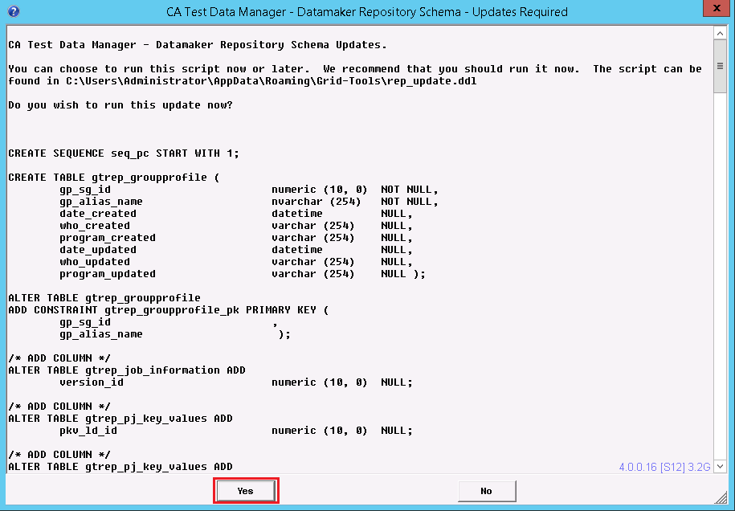

Once completed you will be prompted with the login dialog box.

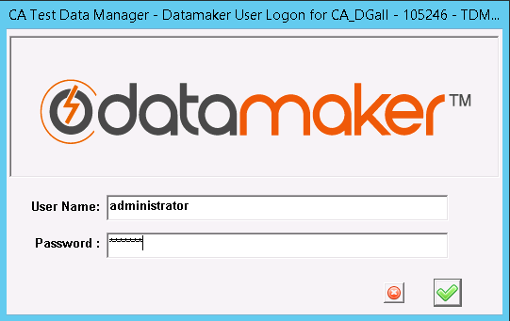

Login and proceed to connect to a Source and Target Databases.

NOTE: You should not need to worry about a license key with this upgrade as the currently license key should carry forward without an issue.

You should now see a list of all your old profile connections in the profile list.

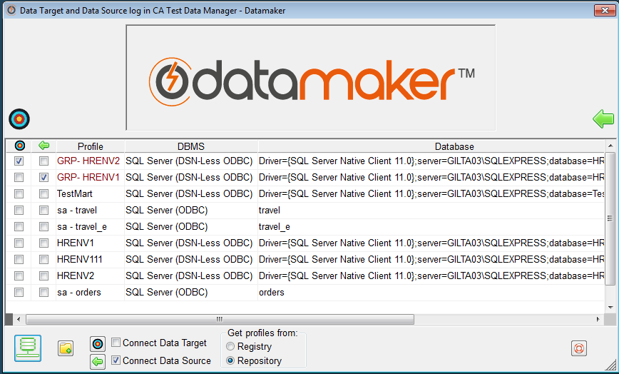

Before connecting to any profiles, you should exit out of Datamaker, and change the old-rep.xml file names back to rep.xml.

Go to C:\Program Files (x86)\Grid-Tools\GTDatamaker\ and C:\Users\AppData\Roaming\Grid-Tools to do so.

Now, launch Datamaker again.

Enter your administrator credentials.

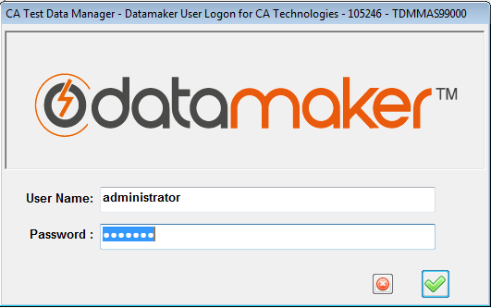

Choose profiles to connect to.

You should be able to access Datamaker and its toolbars.

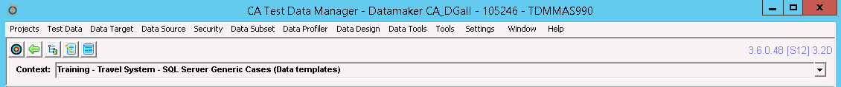

Verify the repository does not need any more maintenance.

To verify that the repository does not need any more maintenance, you can use the Ctrl + Alt + M function.

On your keyboard, press Ctrl + Alt + M while logged into Datamaker.

A 'GT Datamaker Administrator Logon' window should show.

Enter your administrator User Name and Password.

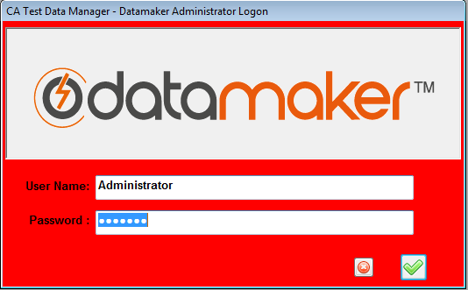

A 'Maintain Connections' window should appear.

Expand the first tree under 'GT Datamaker Connection maintenance'.

Click on the 'Check Repository Tables' icon.

Click on the 'Process' button located in the top, right hand corner.

You should see a 'Checking repository tables' message.

If everything has updated correctly, you should then get a 'Repository Schema OK - No updates required' message.

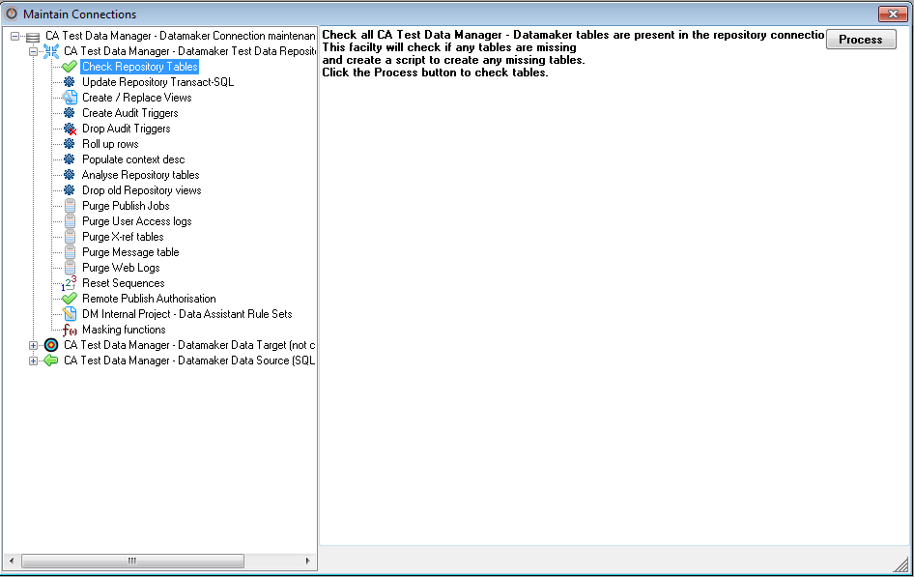

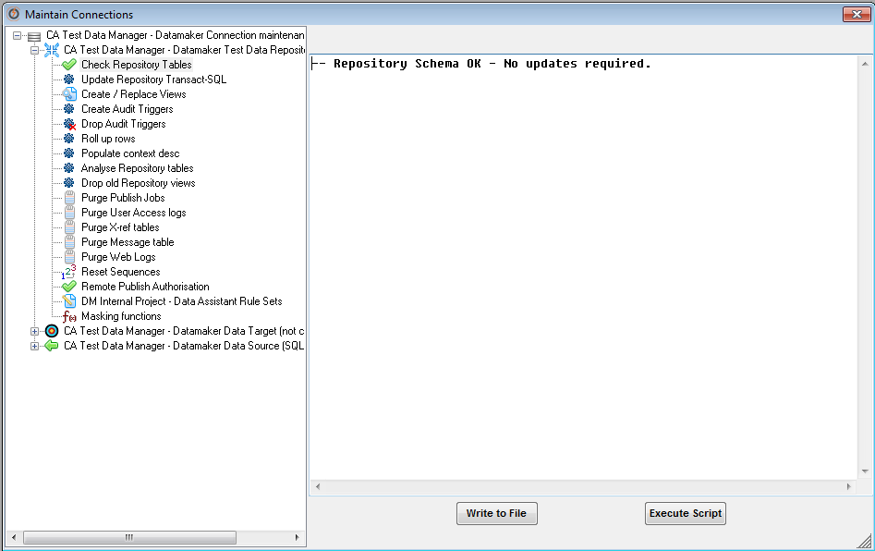

Click on the 'Update Repository Transact-SQL' in the tables section.

In the 'Update Repository Transact-SQL' pop up, you will be asked, 'Do you want to update all the repository Transact-SQL?'

Click the 'Yes' button.

You should get a message returned containing '0 failed or not attempted' message.

Click 'OK'.

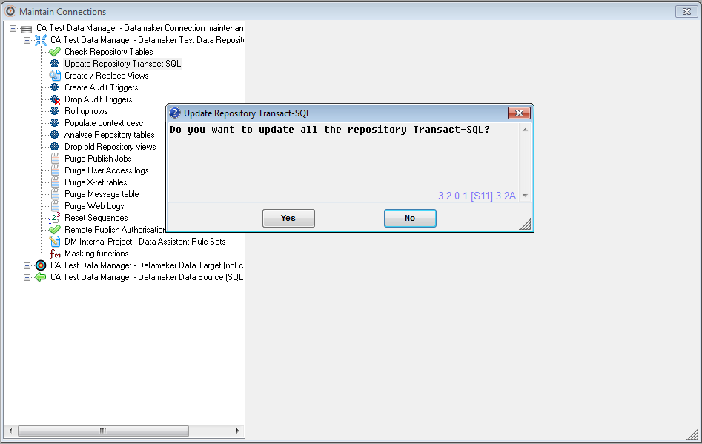

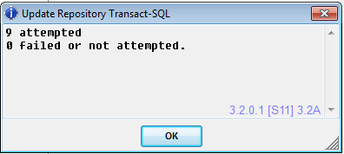

At this point your upgrade has been completed and the product is ready for daily usage.

