- Open The SEPM (Symantec Endpoint Protection Manager) Console.
- GO to Client TAB and click on My Company the Go to Client.

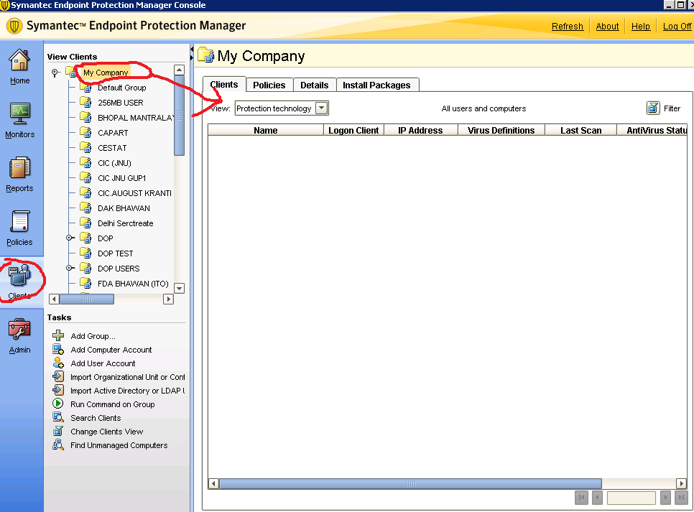

- Click On Find Unmanaged Computer.
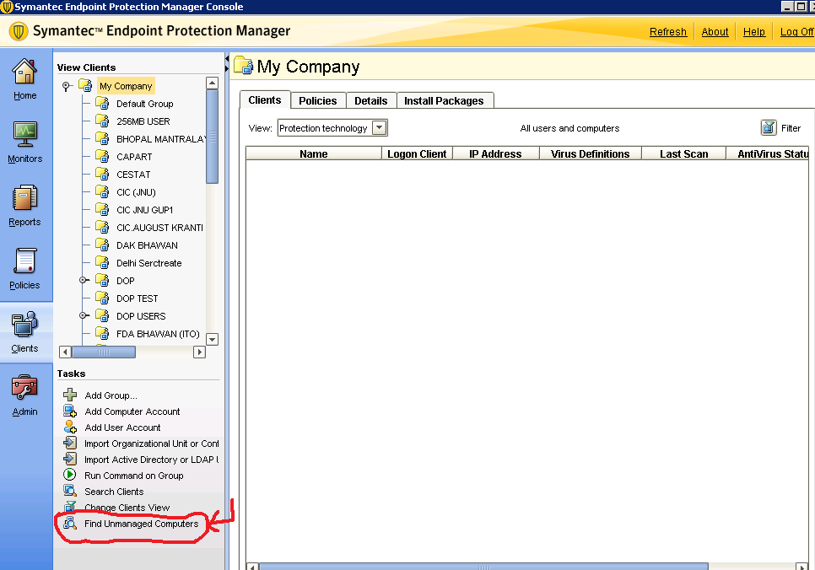

- Slecte your network IP Address Rang.

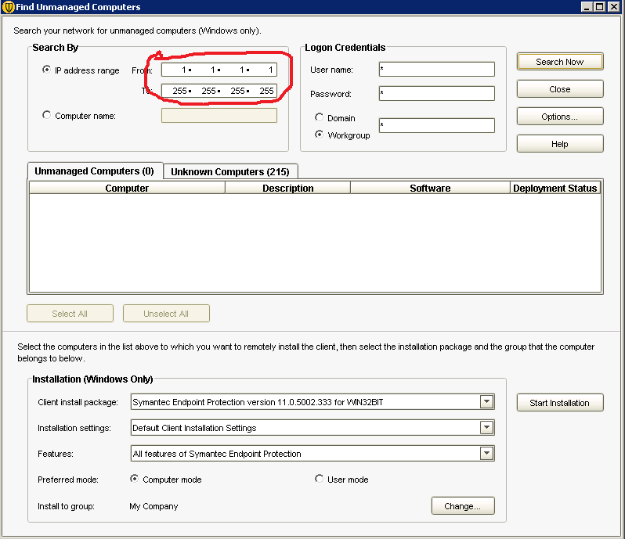

If you have a Workgroup machines type * on are colon.
If you have Domain slecte the Domain and enter the Domain name user name and password.
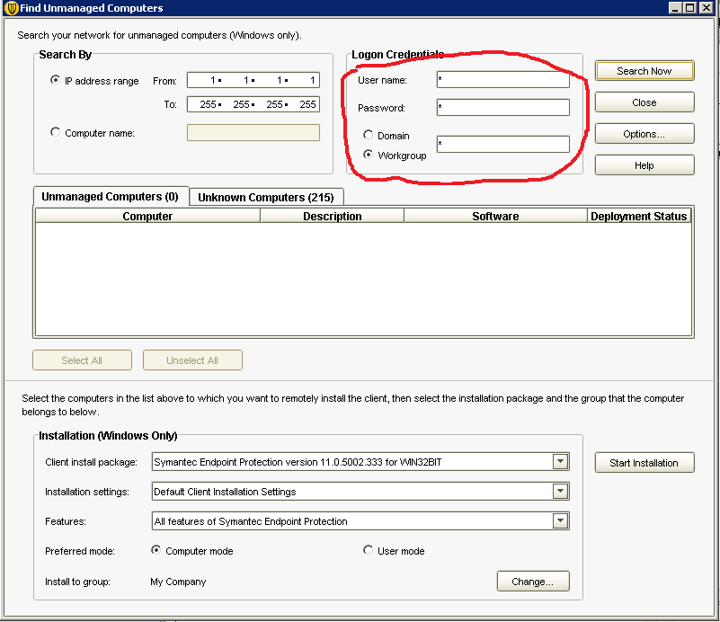
And click on search Now
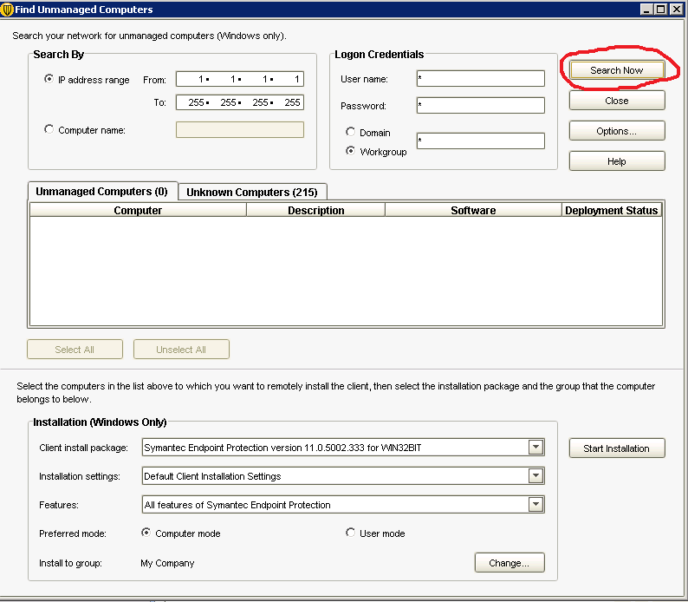

Your Without Symantec AV client show on Unknown Computers.

