To create Basic User Account please follow these steps:
- Navigate to the Broadcom Support Portal
- In the upper-right corner, click REGISTER
- Enter your email address, complete the captcha and click Next
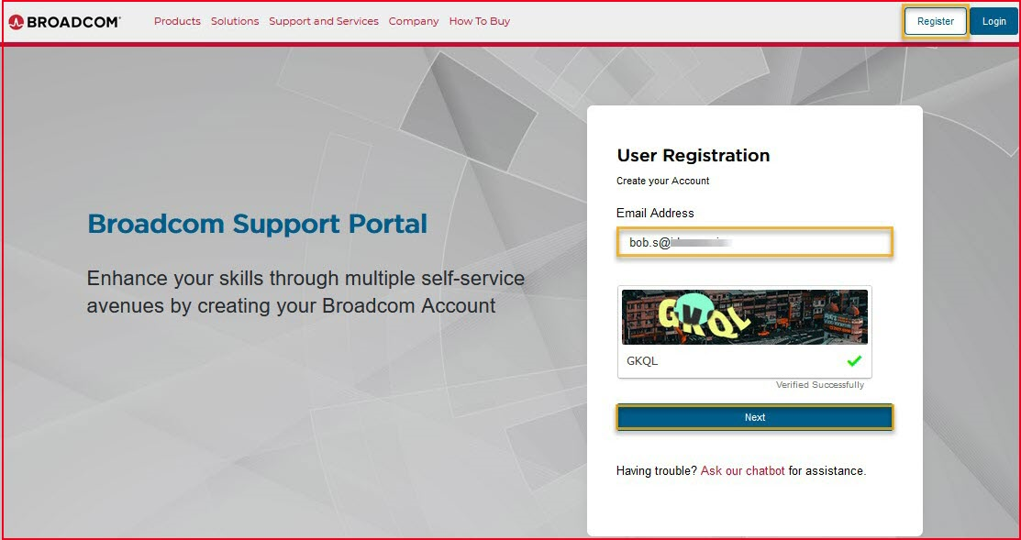
- A Verification Code will be sent to your email address
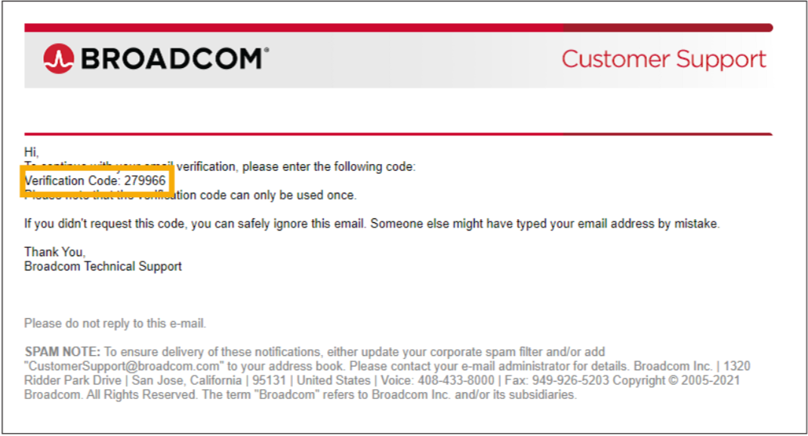
- Enter the Verification Code and click Verify & Continue
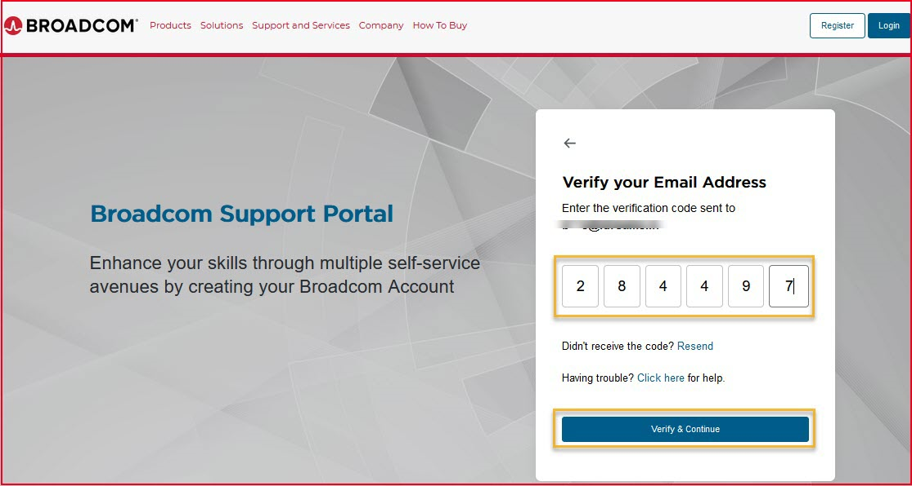
- Enter your basic information, accept the Terms of Use and click Create Account
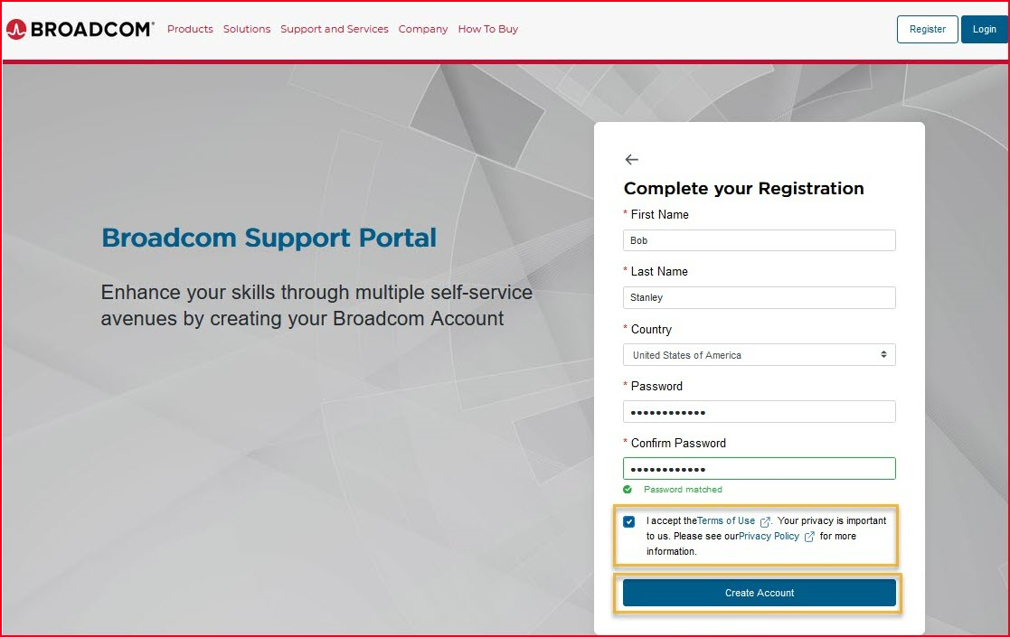
- End-users with pre-approved email domain-to-company associations (i.e. BSN & Semiconductor end-users) will be presented with the Company attribute allowing their profile to be auto-upgraded to an Enterprise Profile
- Your profile has been created and Registered Successfully. After completing the Basic User Account registration, Click on Yes, I want to build my profile to build and upgrade your account to unlock additional services and obtain full access to Case Management, Product Downloads, Entitlements, and other features.
