SOI 4.2 – Jasper Reports – SSO
When a user logged in as an EEM User (Ex: reportuser) to SOI Dashboard and clicks on a chart that opens Jasper Reports page without asking user credentials again
Step 1 – On Jasper Reports server
- Browse to \SOI\Reports\deploy\keystore and edit ‘soi.properties’ file and set “ks.storepass” value as shown below (the value can be anything)
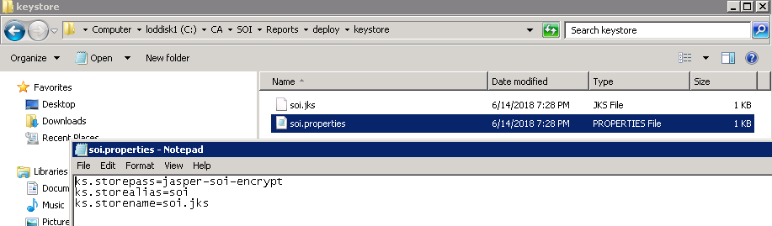
- Run “jskcreation.bat” to create soi.jks file
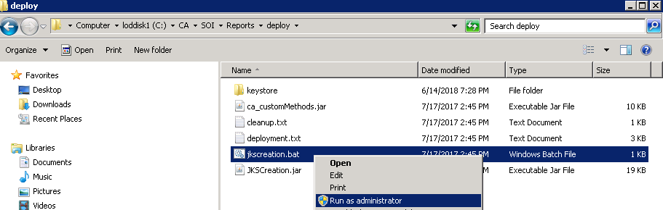
- This will create “soi.jks” file in \SOI\Reports\deploy\keystore folder
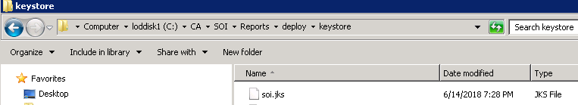
- Create a folder and name it as "config" in the following location
Ex: \CA\SharedComponents\CA Business Intelligence\apache-tomcat\webapps\jasperserver-pro\WEB-INF\
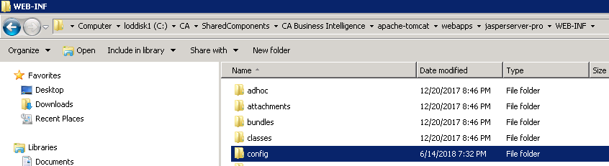
- Copy soi.jks and soi.properties from the following location: <SOI_REPORT_HOME>\Reports\deploy\keystore and paste to the location <Jaspersoft Install Folder>\<tomcat folder>\webapps\<Jasper_Instance_Name>\WEB-INF\config\
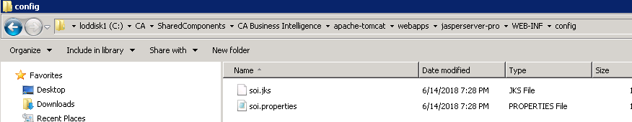
- Restart CA Business Intelligence Tomcat Service
Step 2 – On UI Server
- Copy soi.jks and soi.properties file from the CA SOI Report system and paste it to \SOI\SSO folder
Note: SSO folder needs to be created on UI
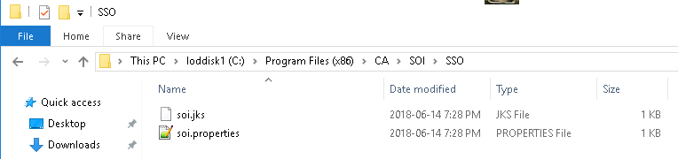
- Create an environment variable named CA_TRUSTEDAUTH_HOME and set the path where jks and properties files is copied in Step 1
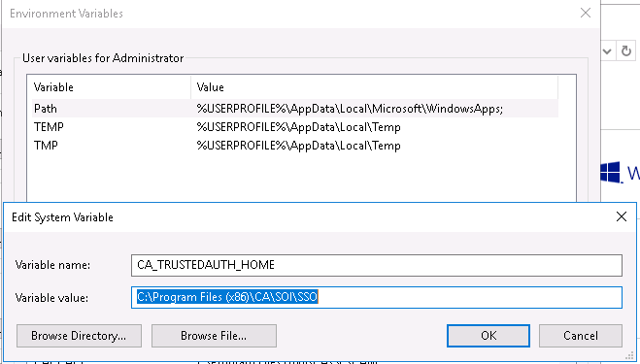
- Restart SOI UI service
Tests
- Login into SOI Dashboard as one of the EEM user (Ex: brahma)
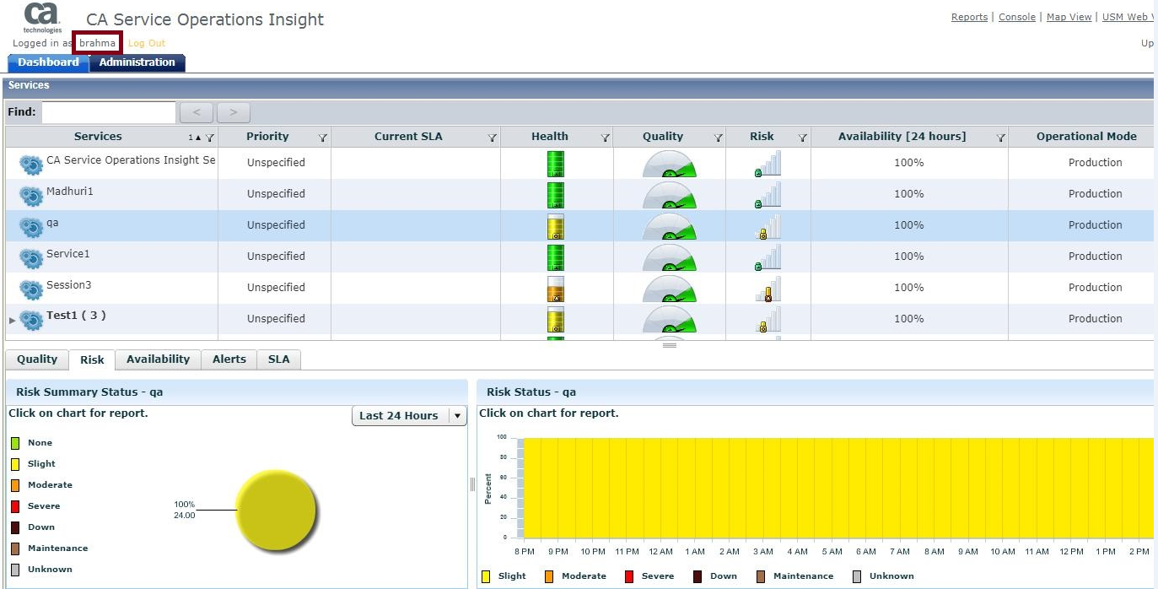
- Click on Risk | Availability chart for any selected service
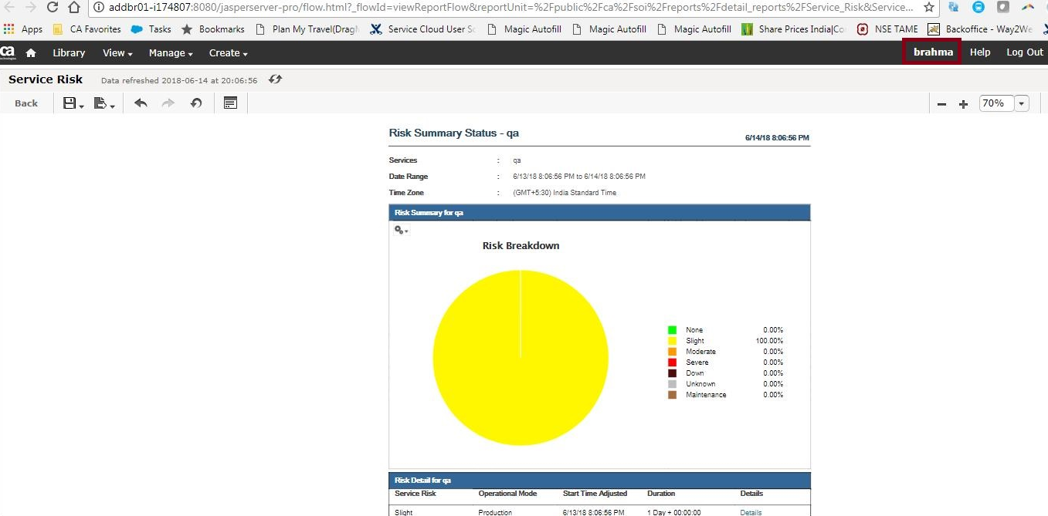
The report opened without prompting for user credentials
Tests 2
- Login into SOI Dashboard as another user (Ex: reportuser)
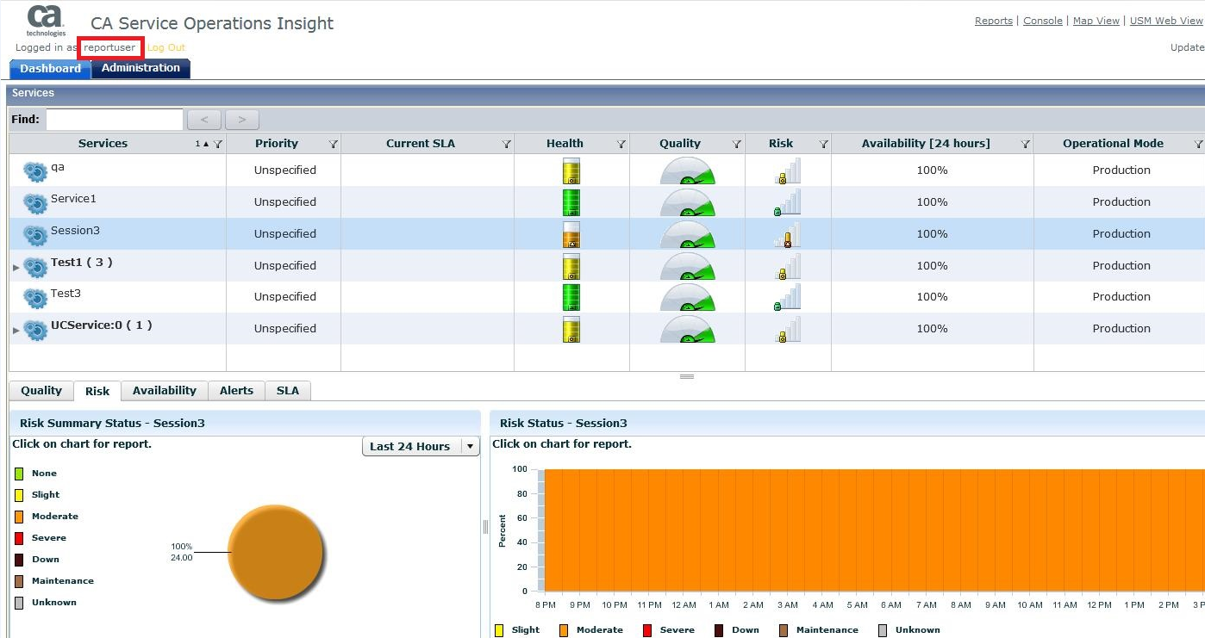
- Click on any chart for the selected service, it should open Jasper reports page
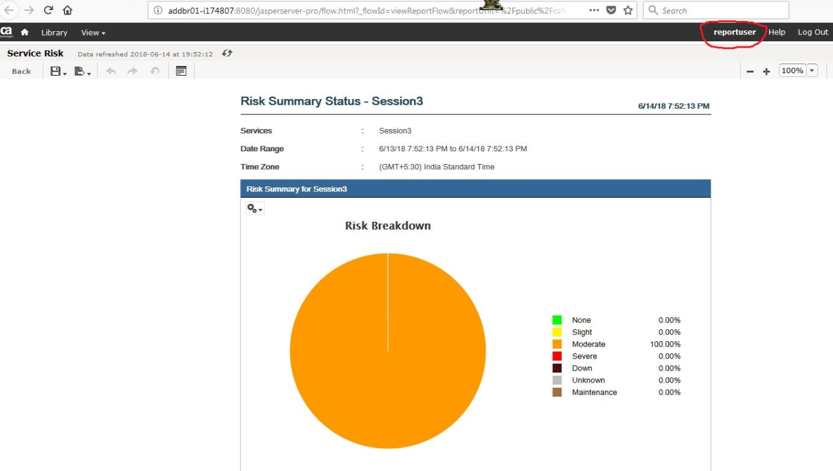

SOI Version – 4.2
Jasper Version – 6.3.0
