Forum: Sorting categories in Hierarchy Tree and deleting incidents
Forum Link http://www.symantec.com/connect/forums/sorting-categories-hierarchy-tree-and-deleting-incidents

Date: Sunday, May 30, 2010
Author: Kevin Valente
Contributors: Fabrice B M Raud and Geoffroy Perrier from FABEMARA Consulting
Subject: Sorting Hierarchy Tree in Symantec ServiceDesk 7
Knowledge Base Article: FEATURE REQUEST: To be able to sort ServiceDesk categories in alphabetical order
https://kb.altiris.com/display/1/kb/article.asp?aid=50511

Issue: The Hierarchy Tree is unsorted and there is now way to sort it within the Symantec ServiceDesk 7 GUI.

Example: Anaqua and ADP should be reversed in order.
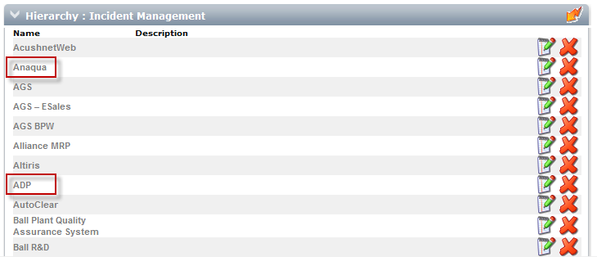

Resolution:
Step 1: Log into the server that your MS SQL Server 2005 is located on.
In this example, my MS SQL Server 2005 is located on the same server as ServiceDesk7.

Step 2: Select All Programs > Microsoft SQL Server 2005 > SQL Server Management Studio
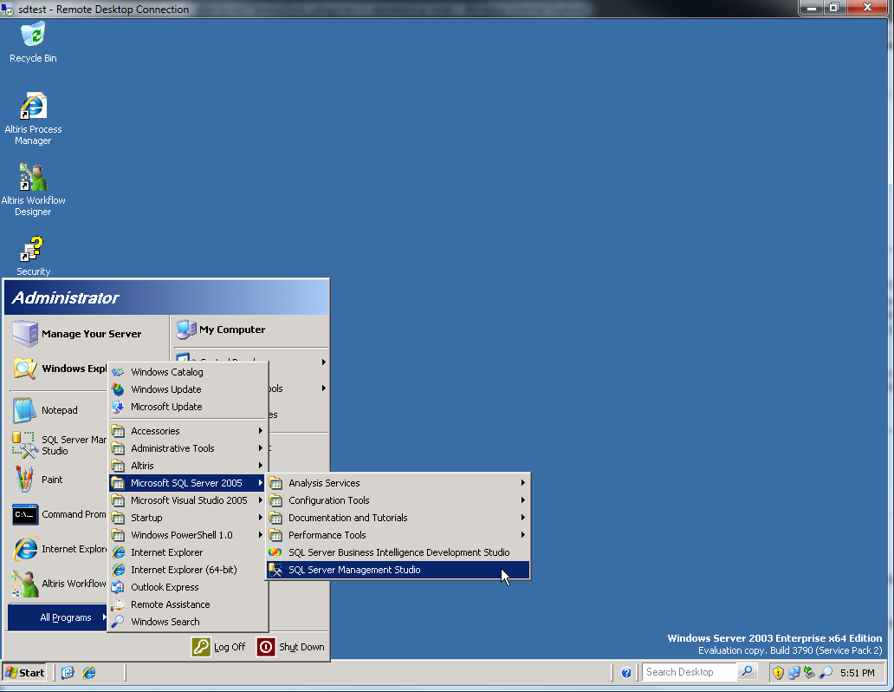

Step 3: Enter SQL Server 2005 authentication credentials and click on Connect.
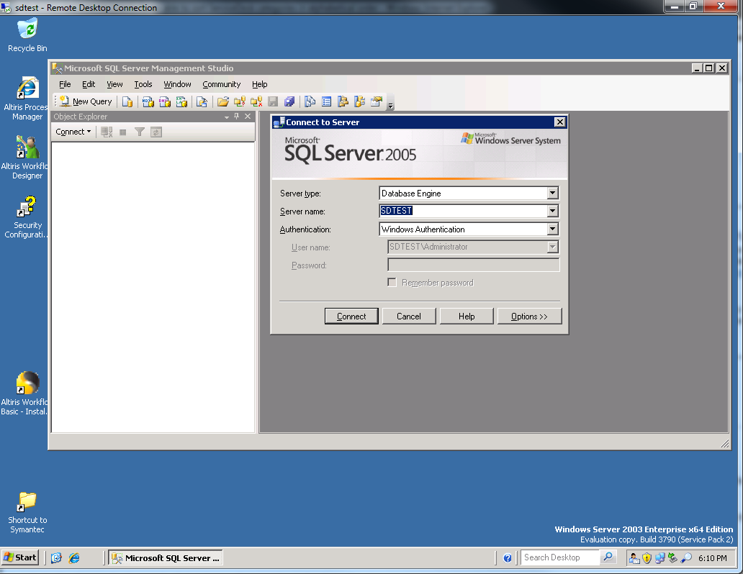

Step 4: Once logged in, double click on Databases.
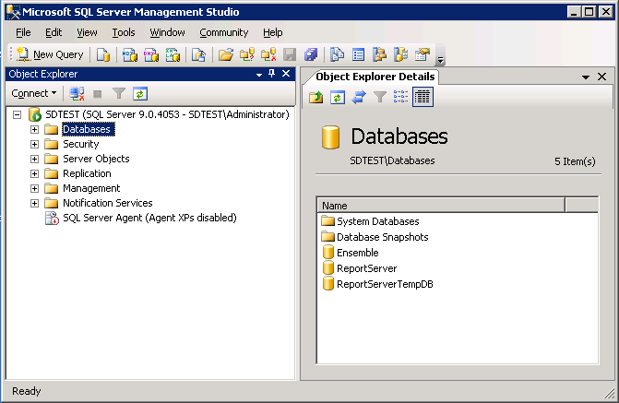
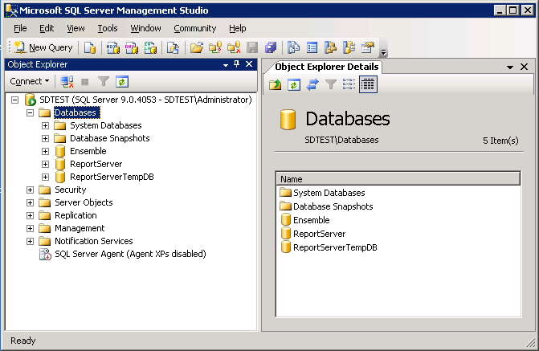

Step 5: Right click on Ensemble, and select New Query.
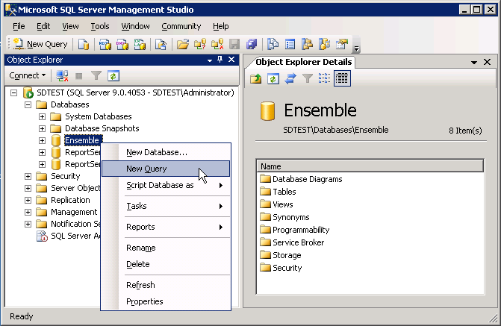
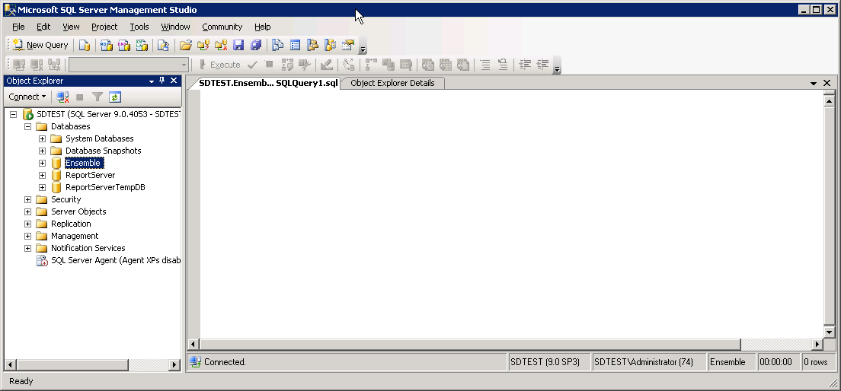

Step 5: Enter the following commands into the SQL window:

IF EXISTS(SELECT * FROM sys.indexes WHERE object_id = OBJECT_ID(N'[dbo].[HierarchyItem]') AND name = N'PK_HierarchyItemID')
ALTER TABLE [dbo].[HierarchyItem] DROP CONSTRAINT [PK_HierarchyItemID]

Go

ALTER TABLE [dbo].[HierarchyItem] ADD CONSTRAINT [PK_HierarchyItemID] PRIMARY KEY NONCLUSTERED
(
[HierarchyItemID] ASC
) WITH(PAD_INDEX = OFF, SORT_IN_TEMPDB = OFF, IGNORE_DUP_KEY = OFF, ONLINE = OFF) ON [PRIMARY]

Go

CREATE CLUSTERED INDEX [IX_HierarchyName] ON [dbo].[HierarchyItem]
(
[Name] ASC
) WITH(PAD_INDEX = OFF, SORT_IN_TEMPDB = OFF, DROP_EXISTING = OFF, IGNORE_DUP_KEY = OFF, ONLINE = OFF) ON [PRIMARY]

GO
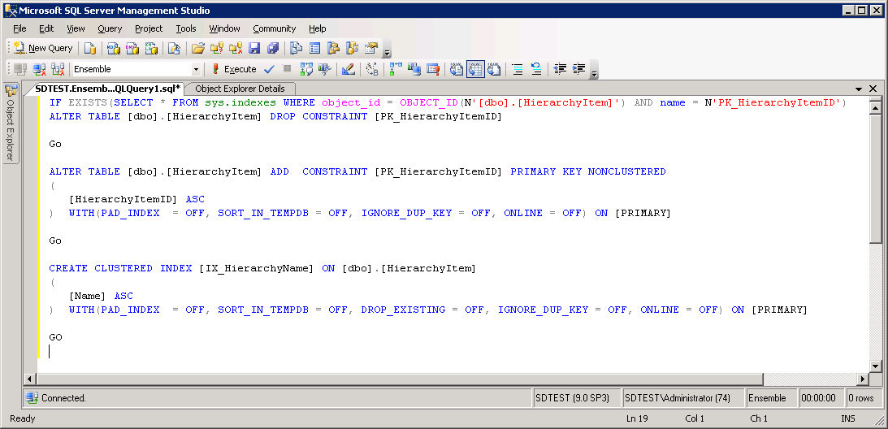

Step 6: Click on Execute.

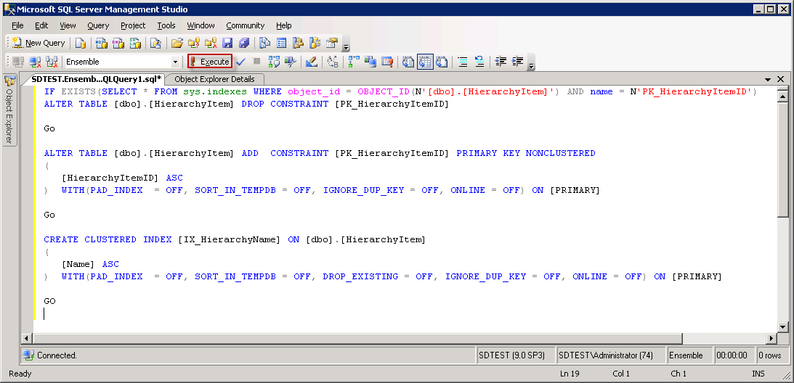
Note: This is only to be run one time. This will also resolve any future sorting issues in the future.

If you run it more than once, you will receive the following error message.

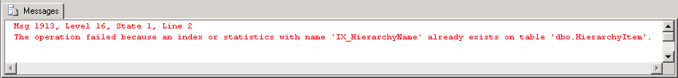

You may need to log off and log back on for the changes below to be noticeable.

