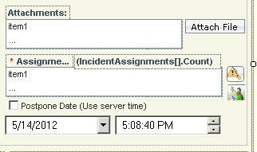
When working tickets on an initial contact, the worker may have to assign the ticket to him or herself for further investigation or they resolved the issue. Therefore, they would have to click on the Assign Incident button, type in their names, select themselves, and click OK. I added a copy of the current incident assignment button so when they click on it and it will use their Ensemble Security information and therefore, assign the incident to themselves.
- In the Primary Model of the SD.Feeder.TechnicianForms workflow, modify the Web Form for “Create Incident”
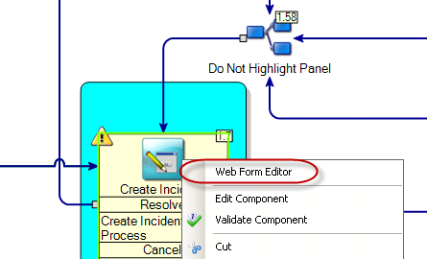
- Right click on the button for “Incident Assignments” and make a copy.
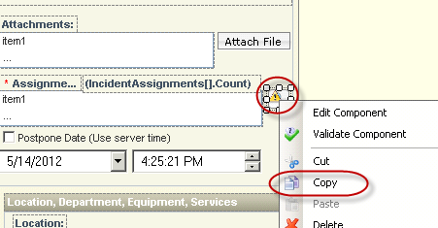
- Paste the button on the same form (like under the current button)
- Right click on the button you just created and click on edit.
- On the appearance tab, change the text to “Assign Incident to Me”
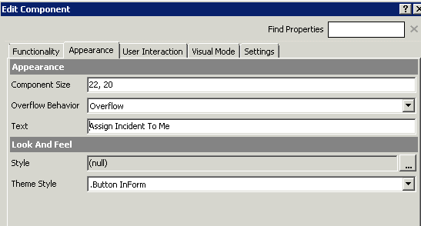
- On the User Interaction tab, click the ellipses on the forms model.
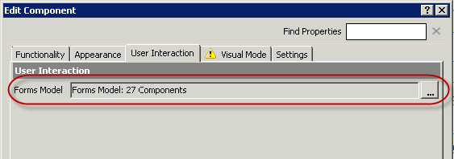
- Remove the components with the Xs.

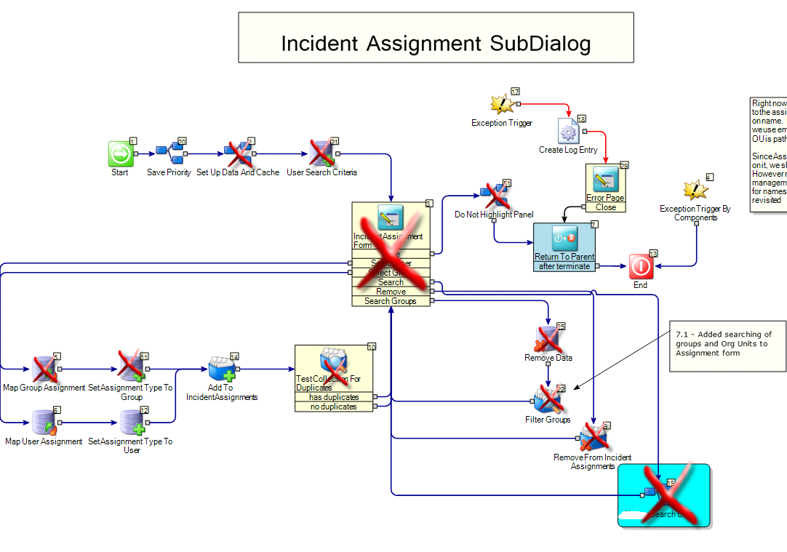
- Connect the “Save Priority” (number 20) Embedded Model to “Map User Assignment” (number 6)
- Connect the “Add to IncidentAssignments” (number 14) AddItemsToCollection component to the “Return to Parent” (number 7) TerminateWindowAndCloseDialog component.
The workflow should now look like this (after straightening and cleanup.)
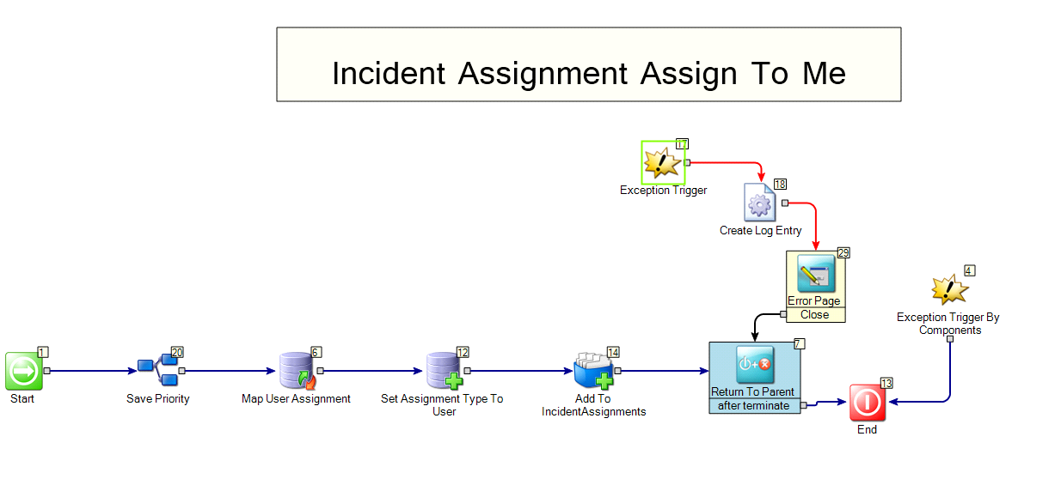
- Edit the “Map User Assignment” SingleValueMapping Component
- Click on the ellipses next to the Mapping Definition
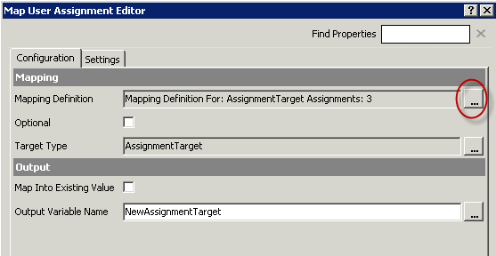
- Remove any mappings to the current target assignments
- Map the following source data to the AssignmentTargets (all the source data will come from EnsembleSecurityToken)
  - Email to TargetName
  - Name to DisplayName
  - UserID to TargetID
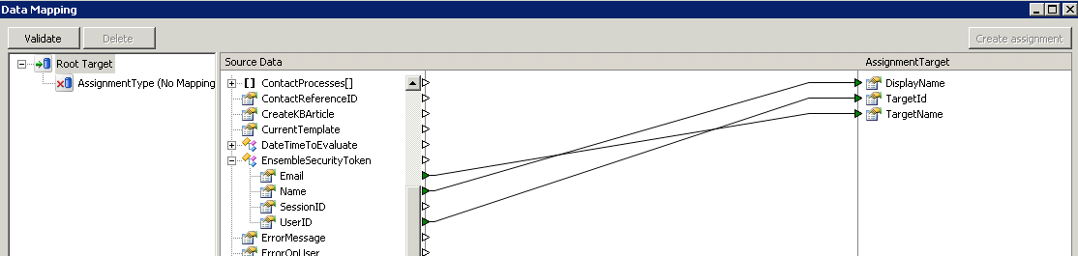
- Click ok to save the workflow.
- On the Visual Mode tab, I changed the button to something different than the current icon. I used
  - Image Source: Resource
  - Resource Name: “.\altiris.png”
  - Alternate Text: “ME”
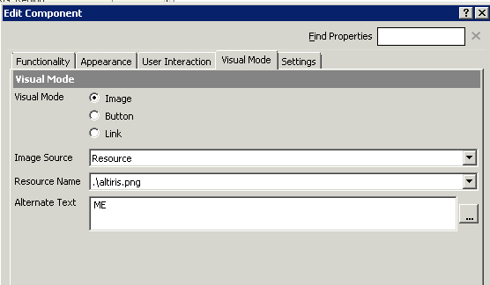
- On the settings tab, modify the description to “Assign Incident To Me”
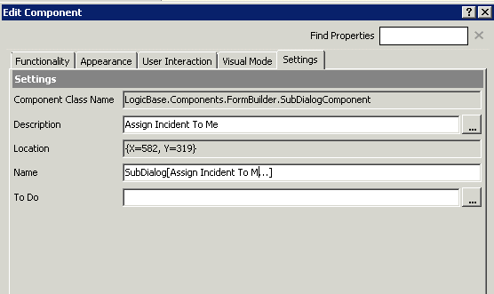
- Click OK to close the component
- Click OK to close the Web Form Editor
- Debug/Test, Save, and Publish.

