Test model with login & menu PSteps
Development
Modify generated code for the menu PStep to process “CLEAR SCREEN INPUTS” which forces its code to be executed before its window is displayed. To achieve that add this extra line to the generated jsp before building the app:
request.setAttribute("clearScreenInputs", "myValue");
https://docops.ca.com/ca-gen/8-5/en/distributed-processing/working-with-web-generation/building-and-running-a-web-generation-application#BuildingandRunningaWebGenerationApplication-RunWebGeneration
A link flow is also needs to be created between the 2 PSteps so that when the CLEAR SCREEN INPUTS forces the menu PStep code to be executed before display it can check if client_user_id is set or not. If client_user_id is not set the code:
- Sets an exit state to flow to the login PStep (with display first at “To” Pstep to force the user to enter login credentials).
- Then returns to menu PStep on the return flow forcing execute first so that username is displayed on window from the client_user_id.
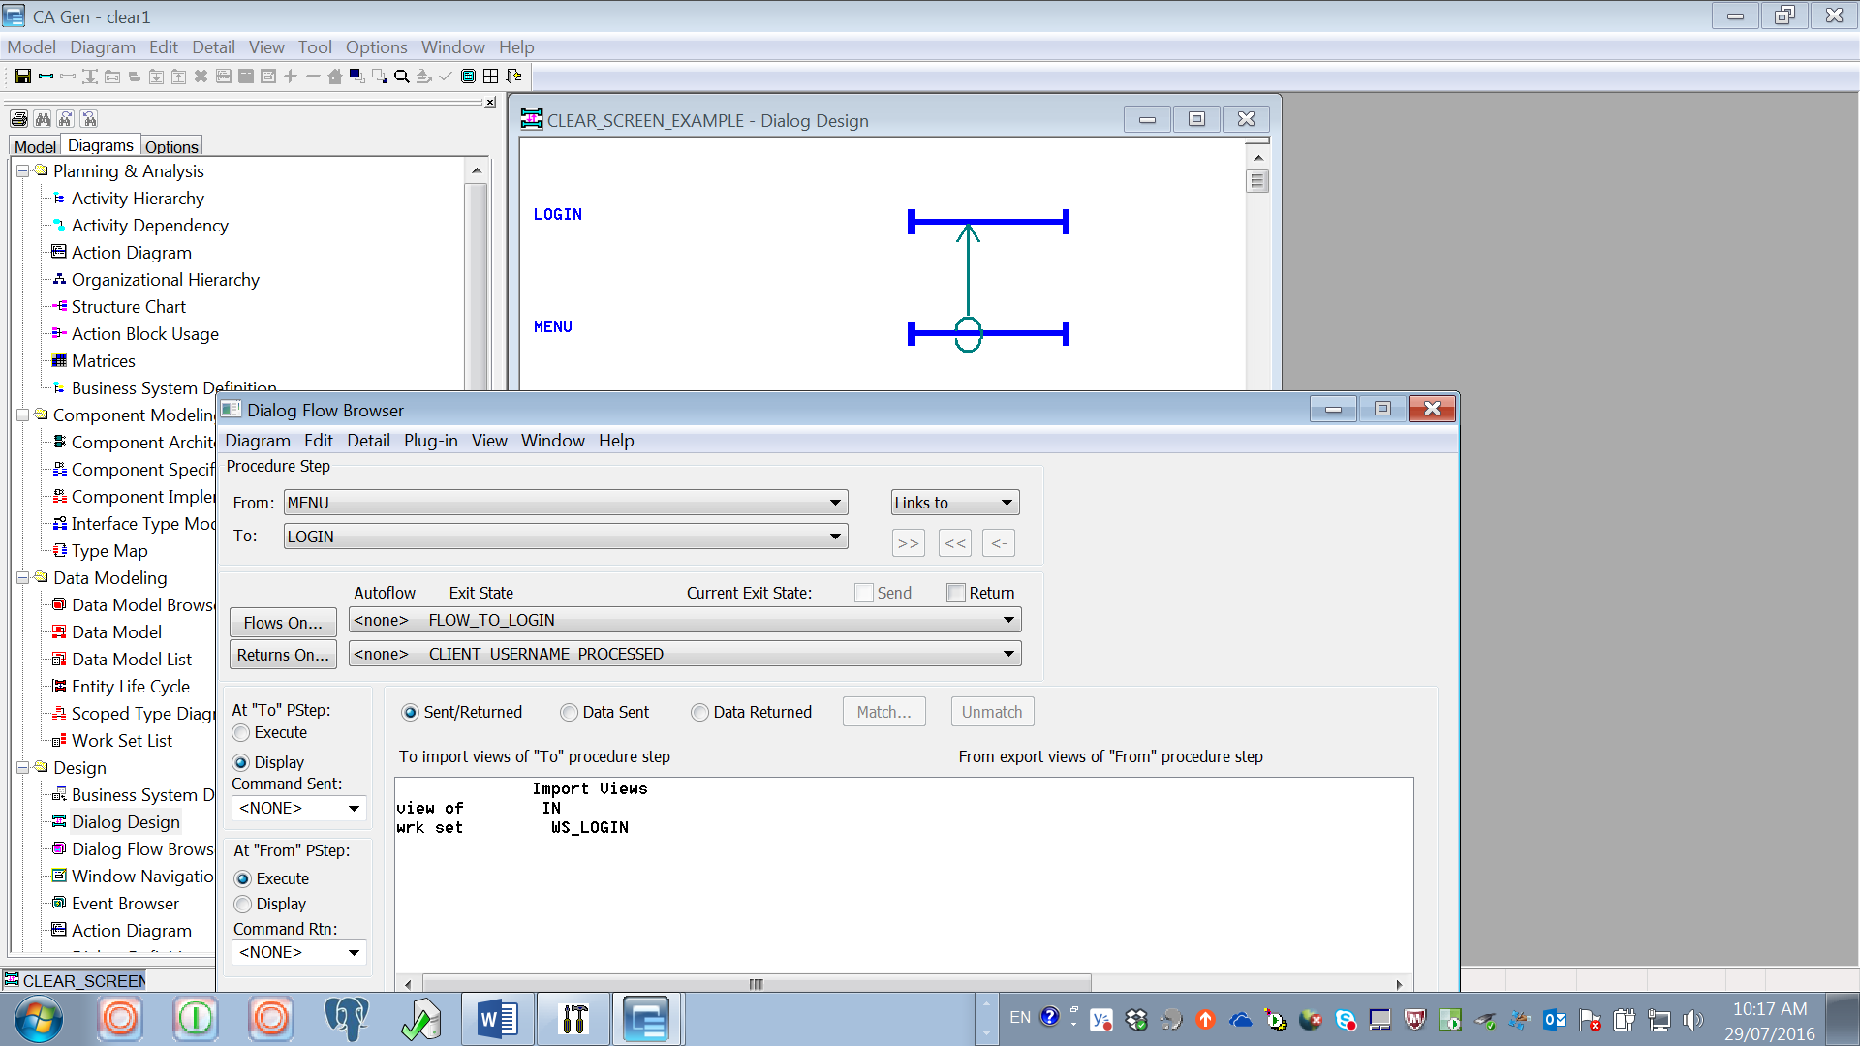

Build and test
Enter the menu.jsp URL e.g. http://localhost:28080/clear1/menu.jsp
clearScreenInputs attribute forces menu code to be executed first.
That code checks for client_user_id set to SPACES & if yes sets exit state to flow to login.jsp (used Informational exit state to illustrate). Run with Gen diagramtrace to see the flow details:
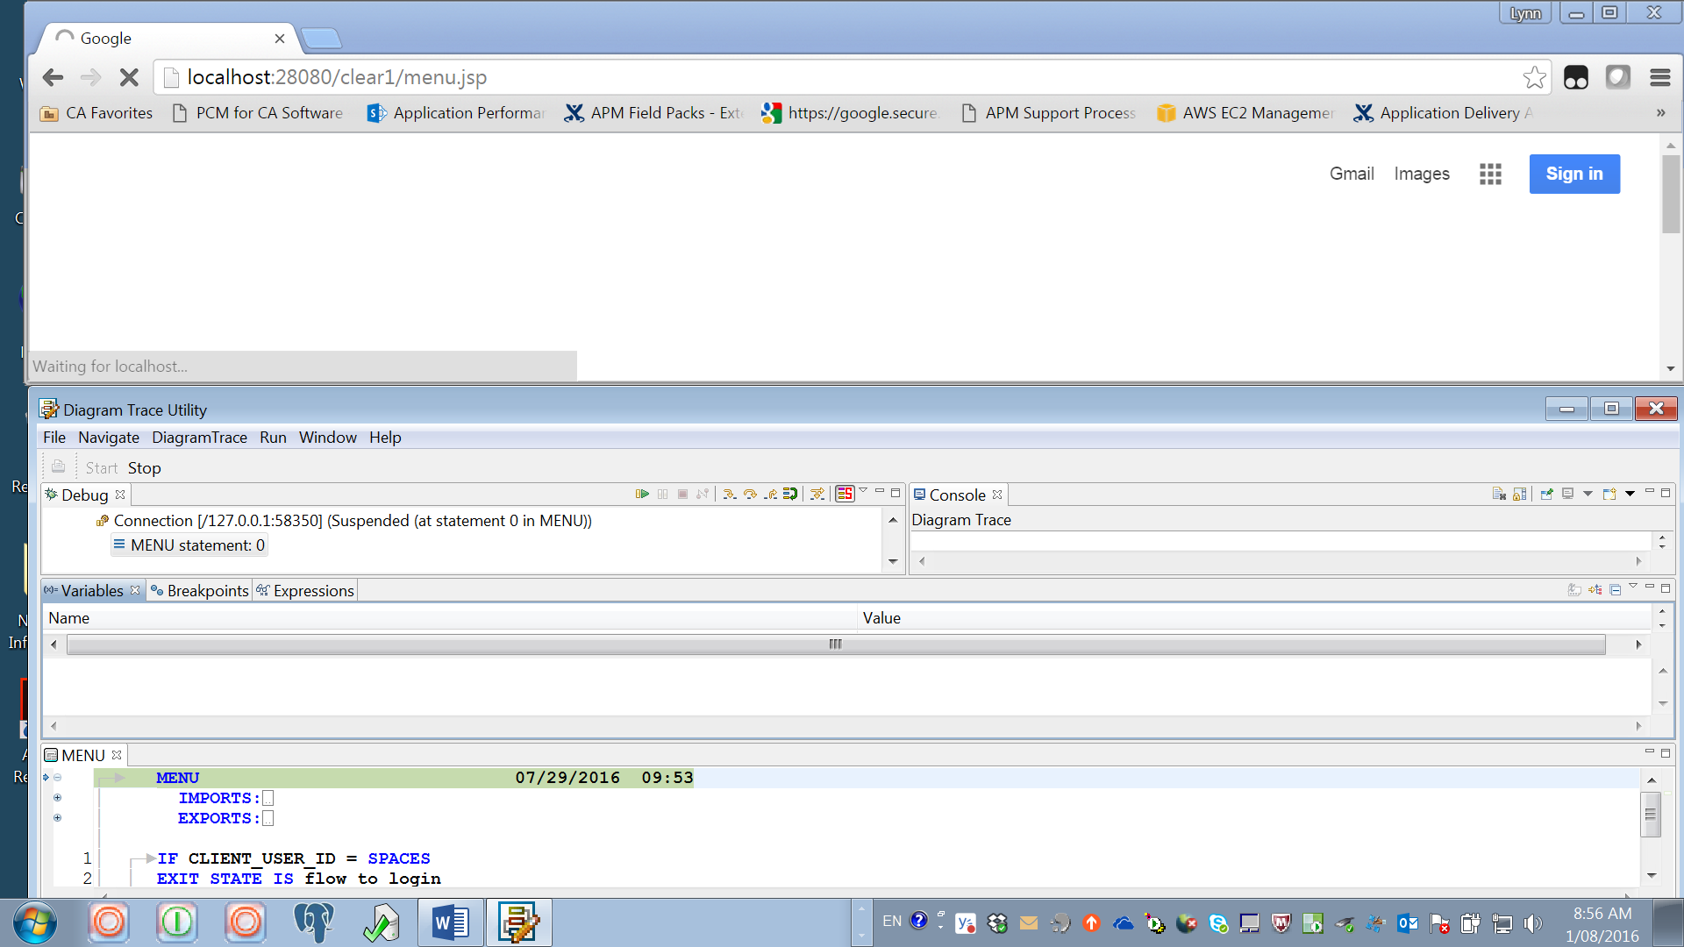
Exit state is set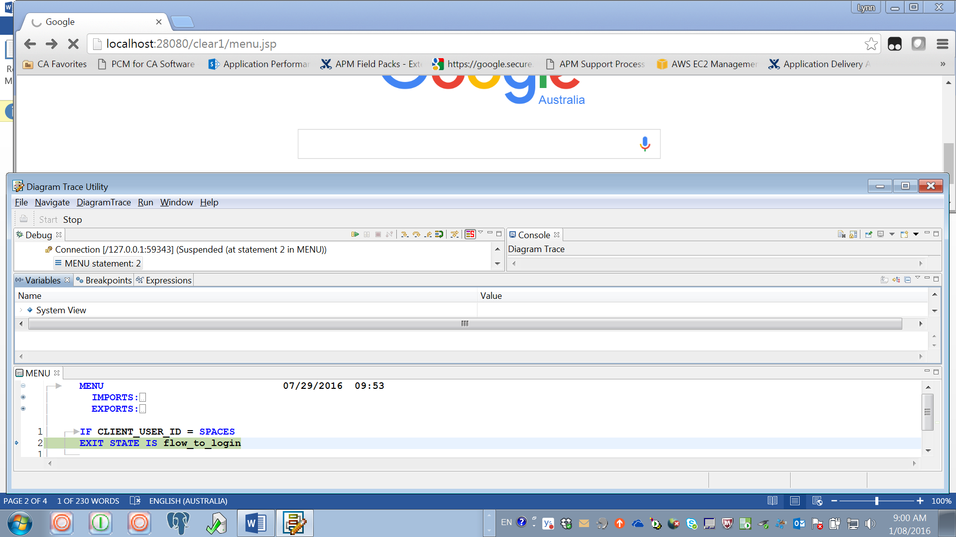

Exit state runs to load the login window
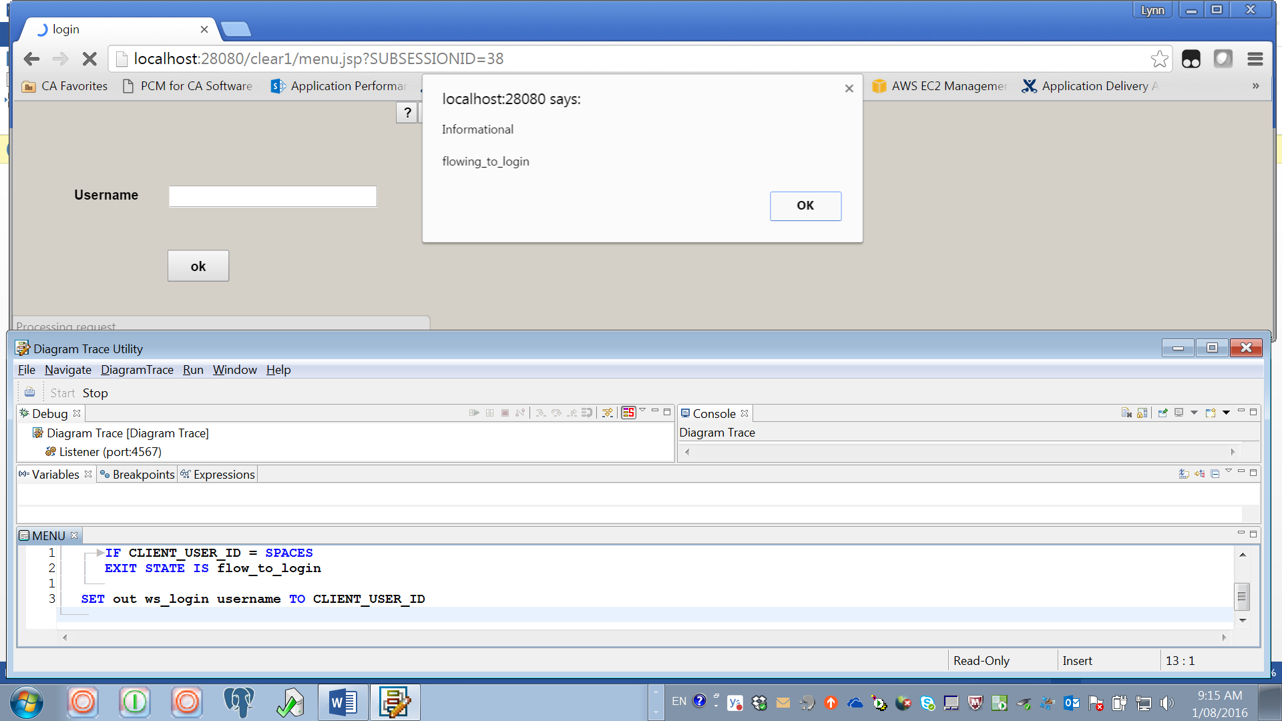

Hit OK on exit state & the login window becomes visible so data can be entered and when hit OK the flow goes into the login code.
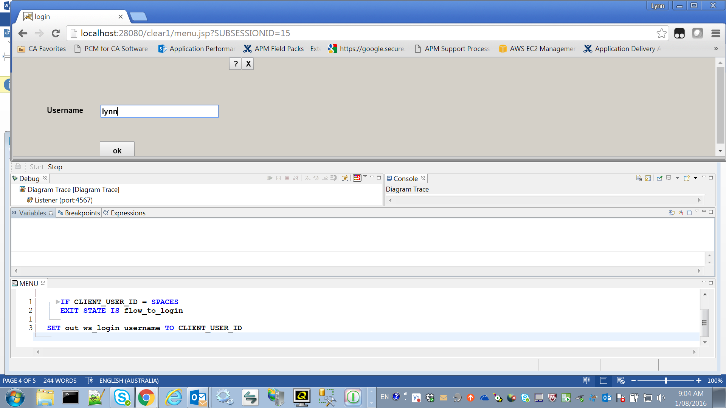

Hit OK on exit state & the menu code loads into trace
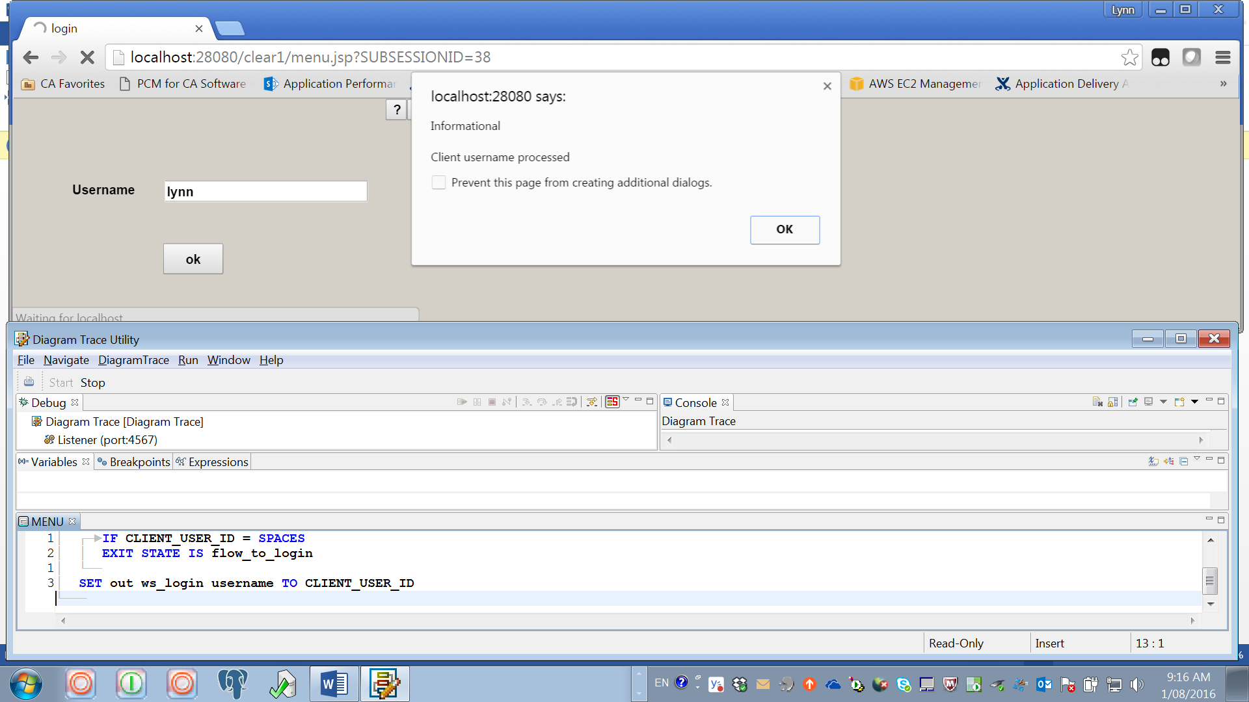

Exit state does not run because client_user_id has a value and the menu window opens.
