Issue with logging into the Clarity Support site
I have checked with the vendor on the addresses and account settings
Can access the community site.
https://community.broadcom.com/
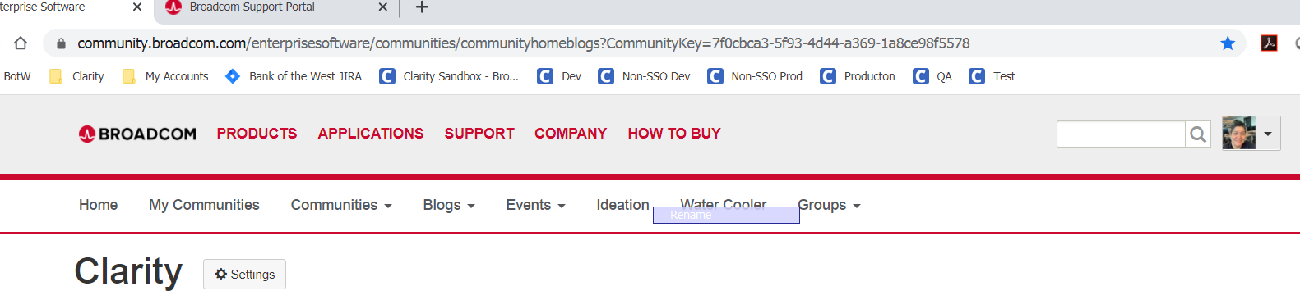
https://www.broadcom.com/support
Can access the site and login.
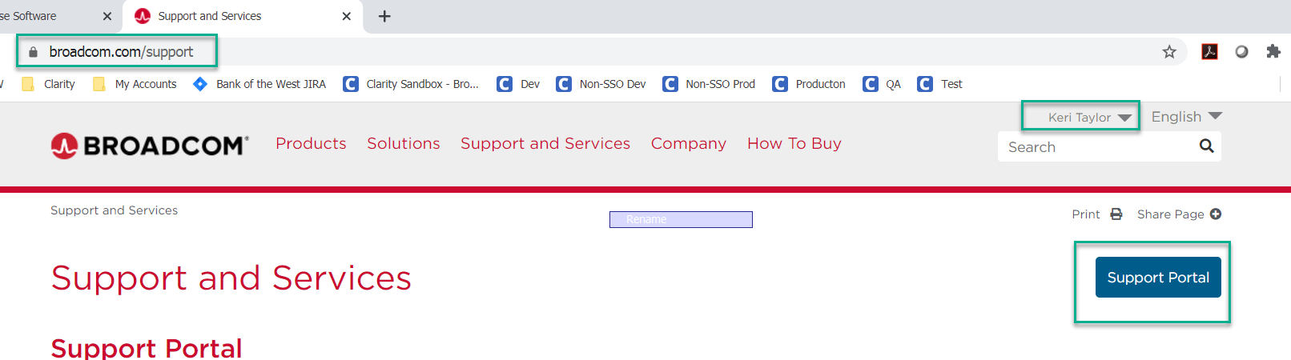
Clicking the Support Portal button gives me the below.
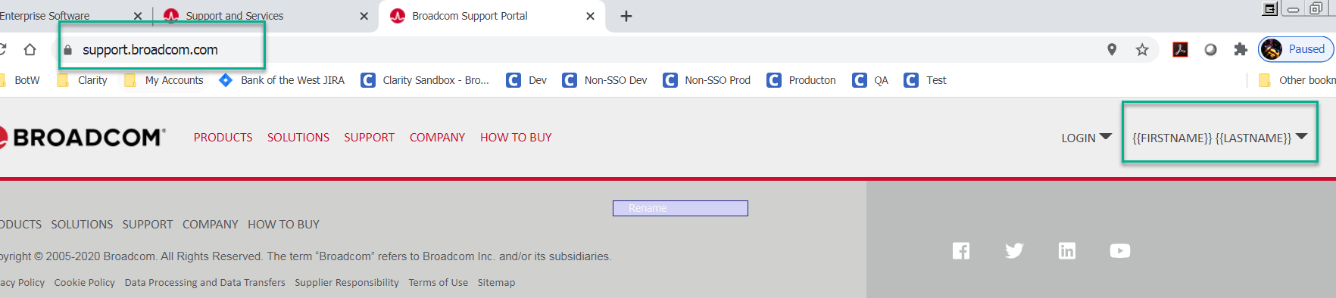
If I try to login from here, it gives me a 404 page.

