MGRMSG artefacts
Job with PRIORITY 10
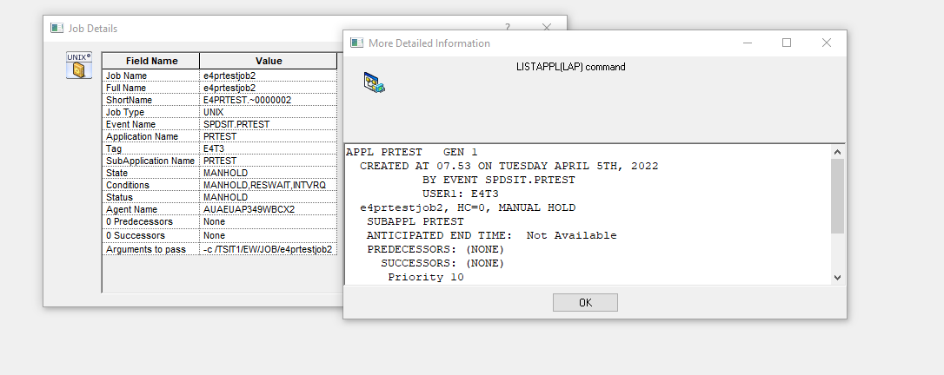

My JCL:
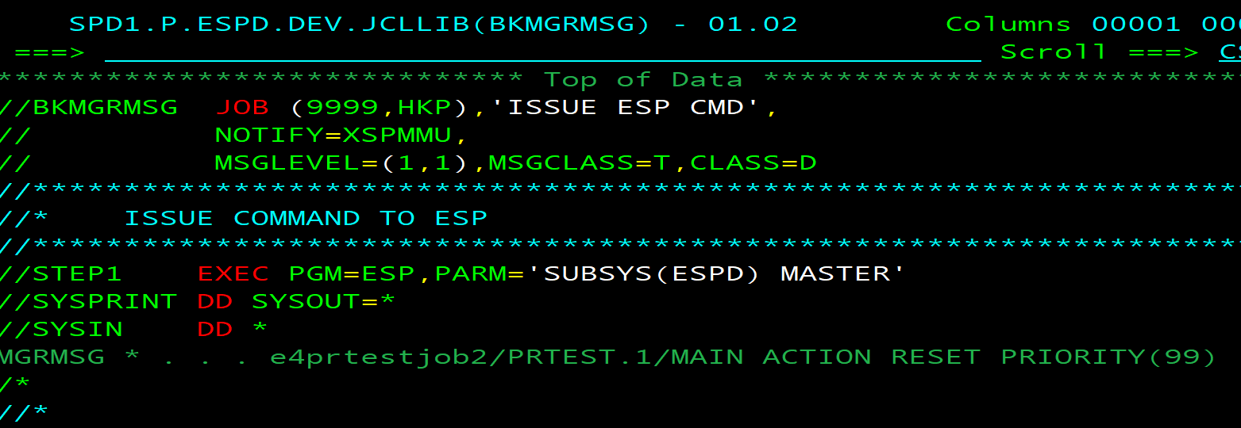

Job end RC=0
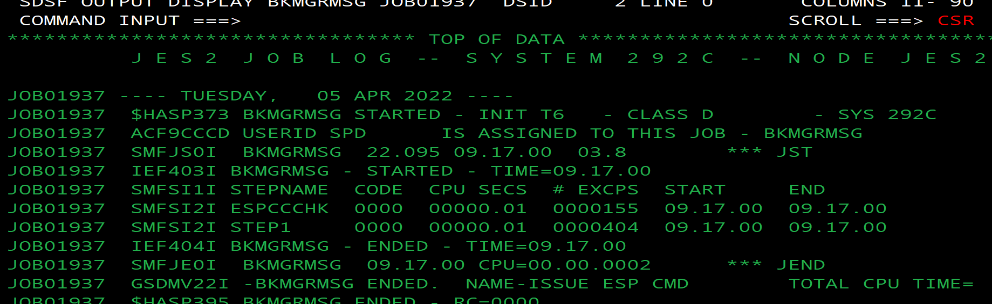

SYSPRINT
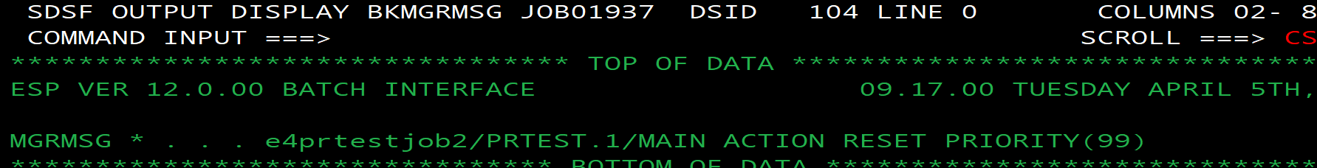

STC output

