Variable not getting resolved in expected result field of all common symbols is there any way to get them resolved?
Eg.

Variables defined in decision table

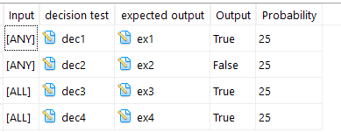

Expected result updated for “True” Output

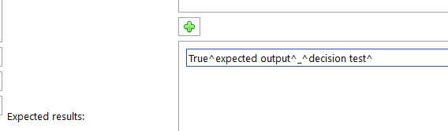
Design step uploaded in ALM showing variables defined is not resolved
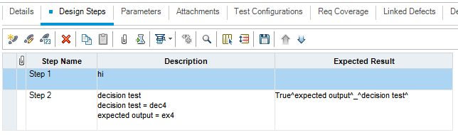

Is it possible by any means/configuration in ARD to upload columns of decision table for selected row as different step in HP-ALM ?
As of now, we are getting all column of selected row in single step. E.g.

Row defined in Decision table

Description of step updated by ARD in HP-ALM

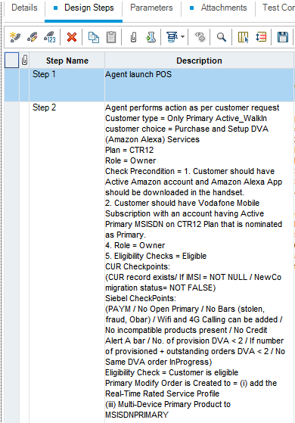

Upload in ALM, is there any way to updated ALM_Description field via calling variable defined in ARD ?
Variable defined in model not getting resolved for ALM_Description defined in custom field at time of store path, it is only resolving attribute reference defined in drop down

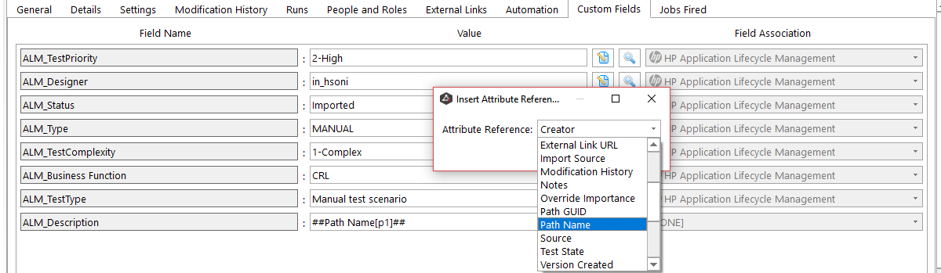

Customer selects a Device or Plan from suggested list by retail agent

