Upgrade SM14.1/USS to SM17.0/USS.
Set Company Admin Name(casmadmin).
And check ‘Use existing database’ with Browse for the ‘Path to Backup File’.
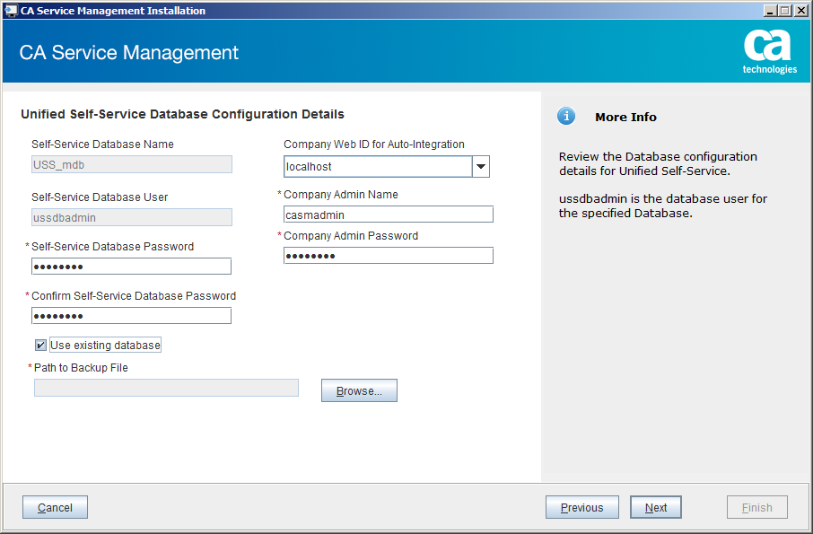
Invalid backup file specified.
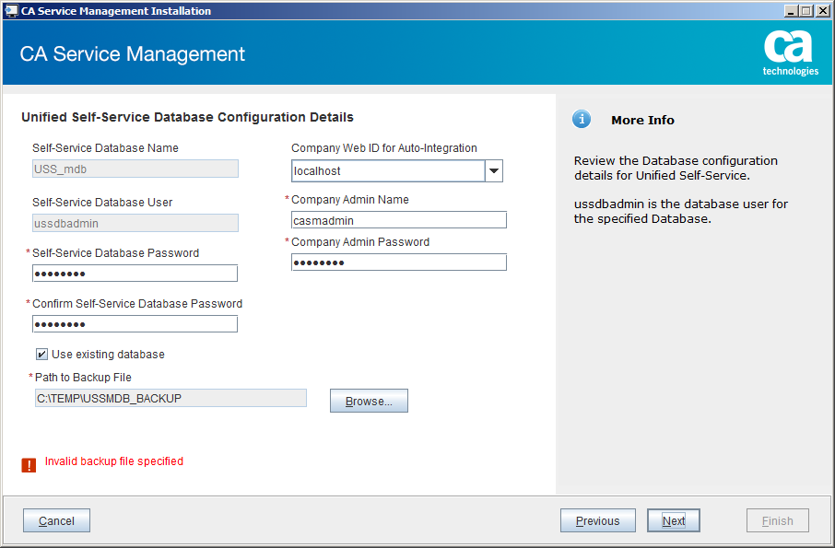
Open the Browse button.
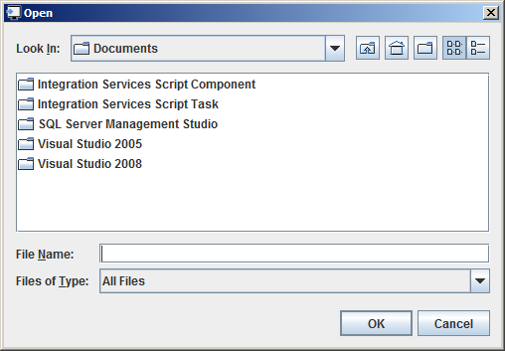
From the Browse-popup, open dropdown for ‘Files of Type:’ and find .car in there.
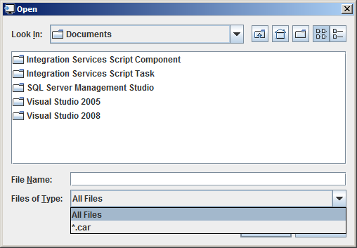
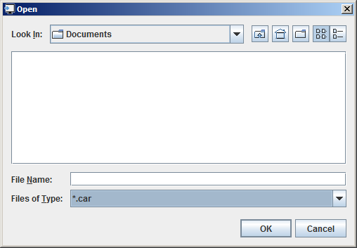
And enter/add that ‘.car’ file extension in the name of the backup file accordingly.
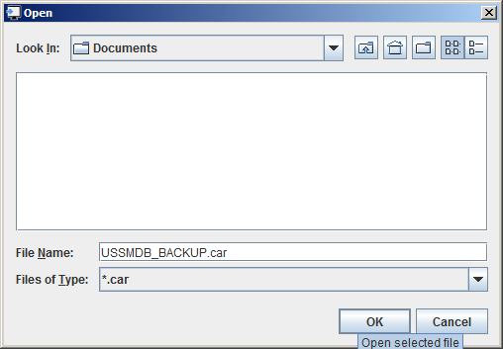
OK.
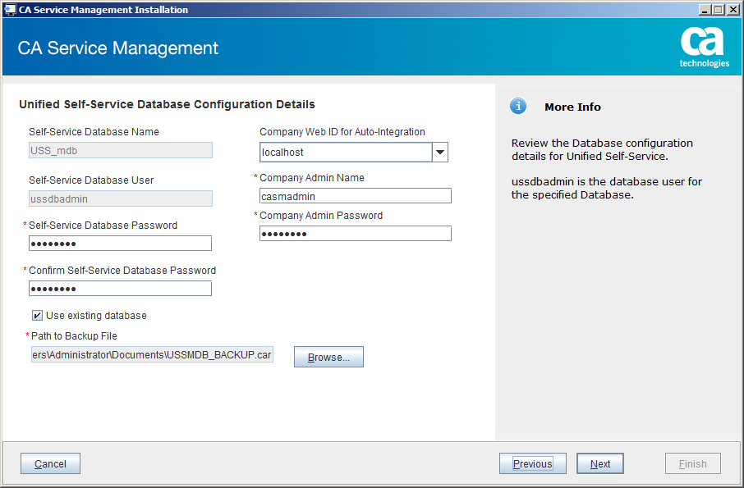
Next.

