As soon as publish putton is pressed, the calls can be seen in Network tab of Inspection view.
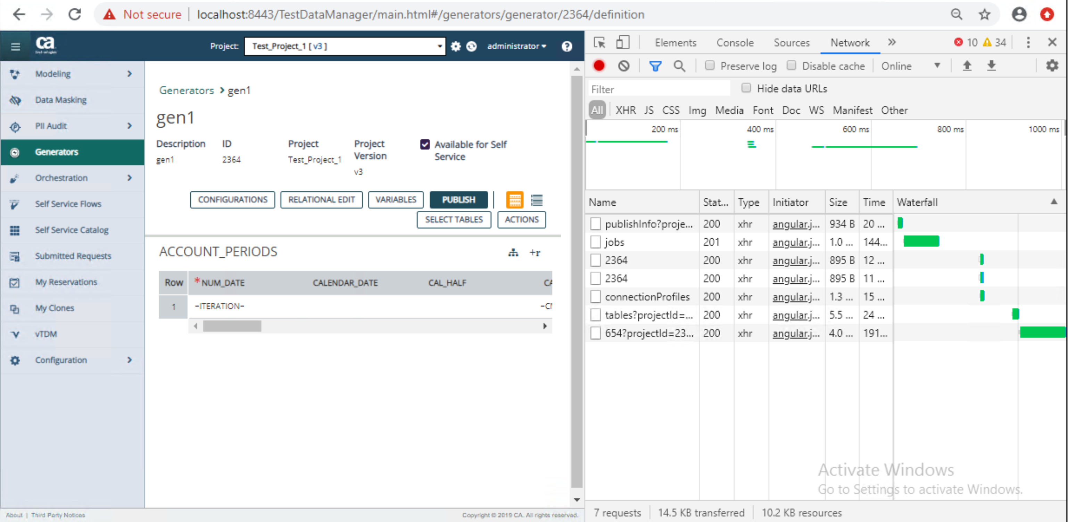

From “jobs” call, copy the Authorization token under headers.

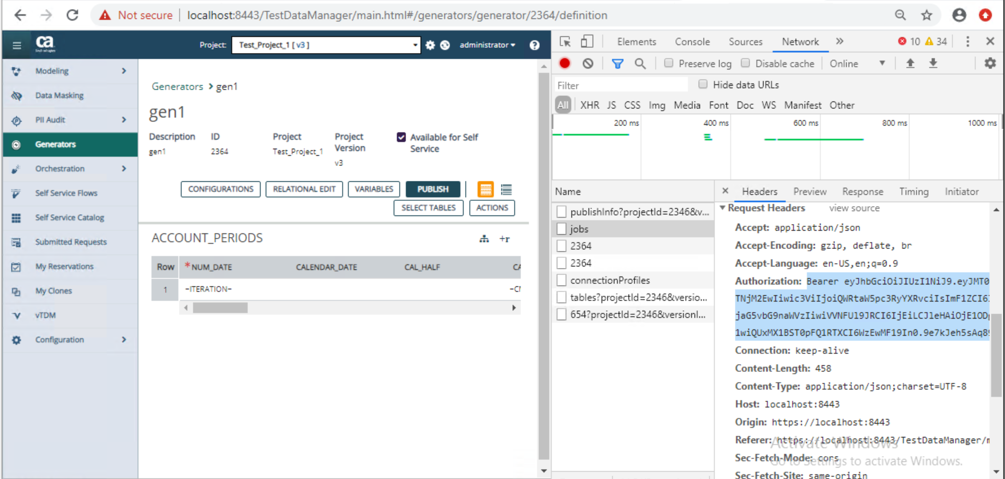
Similarly copy the Request payload after clicking on “View Source”

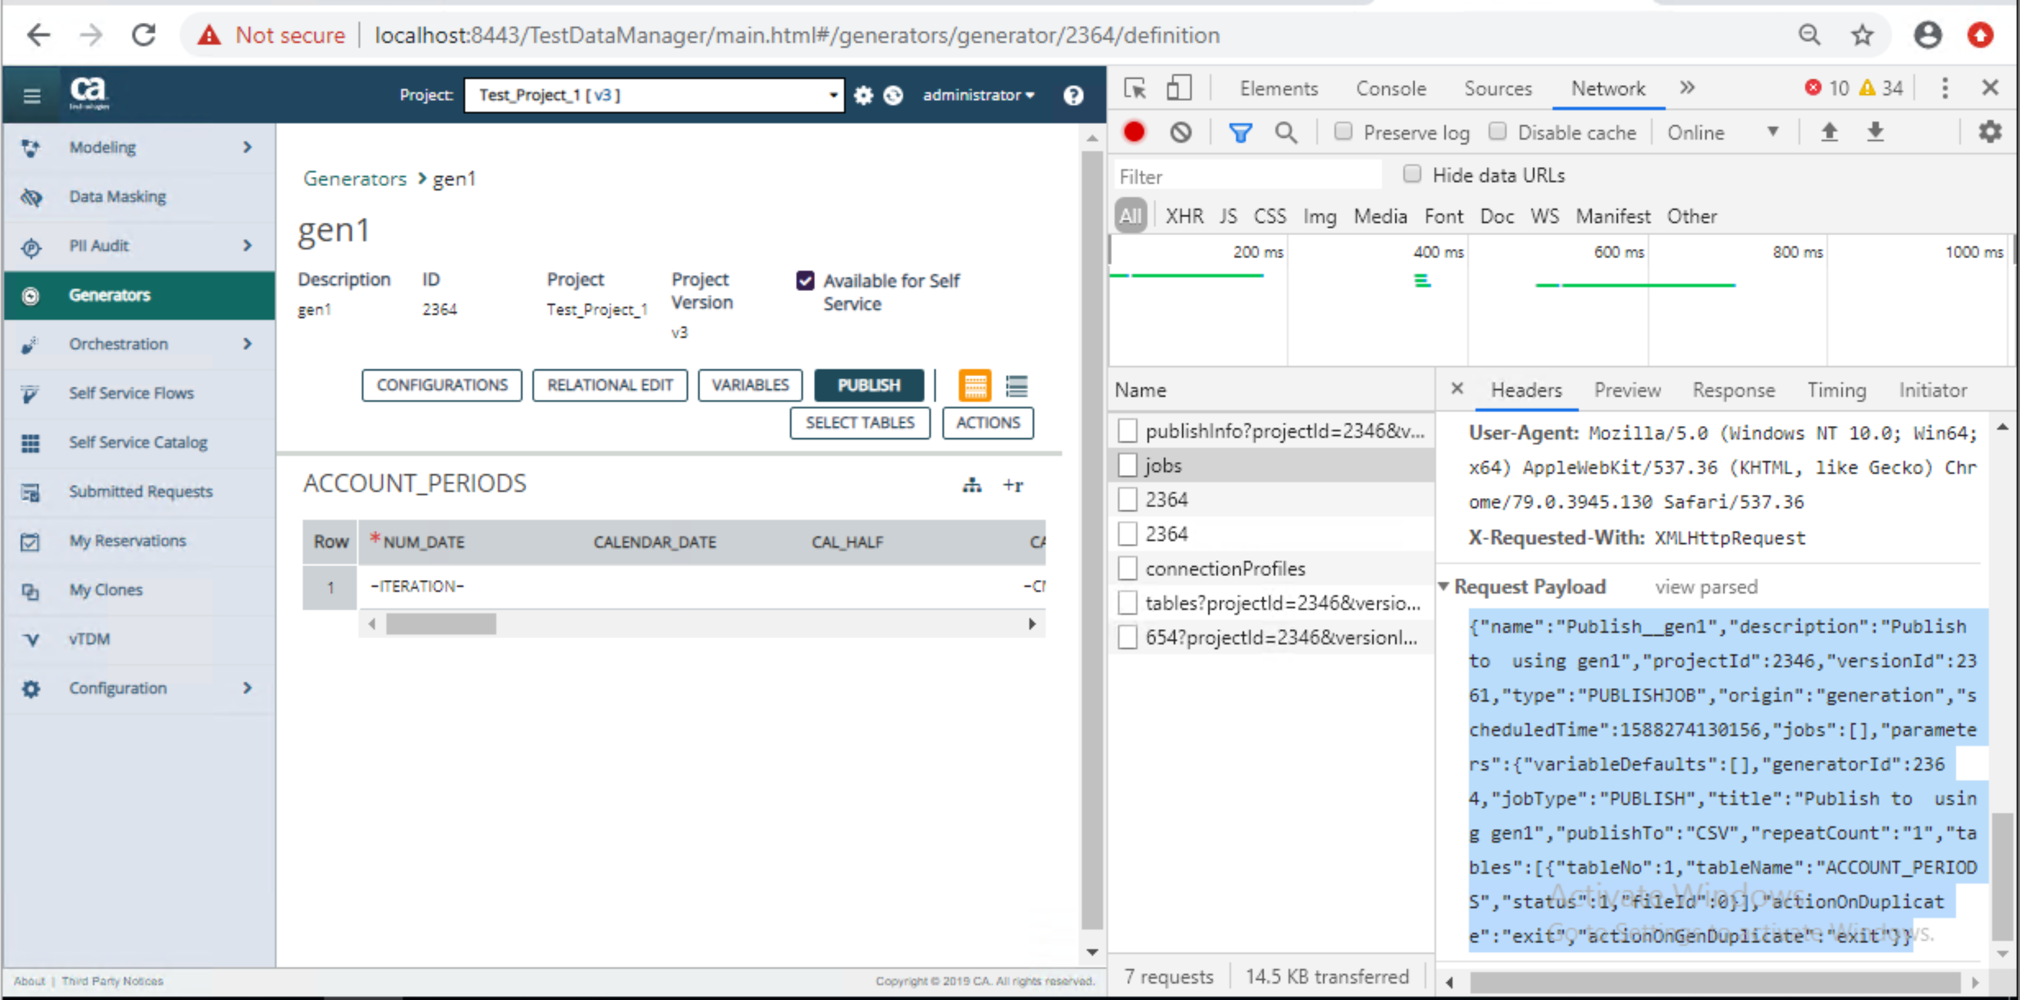

Put the copied authorization token under Authorization field of the “/api/ca/v1/jobs” POST call.
Paste the copied request payload into jobInfo field.
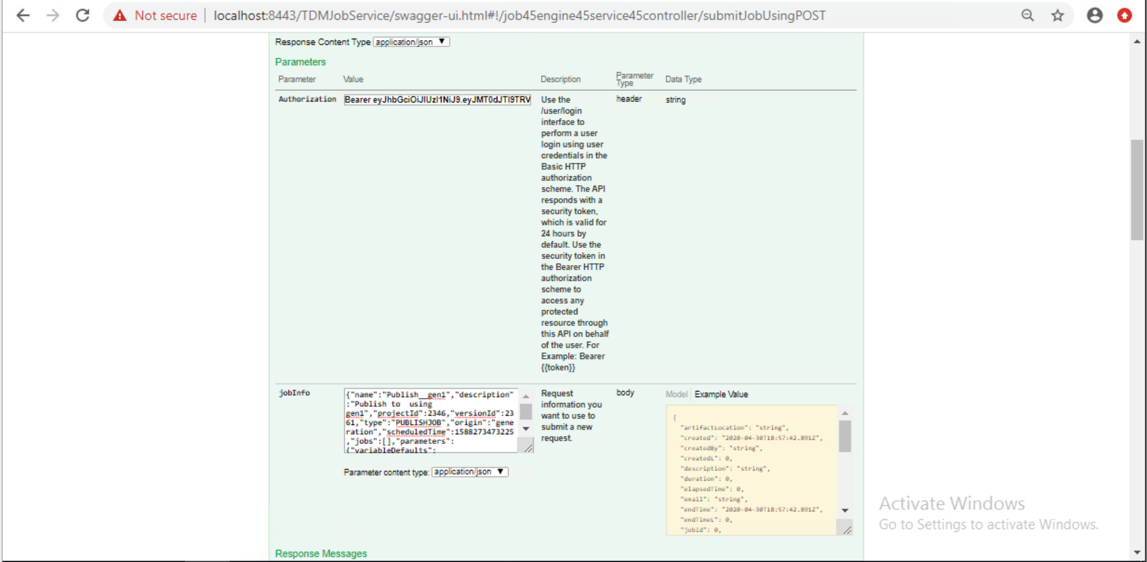
If submitted successfully, you will get below response with submitted job id.

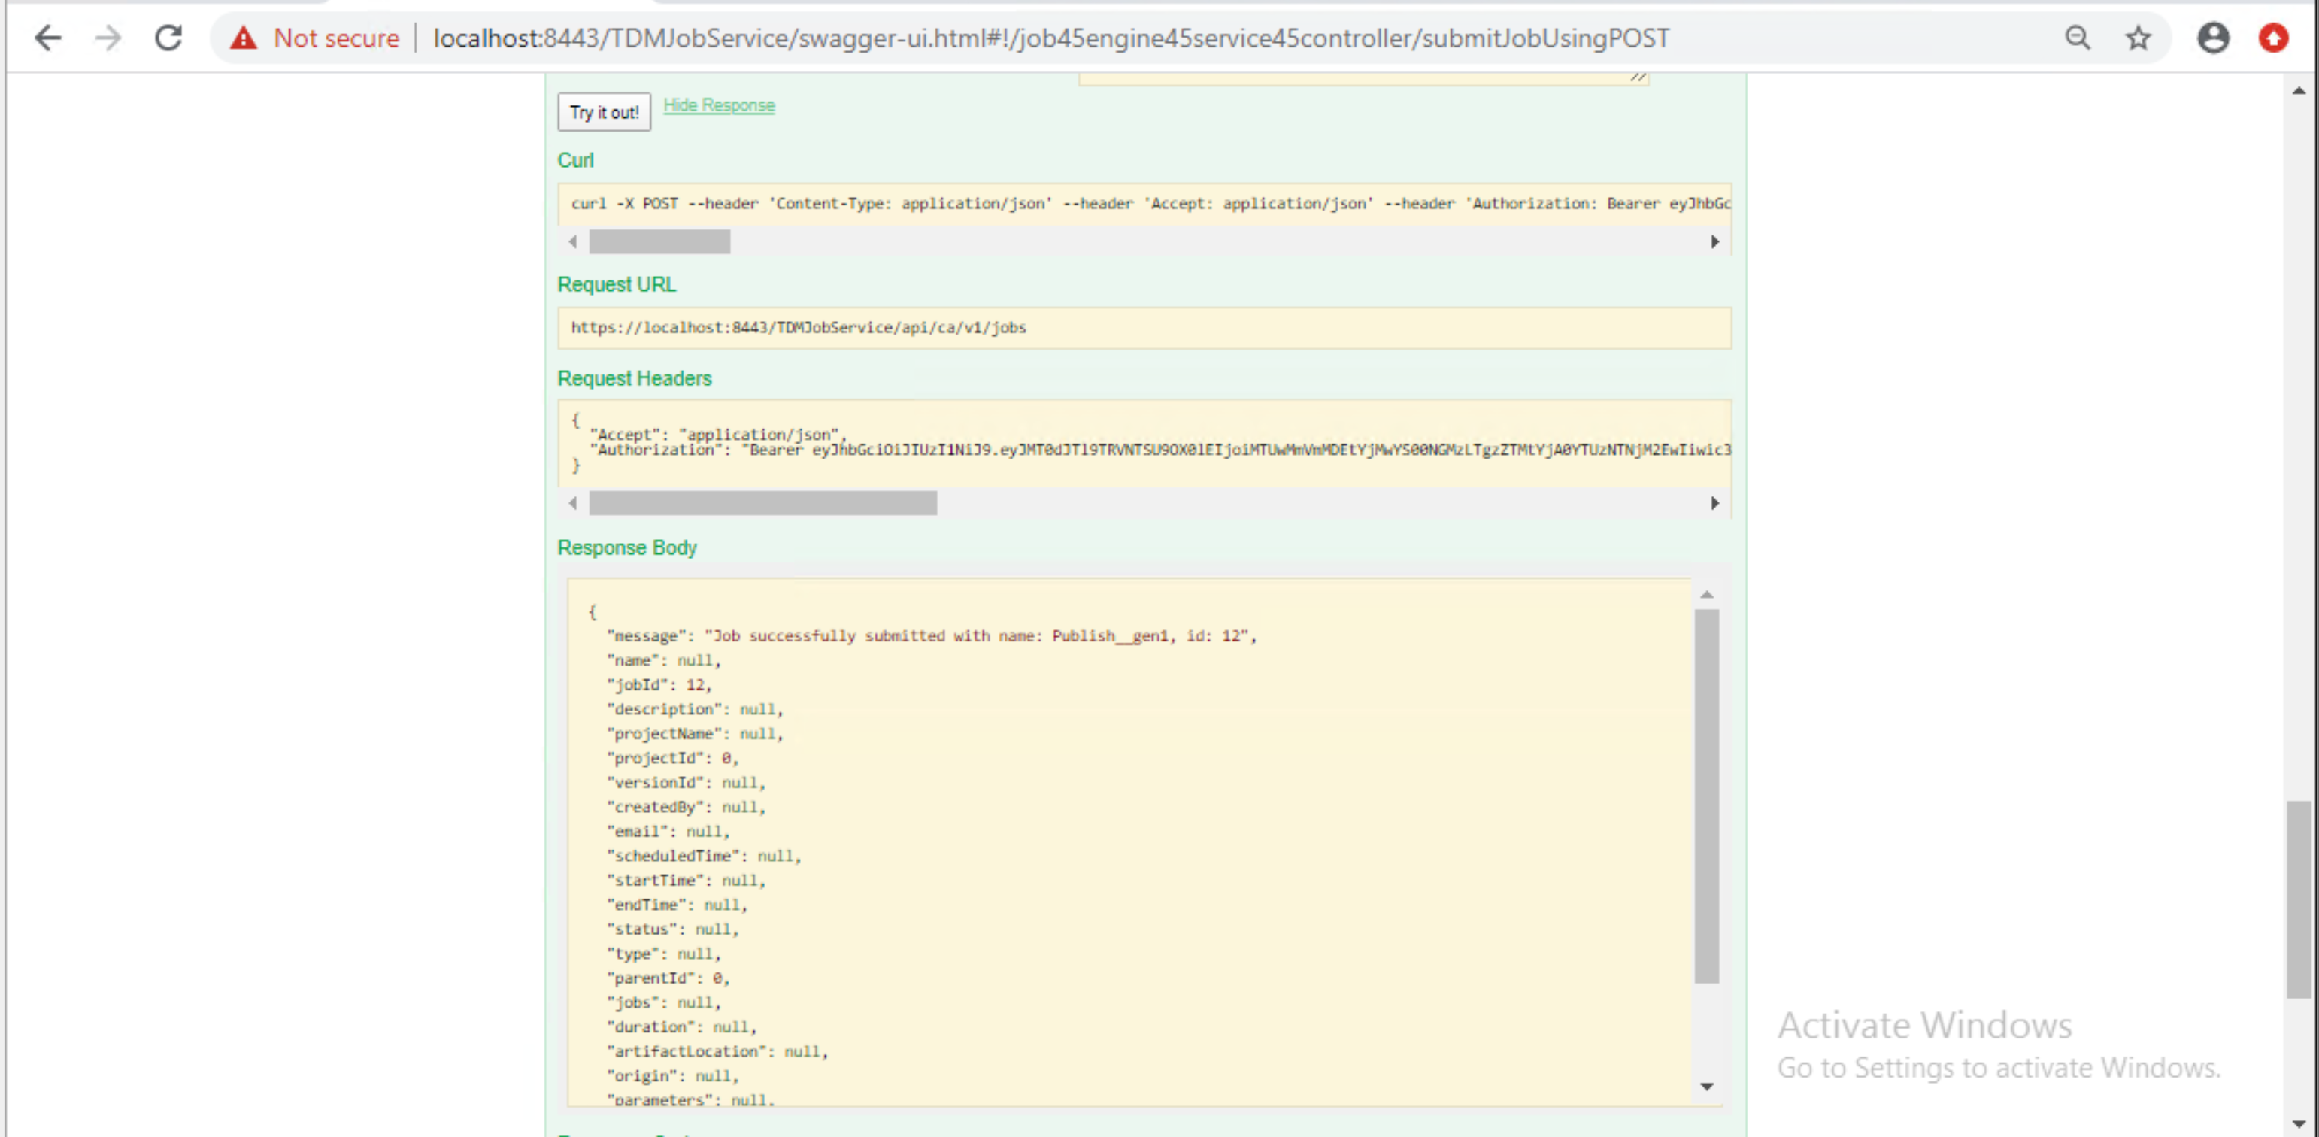

You can now use this job id with other API calls of Job service to get other information.

