Add PIN Length restriction for CA Mobile OTP client or Desktop Client
In order to provision an account on CA mobile device or CA Desktop client the clients need to input a PIN after the Provisioning URL, User Identifier and Activation code, OOTB PIN length can be anything so to restrict that PIN length depending upon the environment, below steps can be followed-

- Login to Admin console with Global Admin privilege
- Go to Organization Tab and then search for the organization for which changes needed to be made
- Click On Strong Authentication Configuration on the screen
- On left hand panel look for CA Mobile OTP (ArcotOTP-OATH)->Issuance
- Create a profile or update an existing one
- Under Advanced Configuration section look for “Custom card Attributes”
- Input values specified below and as per need
MPL_=0 (no pin required)
MPL_=6 (in this whatever 6 we have given can be anything so it will accept provided inter and above length PIN)
MPL_=-1 (it will accept any length of PIN greater than 0)

- Save the Configurations and then go to “Assign Default Configuration” section and assign the newly created profile.

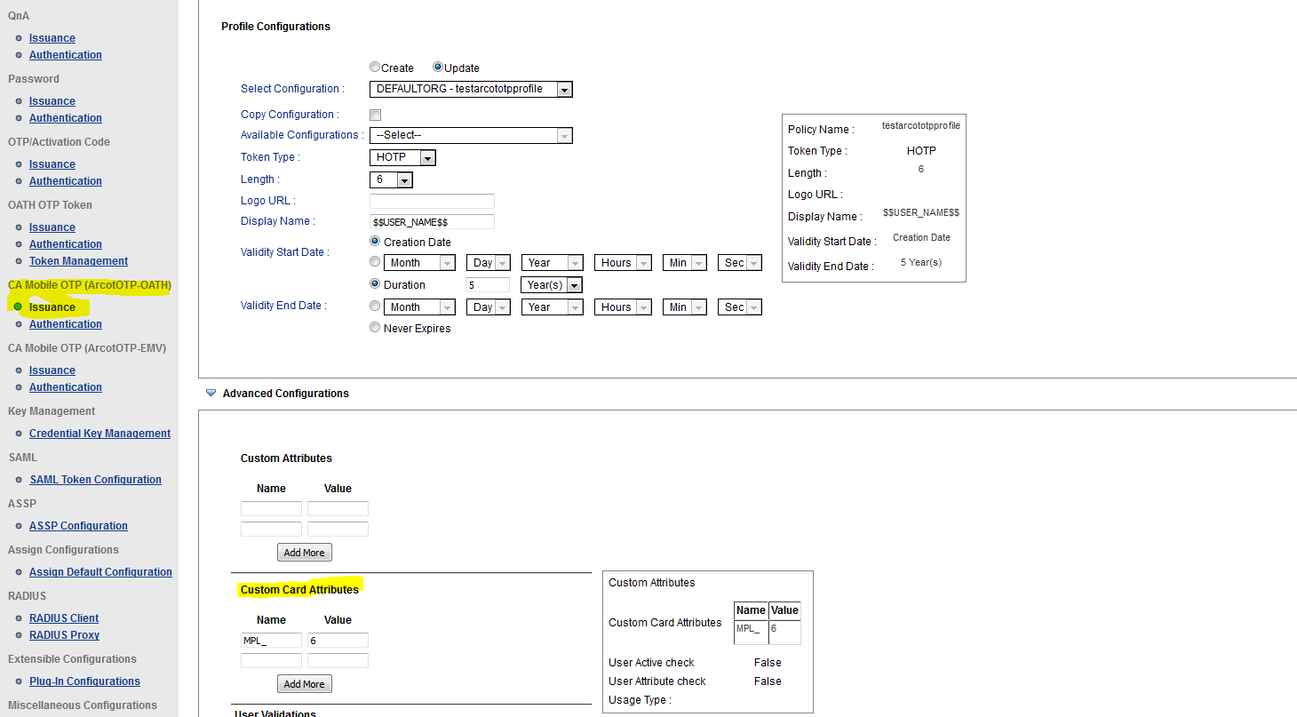

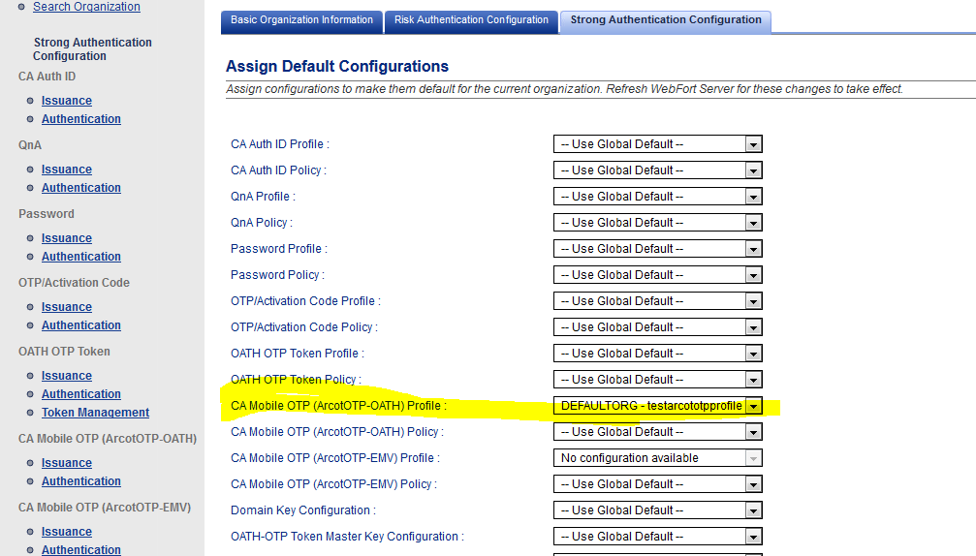

>> Provision a User for CA Mobile OTP or CA Desktop Client and it will accept the PIN length whichever configured. If PIN length is 6 then it will only accept the PIN length of 6 digits else error out.
NOTE OTP will be generated for any length PIN so it is necessary that correct PIN is enetered.

