HOW TO – Obtain a CA PAM License From Broadcom Support

Preferred Method: Create A Ticket Through Woken Service Desk
NOTE: You will need a Broadcom Login Linked to the appropriate Site ID giving you entitlement to CA PAM.

Browse to https://ca-broadcom.wolkenservicedesk.com/esd/mycases
Click + Create Case

Product: Licensing-CA
Provide the SYS INFO File content in the Description or upload the SYS INFO Files to the case after you create it.

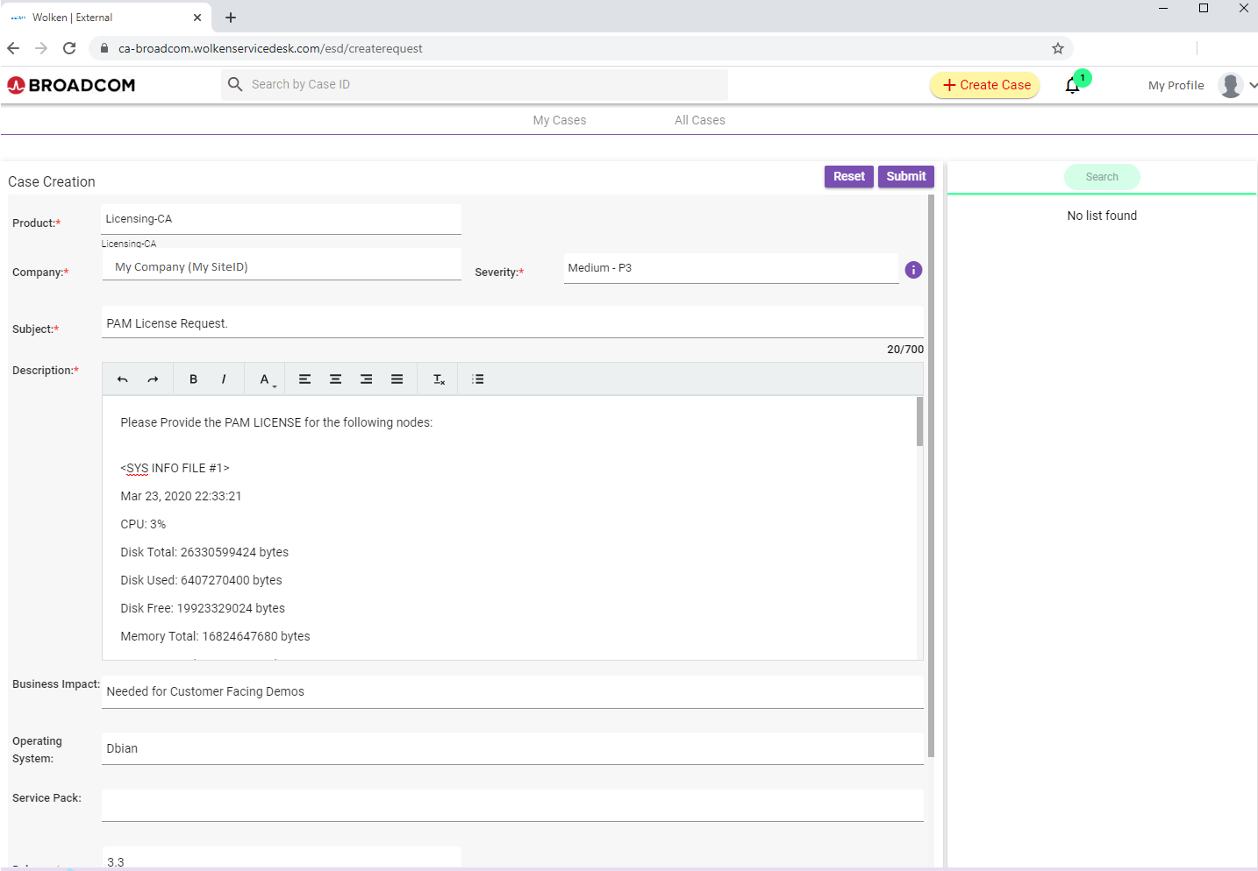

Alternate Method
NOTE: Useful if you do not have an appropriate Broadcom Login yet.

Browse to
https://ca-broadcom.wolkenservicedesk.com/web-form

Fill out the form using you company’s info

Request Type: Licensing – CA Enterprise Software

Summary: CA PAM 3.x License Request

Description:
I need to license my lab PAM Cluster Nodes.
please provide the licenses
Copy and paste the SYS INFO File content into the case notes – each node needs to be licensed, therefore you must provide the contents of each SYS INFO FILE.

>>>Submit the Form <<<<<

