Hi everyone, good afternoon.
I’m looking for information about a custom certification, let me explain myself. In a productive environment i’m working an interaction with CA Mediation Manager 2.2.6 and eHealth 6.3.1, this is working so well by now, i have certified and reporting so well some Tekelek technologie’s elements:

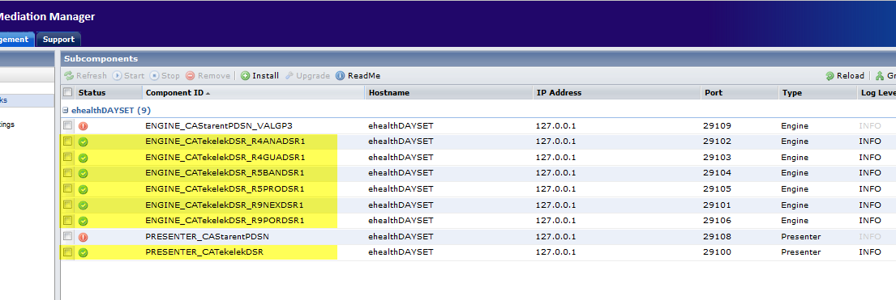
Ilustration 1 Tekelek's technology working.

This isn’t a typical standard certification cause from the total of variables used by the Tekelek’s estandard i only took those that my customer need, and then, the task to search and get charts of them is so easy since the web interface only shown those few variables.

Now, i’m traying to do the same process with the Cisco Starent Technology but it doesn’t work, i had trayed to convert the eHealth database setting only the variables that i need and their respective groups but the BD never could never convert, so, i proceed to use the standard certification for Cisco Technologies (even with all those variables that i don’t need) and add a custom group of variables that manage the calculations and other meanings needed for my customer. The convertion DB for this way works so well, but as you know, i need the DDI file to run the “campoll” comand to the first import data to de database and for the Web Interface building, the problems are:

- In this way, the customer will find all the variables used to the standard that he don’t need, it means a uncofortable task to search those that he really wants.

- The ENGINE and the PRESENTER seems work well, they make them polls completely as you can see in the following image, the PRESENTER write the DDI that i need, with all the groups and variables used in the standard certification but without the custom group and calculations that i added in response to my customer needs.

- Without this complet DDI i can run the “cammpoll” comand in order to update the eHealth database and know if my certifications Works, even with this factor: they’re a lot of variables that i don’t need to see and neither my client.
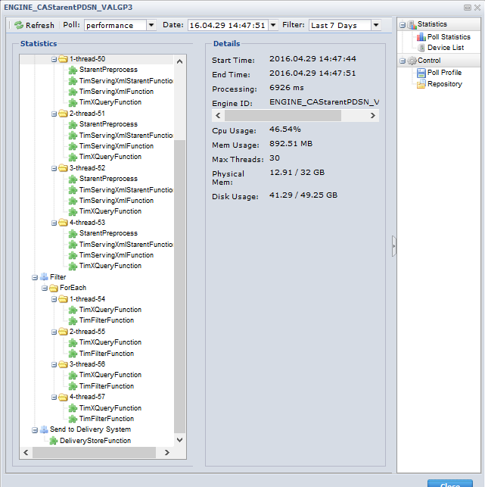
Ilustration 2 Starent Engine Example.
In conclusion, i need information about the way to créate a real custom certification with only the variables and calculations that i need, or, at least, how to resolve the problema with the DDI creation. I’ll be waiting for your response, thank you for your time.

