How to configure SOI with Introscope

Step 1: Configure the APM Connector with the EM
Go to the C:\Program Files (x86)\CA\SOI\resources\Configurations folder
Rename the APM_192.168.101.xxx.xml as APM_192.168.101.130.xml
Update the below properties:
- EMHost= IP of the EM
- EMSNMPHostIPAddress= IP of the EM
- EMSNMPBindAddress= IP of the APM connector server
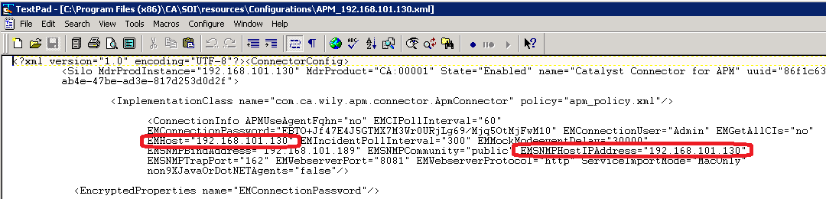
Enable TRACE in the APM connector server, go to C:\Program Files (x86)\CA\SOI\resources\Configurations\log4j\ APM_log4j.xml, change Logger level from INFO to TRACE:
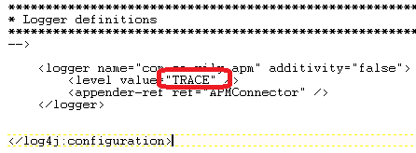
restart the SOI integration service:
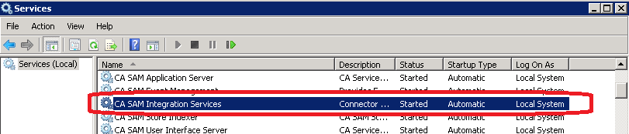
Step 2: Configure the EM with the APM connector:
Open the Management Module editor:
a) Create a Test.jar management module
b) Create a new “New SNMP Alert Action”
Set SNMP Destination hostname = IP of the APM connector. For this example: 192.168.101.189
Set EM and MOM IP addresses = 192.168.101.130
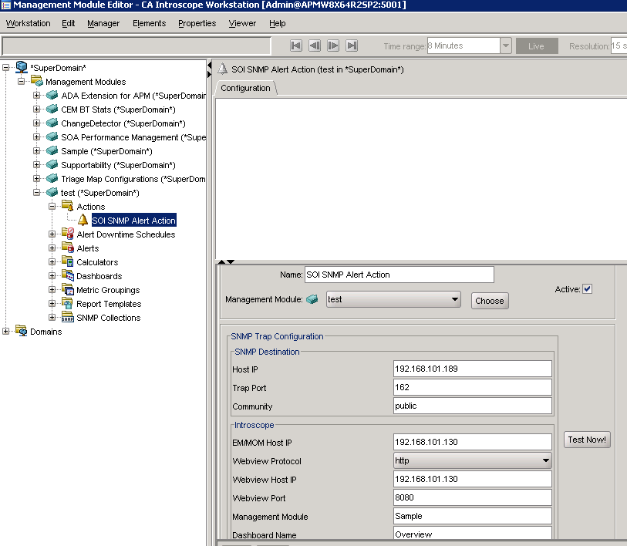
Step 3: Validate communication between the EM with the APM connector:
TEST 1: Go the Management Module Editor, click “Test Now!” button.
Go to the APM Connector server, check the C:\Program Files (x86)\CA\SOI\log\APM_connector.log, you should see the below messages, indicating that the trap has been received.
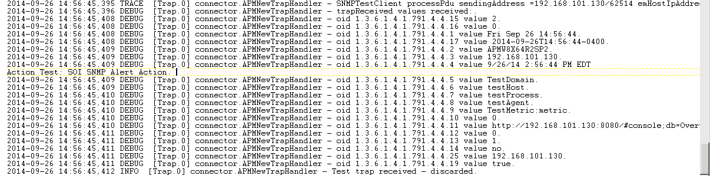

TEST 2: Create a simple alert and configure it with the new SNMP Alert action
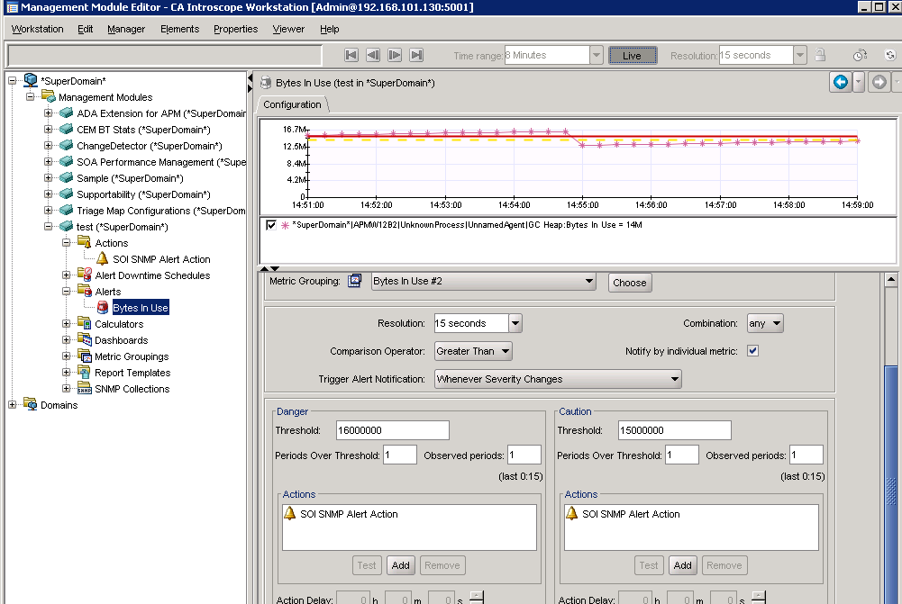
Go to the APM Connector server, check the C:\Program Files (x86)\CA\SOI\log\APM_connector.log, you should see the below messages, indicating that the trap has been received.
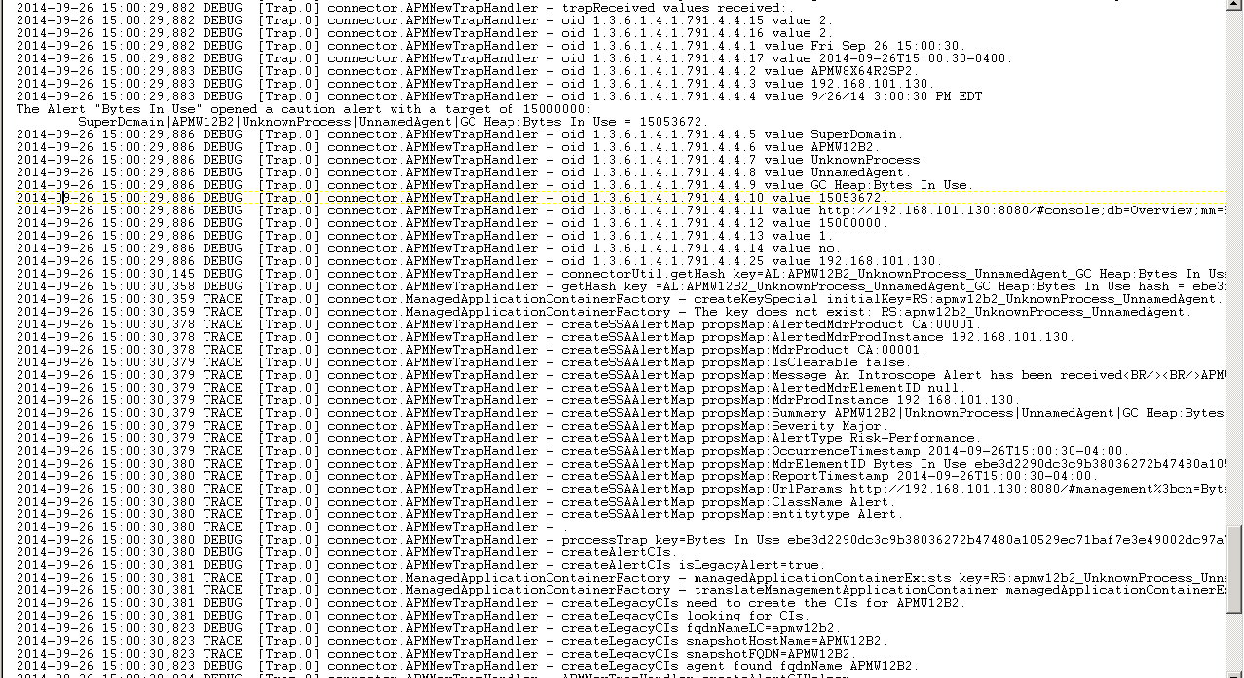
Step 4: Create a new SOI “Service” and view generated alerts from Introscope
Go to the SOI console, click Tools, create a new Service:
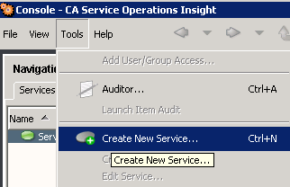

You should see your Agent under Computer System > Running Software. Right click, select “Add with sub-components”:
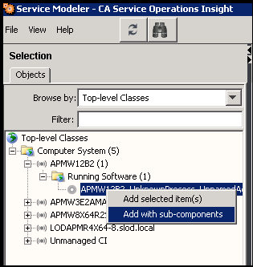

Give a name to the new Service, then click Save
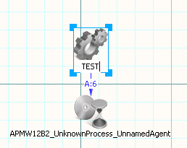

Wait for an alert in the SOI console:
